USER MANUAL

HD Multimedia Converter

（Model No：HDCN0009B1）

Enjoy the vivid world!

REMARK
Manufacturer does not make any commitment to update the information contained herein.
Dear customer

Thank you for purchasing this product. For optimum performance and safety, please read these instructions carefully before connecting, operating or adjusting this product. Please keep this manual for future reference.

The products are designed to make your A/V device use more convenient, comfortable, productive and cost-efficient.

The integrated multimedia converter was designed to enhance the audio and video experience at the guest room of the hotel and the personal home theatre. It can converter easily the multi-channel audio source and the video signal source (Camera, Smart phone, Computer, etc.) into the Full HD signal, and can switches easily between the multiple signal sources. In addition, the multimedia converter was also equipped with RJ45 /RJ11 /USB2.0 interface, which is for convenient connection with the Ethernet /telephone /USB devices.

Our devices offer solutions for noise, space and security concerns, data center control, information distribution, conference room presentation, school and corporate training environments.

INTRODUCTION
FEATURES：
- 5-way input audio and video signal input, converted to one HDMI output
- Support HDMI output up to 1080P/60Hz, the HDMI signal input support 3D HD source film (24p)
- Build-in signal amplifier scales the composite video, YPbPr, VGA signal input to HDMI 1080p output
- The HDMI signal input is compliant with CEC, HDCP and 30bit, 36bit,48bit deep color
- PAL/NTSC automatic video format
- No loss of quality. Support input up to 15metres AWG26 HDMI standard cable length, output up to
20metres AWG26 cable length
- Easily switch between devices manually or with the IR remote control (Internal / external IR)
- Plug and play (Except for MHL)
- The MHL input support the HD Signal transmission from the smart phone to the HD TV and also can
do power charge to the MHL device and support RCP function.
- The HDMI input port can support MHL/HDMI dual mode input.
- Built-in Ethernet / Telephone /USB2.0 pass-through interface, support the USB port 1A power charging function.
- One Switch Key at the front panel and the other Switch key at the rear panel, the two key have the same function that can do switch at the input video signal sources.
- DC5V/2A power supply
PACKAGE CONTENTS:

1、Main unit 1pcs
2、AC power adapter 1pcs（Optional）
3、Remote controller 1pcs
4、External IR receiver 1pcs
5、MHL-MHL cable 1pcs（Optional）
6、MHL-HDMI cable 1pcs（Optional）
7、User manual 1pcs

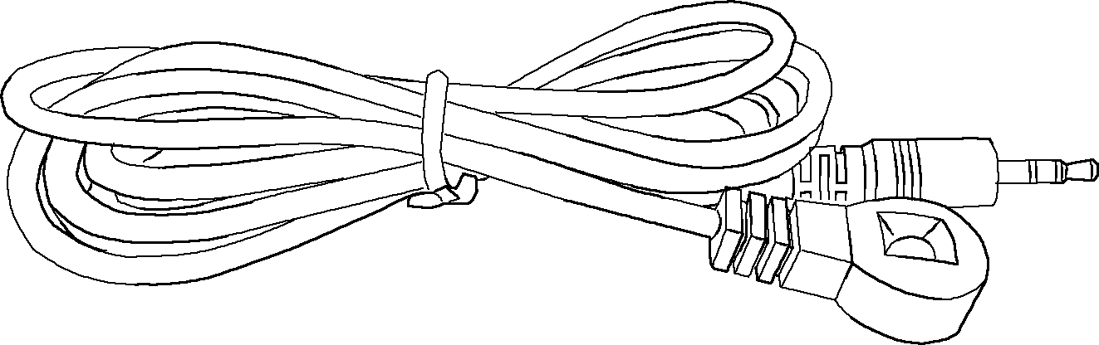
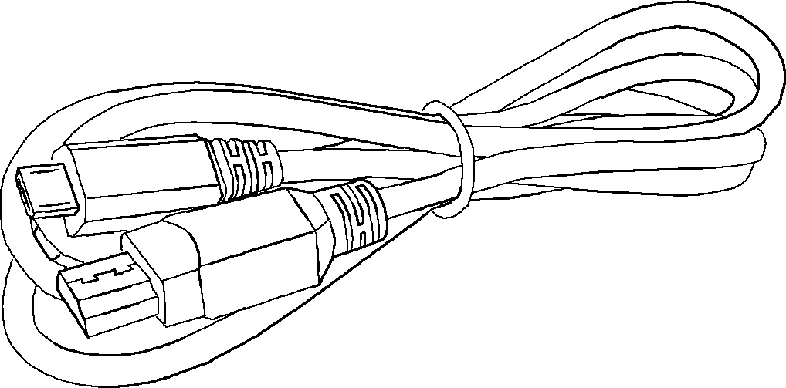
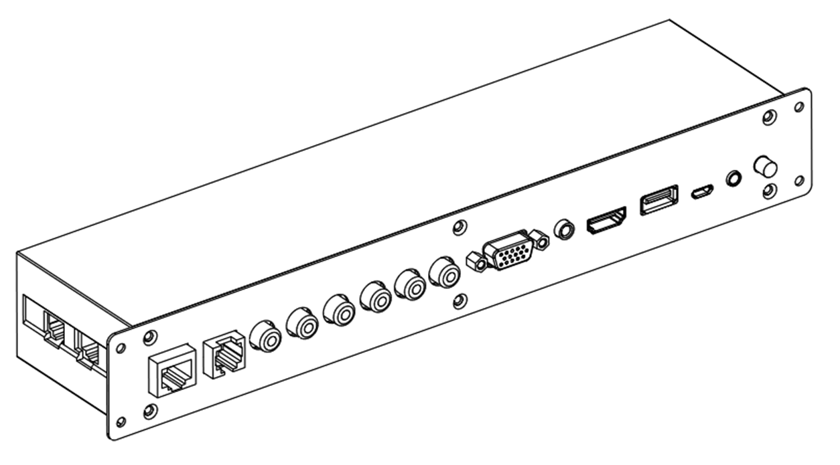
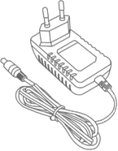
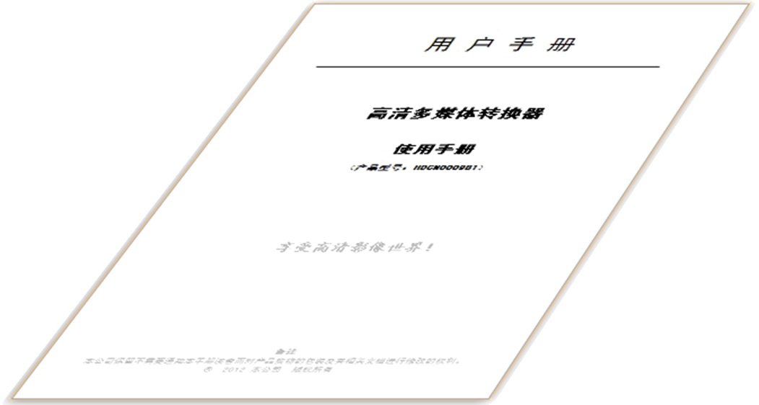
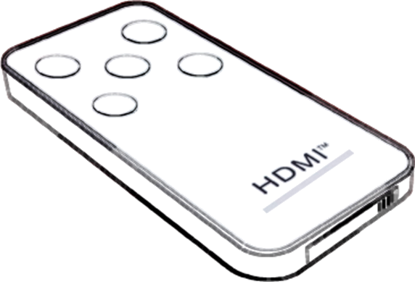

FEATURES OF THE INTERFACE:
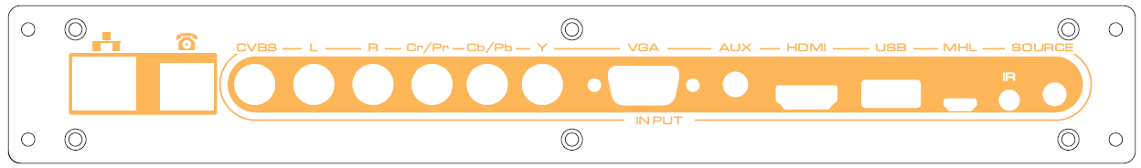

FIG.1.0 Front Panel View
: Ethernet interface (pass-through port, without control system)
 : Telephone interface (pass-through port, without control system)
CVBS: Composite video signal input
L/R: Analog audio input (CVBS and YPbPr use the same Audio signal input channel)
YPbPr/YCbCr: Component video signal input
VGA: VGA input
AUX: Auxiliary audio input (this audio channel is used together with the VGA Video signal input)
HDMI: HDMI/MHL input (dual mode capability)
USB: USB2.0 interface (pass-through port, without control system, can charge for the mobile devices)
MHL: MHL input (can charge for MHL devices)
IR: External IR receiver jack
SOURCE: Source selection key
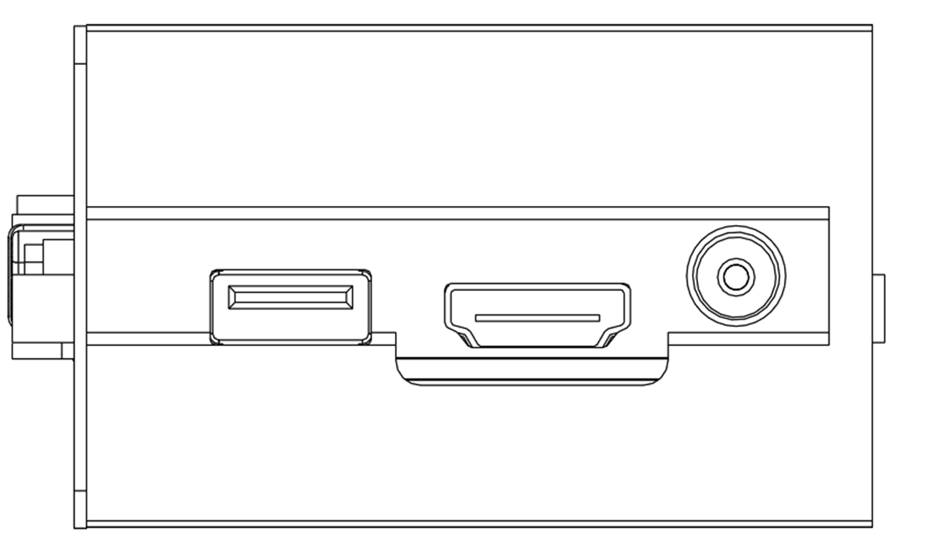
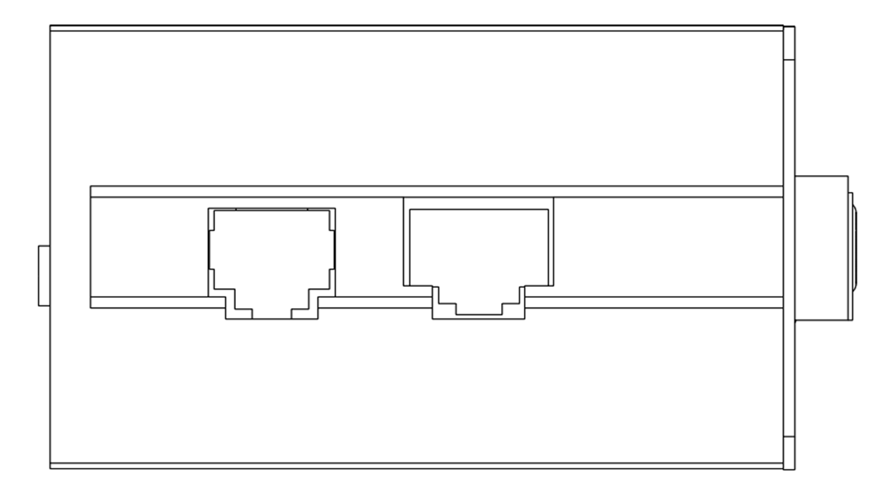
USB
HDMI OUT
DC 5V

FIG.1.1 Left Panel View FIG.1.2 Right Panel View

USB: USB2.0 interface (pass-through port)
HDMI OUT: HDMI output port
: Telephone (pass-through port)
: Ethernet (pass-through port)

DC 5V: 5V DC in jack
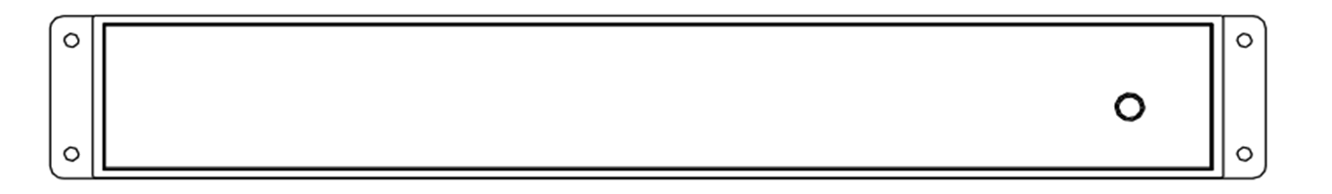
POWER
IR
SOURCE
HD Multimedia Converter

FIG.1.3 Rear Panel View
PWR: Power status LED
IR: Internal IR receiver window
SOURCE: Source selection key（the same with the front panel SOURCE key）
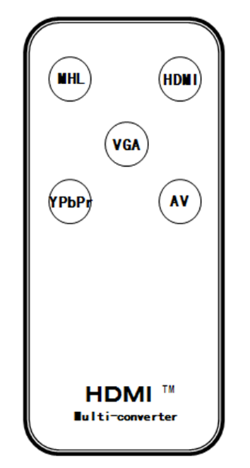

MHL: Select MHL for the input port
HDMI: Select HDMI/MH for the input port
VGA: Select VGA for the input port
YPbPr: Select YPbPr /YCbCr for the input port
AV: Select CVBS for the input port
(Note: Use after the battery separator film is pulled out)

FIG.1.4 Remote Panel View
OPERATIONG AND CONNECTION:
- Connect one cable from each display (monitor or projector) into the converter HDMI output.
- Plug the network cable, telephone line and USB cable both sides of the converter.
- Connect 5V power supply to the switcher and inserted into the power socket.
- Insert the external IR receiver into the IR IN jack.
- Connect one cable from signal source devices into converter anyone inputs, the converter will automatically detect the signal and switch to the current input. At the same time, the HDMI output HD signal to HDTV.
- Use of select key or remote controller to select the input signal source.
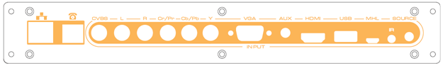
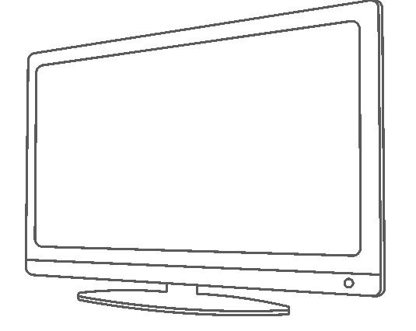
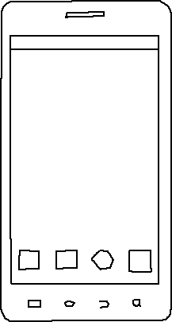
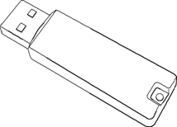
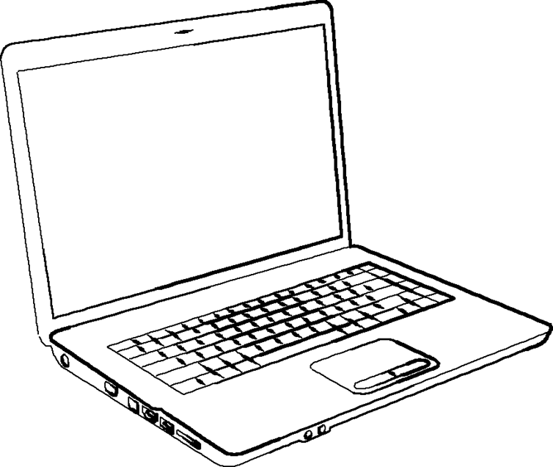
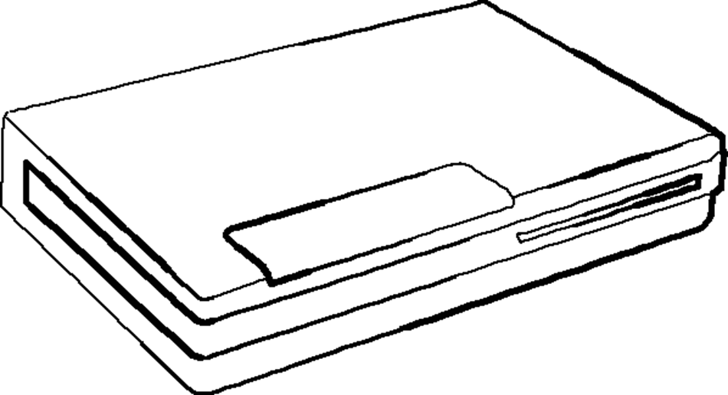
Ethernet
HDTV /Projector
HDMI/USB Cable
MHL Cable
Phone
VGA Cable
PC
USB Cable
HDMI Cable
Modem /Router

Ethernet
Cable
HD Multimedia Converter

Telephone line
AV Cable
Component
Cable
Ethernet Cable
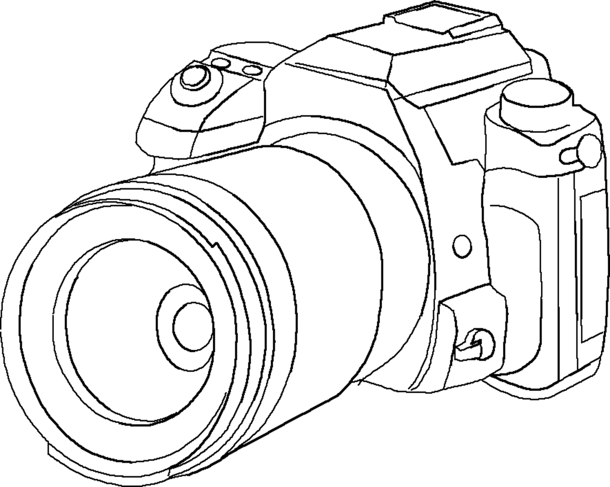
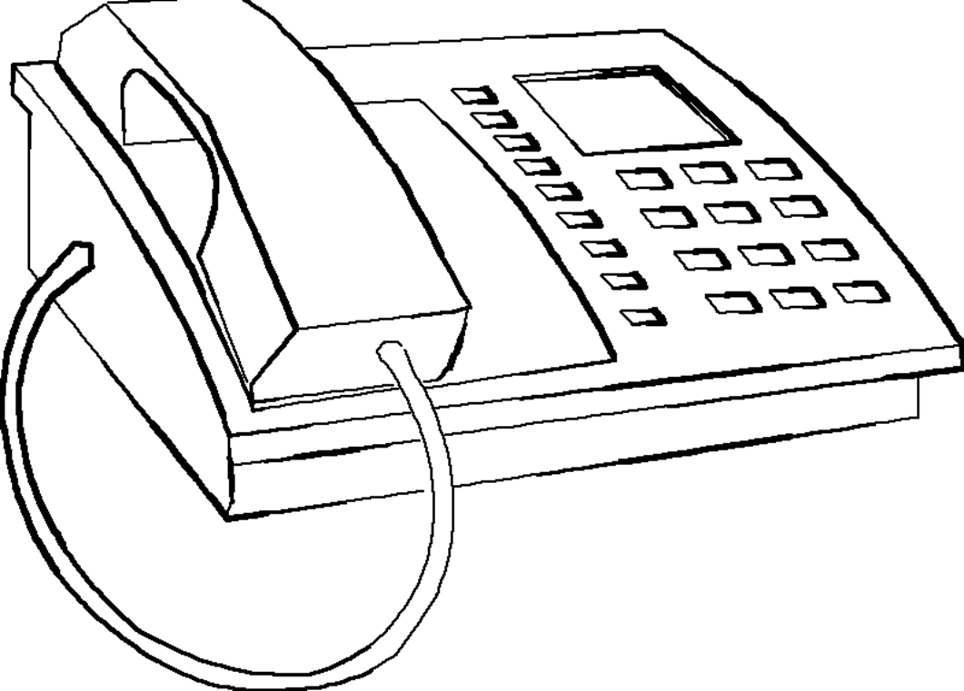
USB Devices
PC

Camera
7. After In the TV menu settings with the MHL DEVICE synchronization, you can use the TV
remote controller to control mobile device and switch signal source channel selection. But it requests the TV that can support the CEC function and mobile device can support RCP function. For details, please talk with TV or mobile device manufacturers to confirm. For example, the following mobile phone has passed the factory test, can support high-definition output and RCP function.
HTC sensation(G14) | Samsung SII I9100
HTC sensation XE | Samsung I9108
HTC EVO 3D | Samsung Galaxy Note Phone
HTC One X | Samsung SIII
HTC Flyer

- Note: No OSD display when the MHL and HDMI input.

SPECIFICATIONS: HDCN0009B1
HDMI input resolution ………………………………24/50/60fs/1080p/1080i/720p/576p/576i/480p/480i
VGA input resolution..…………….……..…………….……..…………….……up to 1920 x 1080 @60Hz
HDMI output resolution ……………………………………………………………………………up to 1080P/60Hz
HDMI video color format ……………………………………………………………24bit/deep color 30bit/36bit/48bit
HDMI audio format……………………………………DTS-HD/Dolby-trueHD/LPCM7.1/DTS/Dolby-AC3/DSD
MHL pixel clock rate (24-bit mode) …………….…….……………….…75MHz（8bit 1080i/720P 60Hz）
MHL pixel clock rate (Packed Pixel mode) …………….…….……150MHz（8bit 1080i 60Hz YCC422）
Max bandwidth…………………………………………………………………….…….….…………225MHz
Max baud rate……………….…….………………….……………………………….…….……… 6.75Gbps
Input/Output TMDS signal ………….…………………………….…..…….………0.5~1.5Volts p-p（TTL）
Input/Output DDC signal ……………………………………………..…….…….…….……5Volts p-p (TTL)
HDMI Input cable distance…...……………………….……….……. ≤15m AWG26 HDMI standard cable
Output cable distance ….…….…….…….…….…….…….…….……≤20m AWG26 HDMI standard cable
Max working current……………………………………………………………….……….…….….….. 1.4A
Power adapter format Input: ……......….….…….…….…….… AC 100V～240V 50HZ/60HZ; DC5V/2A
Operating Temperature range……..…………….………………………………………………-15 to +55℃
Operating Humidity range………………………….….……….………… 5 to 90%RH (No Condensation)
Product size (L x W x H) ……………………………….…………………………………266x65x40 (mm)
Front panel size (L x W x H) ……………………………….………………………………286x40x1 (mm)
Recommend wall opening size……………………………….……………………………300x41x65(mm)
Recommend Decorative panel size………………………….……………………………320x80x5.5(mm)
Weight…….…………………………….………………………………………….………………………320g

Notes:
Pls use the machine as the instruction listed to keep the long use lifetime of the machine.
- The machine should be placed at the spot far from the Damp, High-Temperature, Dusty, Erosive, and oxidative environment.
- All parts will be free from the strong shake, hit, fall.
- Touching the power adaptor with the wet hands is prohibited.
- Pls hold the power adaptor head and do not pull the power cord when cut off from the socket.
- Pls turn the power off when the machines not used for long time.
- Pls do not open the cover and do not touch the inside parts.
- Pls use the original factory power adaptor.

FAQ:
Before power on, pls check the connection line carefully. And make sure that all interfaces are normally connected. The common trouble shooting way shows below:
No. | Problem Description | Solutions
1 | Non-Power-Connected | 1. Check if the power adaptor head is truly and correctly inserted the power socket.  2. Check the remote power switch if it is in standby status.
2 | No Picture | 1. Pls to make sure that the TV is on and has been connected with the machine.  2. To check if the signal source is on and well connected.  3. Check if the line is all good quality.  4. Check signal source channel selection is correct
3 | Obscure Picture | 1. To try again to connect the cable to be free from the unsuccessful connection.  2. HDMI Cable Quality
4 | MHL devices without RCP | 1. Please confirm the TV support CEC function, and confirm the mobile device support RCP function.  2. HDMI Cable Quality

