User Manual

1x4 HDMI TV Wall Video Processor

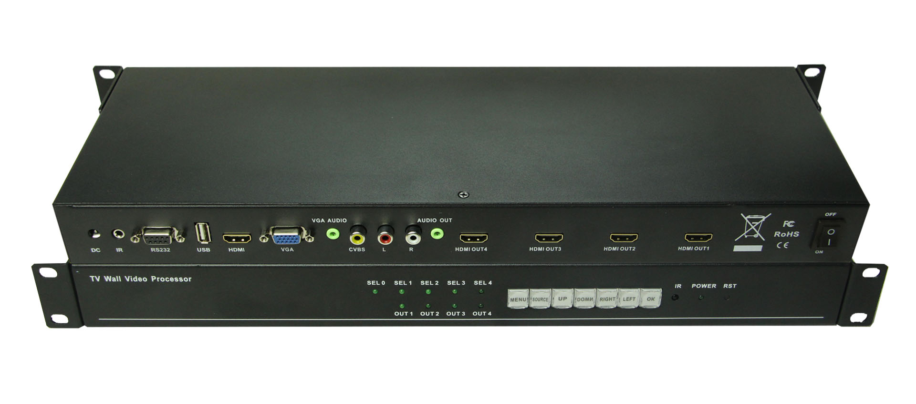

Version: V1.12.16
Contents
1. Introduction 3
2. Features 3
3. Specification 3
4. Packing 4
5. Panels 4
5.1 Description of back panel 4
5.2 Description of front panel 4
6. Remote control 5
6.1 Button Functions 5
6.2 Splicing setup 6
7. DIP Switch 6
8. Sub-title Fucntion 7
9. Supports different installations 7
10. After Sales 8
11. Version Information 9

1. Introduction

TV Wall Video Processor is a very simple and convenient to put one image across for LCD displays with HDMI port, it also converts the USB2.0/ VGA+3.5mm/ CVBS to HDMI output, if it’s an HDMI input source, it can split the audio out from the HDMI to a 3.5mm audio port. With the USB2.0 port, users can have the subtitle scrolling function to add some welcome words. It also can work as a 1 to 4 spliter.

2. Features
- Convert USB/ VGA and CVBS to 4 HDMI outputs
- Sub-title scrolling function
- More than 10 different operation languages to choose
- Support remote control
- Front buttons faster sources switching
- Mirror function
- Supports 2X2, 1X4, 4X1 and so on splicing
- Specification
Model Name | TVWALL-104
Input | USB2.0: Supports sub-title function, supports“.mkv” format video
Input | VGA+3.5mm: Supports 1920x1080/60HZ and below
Input | CVBS: Supports PAL,NTSC
Input | HDMI: Supports 1080P and below 1080P
Output | 3.5mm Audio: de-embedded from the HDMI or 3.5mm VGA Audio input
Output | HDMI: Up to 1080P. Depends on the sources input
Mirror function | Can realize the image 180 degree rotate
Controlling | Remote control, DIP switch, front buttons
Language | Support more than 10 languages to choose
Input voltage | 100VAC ~ 260VAC, 50/60 Hz, DC 5V power adapter
Rack mounted | Come with a pair of rack ears
Dimension(mm) | 5.9"x17.3" x1.7"/ 150 mm (W)×440 mm (D)×44 mm (H)
Weight | 4.4lb/ 2Kg
Operating Temperature | 0 ºC~40 ºC/32 ºF~104 ºF
Storage Temperature | −20 ºC~60 ºC/−4 ºF~140 ºF

4. Packing
1x4 TV Wall Processor | 1 | Unit
Remote control | 1 | Pcs
Power adapter | 1 | Pcs
Rack ear | 1 | Pair

5. Panels
5.1 Back Panel
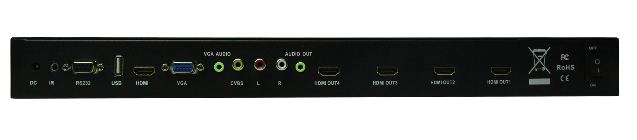

DC | DC Input | 5V/4A
IR | IR input | No use.
RS232 | RS232 input | No use, only support remote and front buttons control
USB | USB input | Supports most of the Video and Audio format
INPUT | HDMI input | Supports 1920x1080/ 60Hz
INPUT | VGA input | VGA input
INPUT | VGA Audio input | VGA audio input
INPUT | CVBS | Supports PAL,NTSC
Audio out | Audio output | Audio output, supports turn up and down the volume
OUTPUT | HDMI output 4 | Supports 1920x1080/ 60Hz
OUTPUT | HDMI output 3 | Supports 1920x1080/ 60Hz
OUTPUT | HDMI output 2 | Supports 1920x1080/ 60Hz
OUTPUT | HDMI output 1 | Supports 1920x1080/ 60Hz
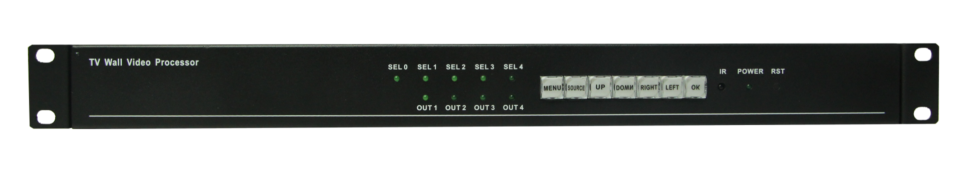
5.2 Front panel
SEL 0 | Input indicator | Light on, input connection successfully
SEL1 | HDMI output 1 indicator | Light on, HDMI 1 have been selected
SEL 2 | HDMI output 2 indicator | Light on, HDMI 2 have been selected
SEL 3 | HDM output 3 indicator | Light on, HDMI 3 have been selected
SEL 4 | HDMI output 4 indicator | Light on, HDMI 4 have been selected
OUT1 | HDMI1output indicator | Light on, HDMI 1 output is connected
OUT2 | HDMI2 output indicator | Light on, HDMI 2 output is connected
OUT3 | HDMI3 output indicator | Light on, HDMI 3 output is connected
OUT4 | HDMI4 output indicator | Light on, HDMI 4 output is connected
MENU | Menu button | Press this buttons to set up
SOURCE | Source button | To switch the input sources(USB/ VGA/ CVBS/ HDMI)
UP | Up button | Up direction button
DOWN | Down button | Down direction button
RIGHT | Right button | To choose the right items
LEFT | Left button | To choose the left items
OK | On button | To display the input info
IR | IR receiver | IR receiver to work with the remote control
RST | Reset | Press for 1 second to back to factory mode

- Remote control
6.1 Button functions
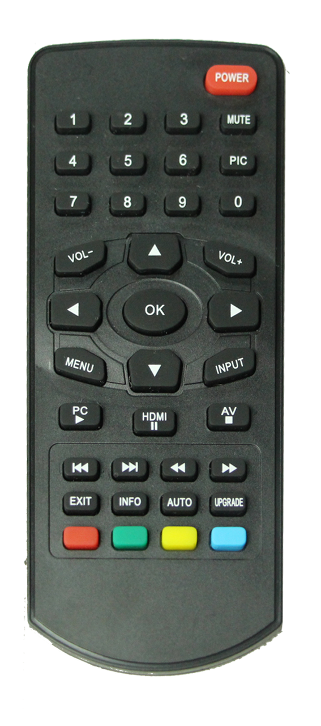
Item | Function
1 | Press 1 to set up the output 1
2 | Press 2 to set up the output 2
3 | Press 3 to set up the output 3
4 | Press 4 to set up the output 4
0 | Press 0 to set up the input
Vol- | Turn down the Audio
Vol+ | Turn up the Audio
INPUT | Exchange the inputs sources
RED BUTTON | USB input
GREEN BUTTON | CVBS input
YELLOW BUTTON | HDMI input
BLUE BUTTON | VGA input

6.2 Splicing introduction

Eg: Set up output 1:

First: Press number 1, the indicator of ront panel “SEL 1” will light up

Second：Press “MENU” button, shows as following：
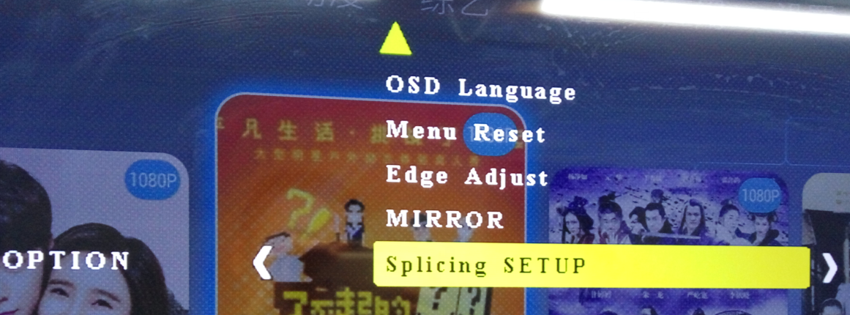

Third：Select splicing setup, enter will show:

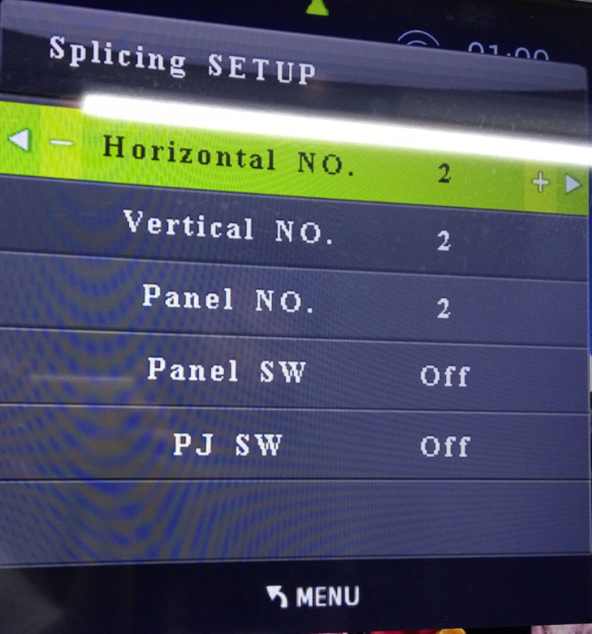

Last step: According to how many TVs to set up the Horizontal and Vertical No. If there are 4 TVs as
2x2 installation. Then users only need to set up Horizontal No. as 2 and Vertical No. As 2
Panel No.: According to real TVs’ number and set up
Panel SW: On: To show Panel No. on the screen. Off: To turn off the Panel No.
PJ SW: Off : To back to 4 TVs showing 4 same pictures;
On: To splice the image across 4 TVs
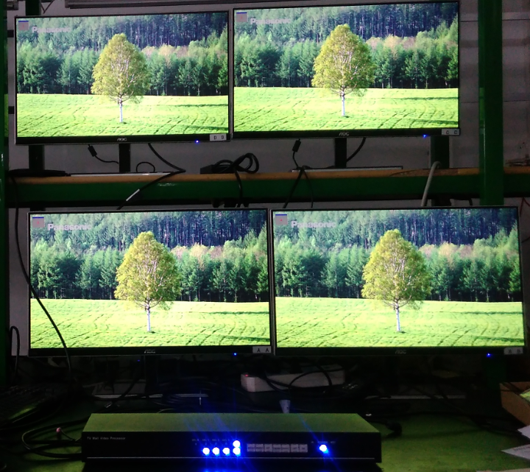
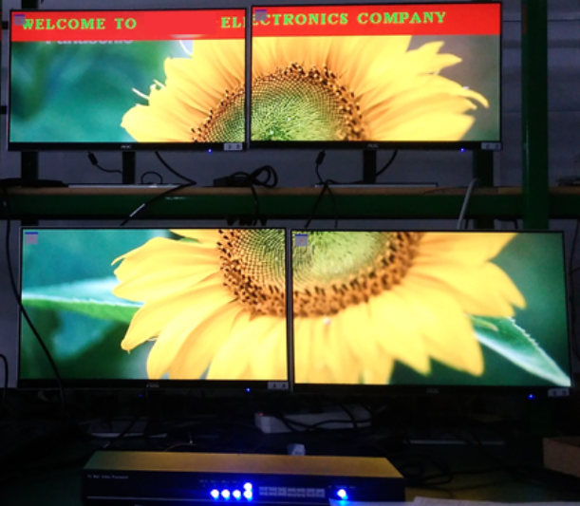
Splitter Mode Splice one picture on 4 TVs
Note: Users need to set up every outputs with the same way to set up output 1. Before setting channel 2,
need to press “1” again to turn off “SEL1”. And press “2” to turn on “SEL2”

7. DIP Switch
This provides users a very convenient and faster way to put 1image across 4 TVs or back to splitter mode
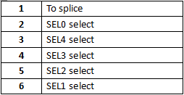
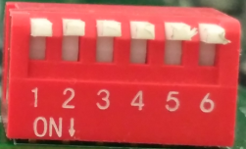

8. Subtitle function
Save sub-title words name as “ARICH.TXT” in a USB driver, the plug the USB drive to the USB port, turn on the Video Processor. Press number “0” on the remote control. Then follow below steps: MENU--ROLL TET-- OK, users also can adjust the word size, color, background and the rolling speed.
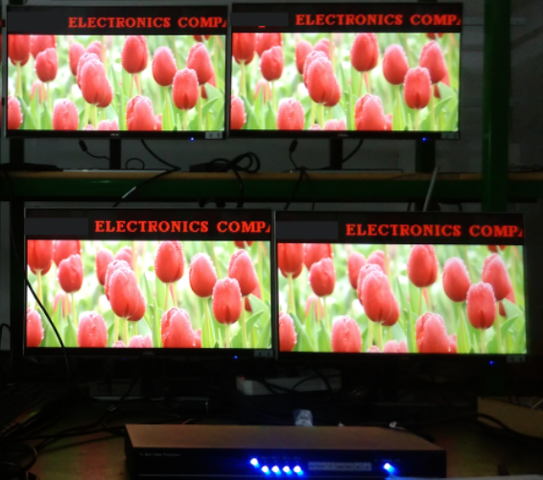
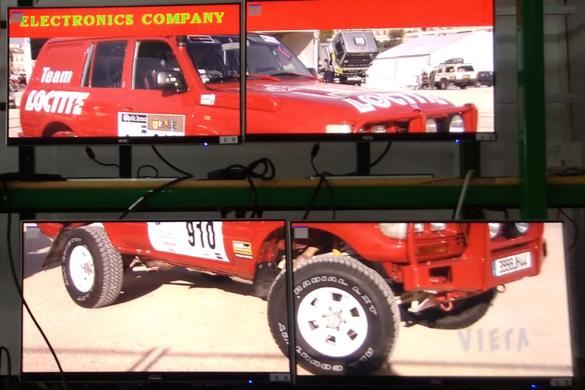
9. Supports different installations
1x4(Horizontal 1 and vertical 4):
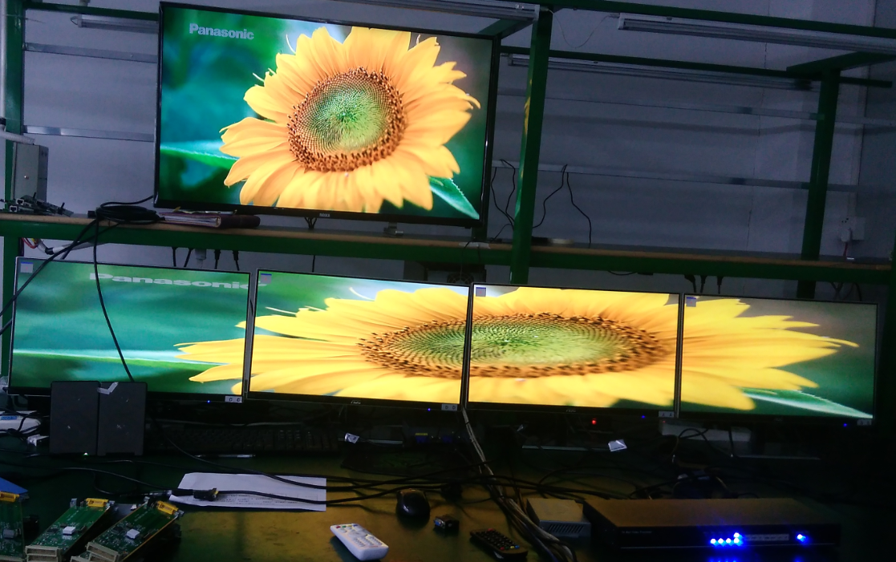

Put the TVs in vertical:
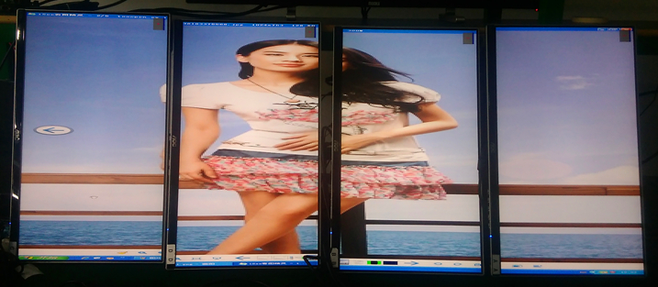

4x1(Horizontal 4 and vertical 1):
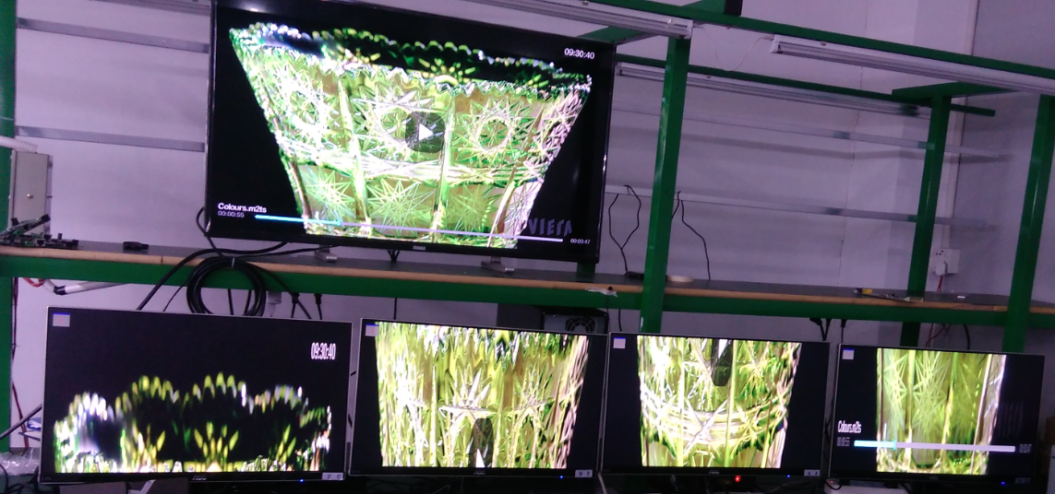
2x2(Horizontal 2 and vertical 2):
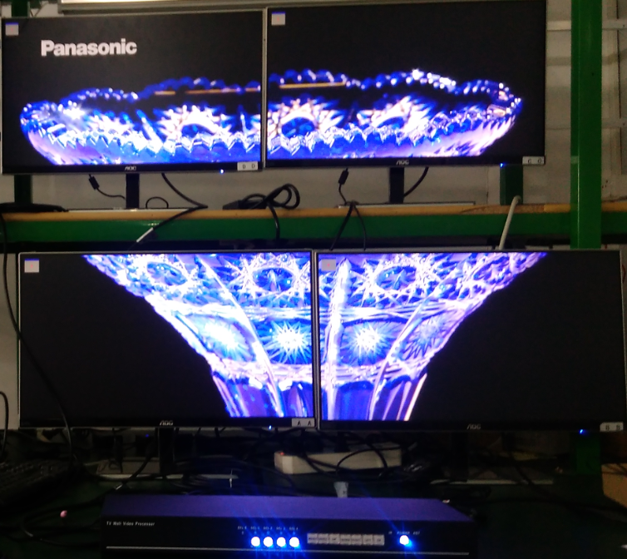
10. After-Sales
8.1 Warranty Information
The Company warrants that the process and materials of the product are not defective under normal use and service for 3 (3) years following the date of purchase from the Company or its authorized distributors.
If the product does not work within the guaranteed warranty period, the company will choose and pay for the repair of the defective product or component, the delivery of the equivalent product or component to the user for replacement of the defective item, or refund the payment which users have made.
The replaced product will become the property of the Company.
The replacement product could be new or repaired.
Whichever is longer, any replacement or repaired of the product or component is for a period of ninety (90) days or the remaining period of the initial warranty. The Company shall not be responsible for any software, firmware, information, or memory data contained in, stored in, or integrated with the product repaired by the customer's return, whether or not during the warranty period.
8.2 Warranty limitations and exceptions
Except above limited warranty, if the product is damaged by over usage, incorrectly use, ignore, accident, unusual physical pressure or voltage, unauthorized modification, alteration or services rendered by someone other than the Company or its authorized agent, the company will not have to bear additional obligations. Except using the product properly in the proper application or normal usage

11. Version Information
Description of version（Document number：DOC-*TV WALL-104）
Date | Version number | Description
Dec 2016 | V1.01.01 | First version

