User Manual

36x36 card cage matrix

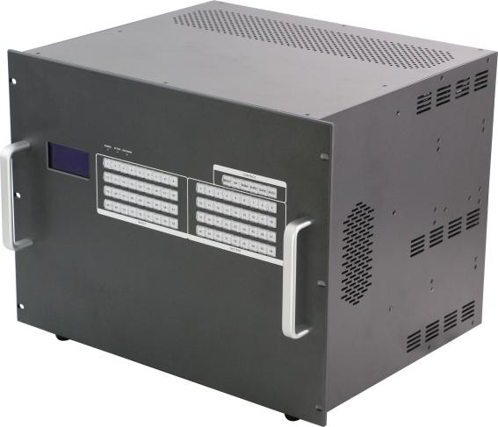

Version:V2016.001

Content
1. Introduction 3
2. Features 3
3. Specification 4
4. Packing 4
5. Front buttons control 5
6. Web control 8
7. RS 232 control command 12
8. Common Porblem shooting 12
9. After Sales 12
10. Version Information 13

1. Introduction
The 36x36 card cage matrix is an integrated video and audio modular matrix switcher. The superior modular matrix manages any type of signals. This switch supports long haul transmission, maintain power reliability in the event of failure and offer the best flexible solutions for AV system deployment. It supports high-resolution HDMI sources routed to HDMI displays, monitors, projectors, or audio receivers and so on. The EDID can be selected between seven different modes or copied from the attached displays. You can control the switch via front buttons, web control, or RS-232.
2. Features
. Using dual control system
. Supports Web/ RE232/ Front Buttons control
. Standard chassis design
. Supports 36 inputs and 36 outputs
. Supports seamless switching, no black/ blue/ split screen while switching
. Supports resolution exchange, several resolutions can be chosen and used
. Input supports 3GSDI, DVI, HDMI, Analog Signal, Fiber Signal, HDBT Signal
. Output supports 3GSDI, DVI, HDMI, Analog Signal, Fiber Signal, HDBT Signal
. Supports fiber signal input and output, the distance can up to 10km with single model fiber
. Supports HDBT signal input and output, the distance can up to 70/100m with Cat5e/ 6 cable
. Flexible card type design, supports 18 input cards(1-port 1 card) and 18 output cards(1-port 1 card)

3. Specifications
Model | 9x9 card cage matrix |  | 18x18 card cage matrix | 36x36 card cage matrix
Modular Design | 9 slots for each ins and outs, 1 port 1 card |  | 18 slots for each ins and outs, 1 port 1 card | 36 slots for each ins and outs, 1 port 1 card
Input card | 1 card 1 port, Support HDMI/ DVI/ 3GSDI/ VGA/ YPBPR/ CVBS/ HDBaseT/ Fiber
Output card | 1 card 1 port, Support HDMI/ DVI/ 3GSDI/ VGA/ YPBPR/ CVBS/ HDBaseT/ Fiber
Protocol | Support HDMI1.4a and DVI1.0, HDCP compatible and EDID function
Color Space | Support RGB444, YUV444, YUV422 and x.v.Color extension
Resolution | 640×480---1920×1200@60Hz(VESA)  480i---1080p60Hz(HDTV)
Bandwidth | 12.5Gbps
Transmission Distance | 70m(Cat5e/6); 500m(MM Fiber); 2Km(SM Fiber); 25m(DVI/HDMI Cable); 30m(VGA Cable)
Control | Dual RS232, dual LAN(WEB GUI), front buttons
Dimension | 482*390*88 | 482*390*178 |  |  | 482*390*355
Weight | 6KG(No cards) | 12.5KG(No cards) |  |  | 25KG(No cards)
Consumption | 17W(No cards) | 21W(No cards) |  |  | 30W(No cards)
Power Supply | AC 110V-240V 50/60HZ
Working Humidity | 10%-90%
Working Temperature | -10℃ - 50℃
Storage Temperature | -25℃ - 55℃

Inputs and outputs cards:
Input Card | HDMI | 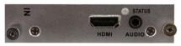 | Resolution up to 1080P60  Supports HDCP  3.5mm audio embedded
 | DVI  (Universal) | 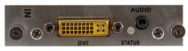 | Supports 1 HDMI/ DVI/ VGA/ YPBPR/ CVBS+LR Signal input  Resolution under 1920*1200  Supports HDCP  3.5mm audio can embedded
 | HDBaseT | 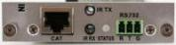 | The distance can up to 70/100m  Supports POC function, RS232 and bi-direction IR transmit  Can work with C70/100 extenders
 | Fiber |  | The distance can up to 10km with 1 core single model LC fiber  Can work with 110D/ M transmitters to realize the long distance transmission
 | SDI | 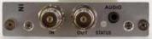 | Supports 1 input and 1 output  Automatically adapt the SD, HD, 3G SDI signal  Audio embedded
Output  Card | HDMI | 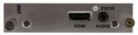 | Supports 1 HDMI+LR Signal input  Resolution up to 1080P60  Supports HDCP  Audio de-embedded
 | DVI  (Universal) | 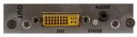 | Supports 1 HDMI/ DVI/ VGA/ YPBPR/ CVBS+LR Signal input  Resolution under 1920*1200  Supports HDCP  3.5mm audio can embedded
 | HDBaseT | 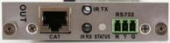 | The distance can up to 70/100m  Supports POC function, RS232 and bi-direction IR transmit  Can work with C70/100 extenders
 | Fiber | 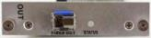 | The distance can up to 10km with 1 core single model LC fiber  Can work with 110D/ M transmitters to realize the long distance transmission
 | SDI | 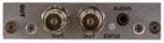 | Supports 1 3GSDI input and 1 3GSDI output  Automatically adapt the SD, HD, 3G SDI signal  Audio de-embedded

Packing
36 x36 Chassis | 1 | Unit
Power Cord | 1 | Pcs

5. Front buttons
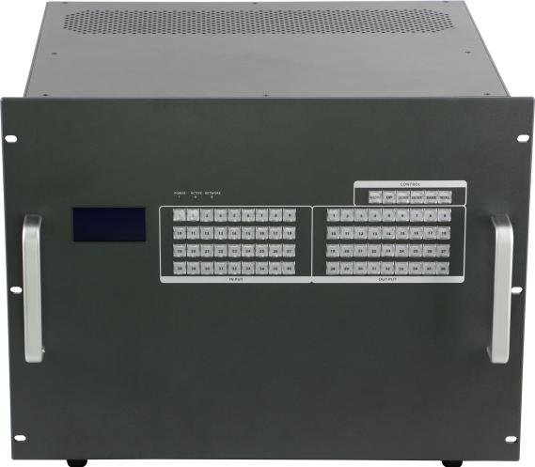
POWER: Power indicator
ACTIVE: Working indicator
ALARM: Problem indicator
INPUT: 36 buttons for inputs
OUTPUT: 36 buttons for outputs

MENU button: Press to switch between all the contents of SWITCH,SCENE,SETUP and VIEW.

UP button: Press to set up the IP address

DOWN button: Press to set up the IP address

SAVE button: Press to save all the changes, Eg, ID change, Scenes saving
ENTER button: Press to enter the number when changing IP address
RECALL button: Press to recall the saved scenes or IP

Operation Steps:

2-button Faster Switching:

Users only need to press the numbers from the keys area to choose input and output

Eg. Input 1 to output 1,2,3. Only need to press input area “1”, then press output area “1” “2” “3”

Front button will show as below:
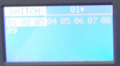
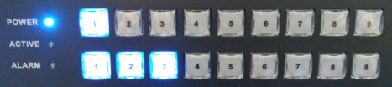

Scene save:

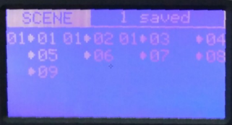
Save current switching status to scene 1: Press MENU switch to SCENE, press number “1” from input area, then only need to press SAVE, display show as below:

Scene recall:

Press MENU switch to SCENE, press number “1” from input area, then only need to press RECALL, display show as below:
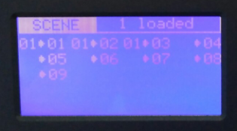

Setup:

IP address set up, Press UP and DOWN to choose the number from input area to change, press ENTER to input, then Press SAVE to save the IP.
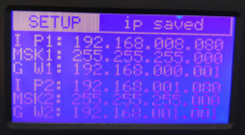
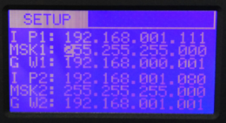

View:

Review the current switching status:1>1,1>2,1>3
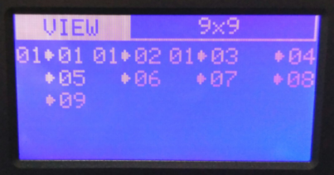

6. WEB control
All the Mini series matrix can support WEB interface control, the default IP is 192.168.0.80 and 192.168.1.80. Enter 192.168.0.80 to a browser, showing below interface:
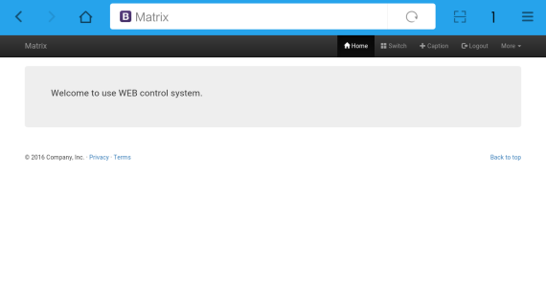

Note: Before using all the function will need to Login first.
After clicking Login showing below interface, both of the user name and password are: admin
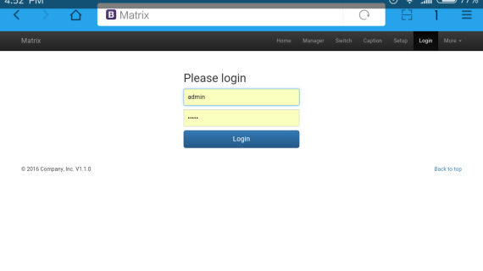
After logging in successfully, on the top will show: Home, Manager, Switch, Caption, Setup, Logout and More icons. Click Manager will show below interface:

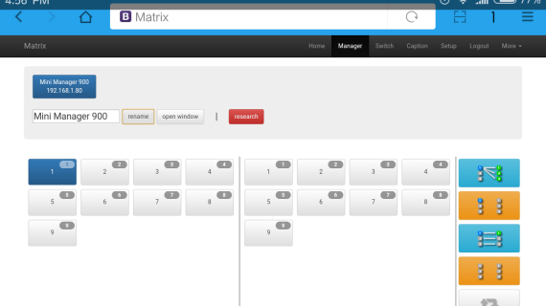
Note: In this icon, users can check all the matrices in the same local area network. Users also can rename and open a window of the selected matrix.

Switch icon:
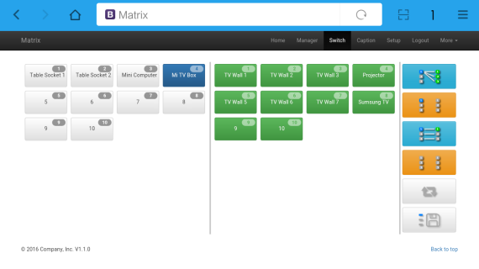
Note: Users can switch here.

Caption icon:
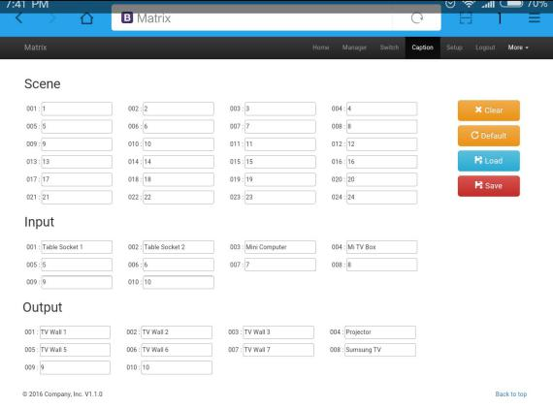
Note: Users can change the scene, input and output names here.

Setup icon:
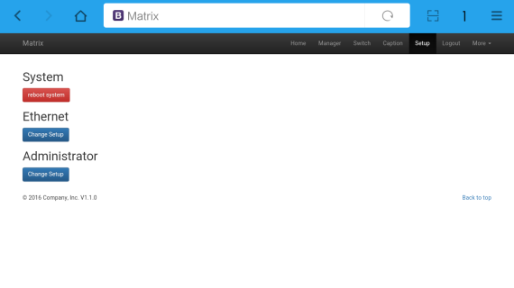
Note: Users can change IP address, user name and password here.

More icon:
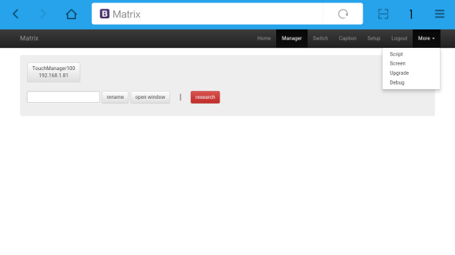
Note: Users can upgrade system from here.

7. RS232 control command
Baud rate: 115200
data bit: 8
Stop bit: 1
Check bit: None

Type | Control command | Function description
Command | [x1]All. | Switch [x1] input to all the outputs
 | All[1]. | Switch all the channels to be one to one. Eg.1->1，2->2，3->3……
 | [x1]X[x2]. | Switch [x1] input to [x2] output
 | [x1]X[x2]&[x3]&[x4]. | Switch [x1] input to [x2], [x3], [x4]
 | Save[Y]. | Save current status to [Y], [Y] can be number 1-9
 | Recall[Y]. | Recall the saved [Y] scene
 | BeepON. | Buzzer on
 | BeepOFF. | Buzzer off

Note:
1. [x1], [x2], [x3], [x4] are the inputs and outputs, normally depend on the matrix, if the matrix is a 10x10 matrix, then the effective range are from 1 to 10. Can’t send this kinds of words ‘[‘And’]’
2. Every command need to add the words ‘-’
3. The letters can be capital and small letter

8. Common problem shooting

No signal on the display?
◆ Make sure all the power code well connected
◆ Check the display switcher and make sure it’s in good condition
◆ Make sure the the DVI cable between the device and display are short than 7 meters
◆ Reconnect the DVI cable and restart the system
◆ Make sure the signal sources are on
◆ Check the cables between the devices and displays are connected correctly.
◆ Dial the switcher 7 to 1, then dial the switcher1,2 and choose the corresponding inputs.
◆ Make sure the resolution less than WUXGA(1920*1200)/ 60HZ
◆ Make sure the display can support the output resolution.

9. After-Sales
8.1 Warranty Information
The Company warrants that the process and materials of the product are not defective under normal use and service for 3 (3) years following the date of purchase from the Company or its authorized distributors.
If the product does not work within the guaranteed warranty period, the company will choose and pay for the repair of the defective product or component, the delivery of the equivalent product or component to the user for replacement of the defective item, or refund the payment which users have made.
The replaced product will become the property of the Company.
The replacement product could be new or repaired.
Whichever is longer, any replacement or repaired of the product or component is for a period of ninety (90) days or the remaining period of the initial warranty. The Company shall not be responsible for any software, firmware, information, or memory data contained in, stored in, or integrated with the product repaired by the customer's return, whether or not during the warranty period.
8.2 Warranty limitations and exceptions
Except above limited warranty, if the product is damaged by over usage, incorrectly use, ignore, accident, unusual physical pressure or voltage, unauthorized modification, alteration or services rendered by someone other than the Company or its authorized agent, the company will not have to bear additional obligations. Except using the product properly in the proper application or normal usage

10. Version Information
Description of version（Document number：DOC-Mini3600）
Date | Version number | Description
Dec 2017 | V1.01.01 | First version

