User Manual

HDTV Supply WolfPack Mini Manager1800
Supports 18-4K HDMI/ HDBaseT inputs and 18-4K HDMI/ HDBaseT Outputs
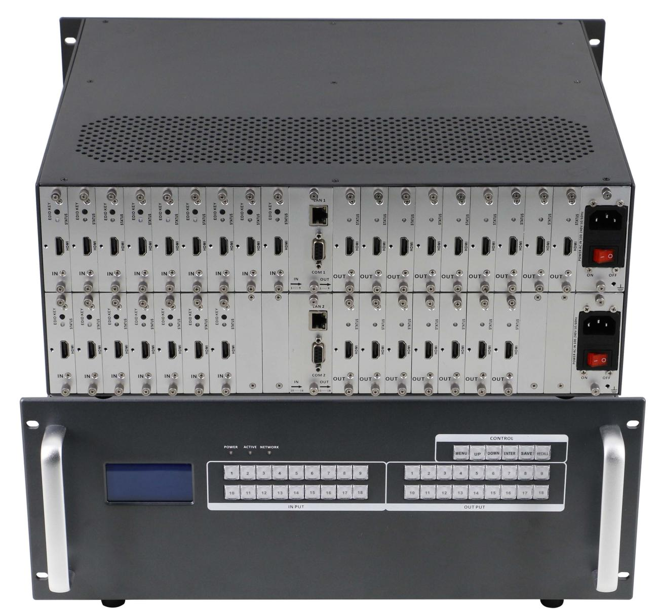

Version: V2017.001

Content
1. Introduction 3
2. Features 3
3. Specification 4
4. Packing 4
5. Front buttons control 5
6. Web control 8
7. APP control 8
8. RS 232 control command 12
9. Common Problem shooting 12
10. After Sales 12
11. Version Information 12

1. Introduction
HDTV Supplys WolfPack Mini Manager1800 is an integrated video and audio modular matrix switcher. The superior modular matrix manages any type of signals and for 4K it can support HDMI/ HDBaseT inputs and outputs. This switch supports long haul transmissions, maintains power reliability in the event of failure and offer the best flexible solutions for AV system deployment. It supports 4K HDMI/HDBaseT sources routed to the displays, monitors, projectors, or audio receivers and so on. Users can control the matrix via front buttons, web control, RS-232 and/or an IOS/ Android APP.
2. Features
. Using dual control system
. Dual power system
. Supports Web/ RE232/ Front Buttons/ APP control
. Standard chassis design
. Supports 18 inputs and 18 outputs
. Supports 1080P seamless switching, 4K fast switching
. Supports HDBT signal input and output, the distance can up to 70/100m with Cat5e/ 6 cable

3. Specifications
Model | MINI MANAGER-900 | MINI MANAGER-1800
Description | 9x9 card cage matrix | 18x18 card cage matrix
Modular Design | 9 slots for each ins and outs, 1 port 1 card | 18slots for each ins and outs, 1 port 1 card
Input card | 1 card 1 port, Support HDMI/ HDBaseT
Output card | 1 card 1 port, Support HDMI/ HDBaseT
Protocol | Support HDMI1.4a, HDCP compatible
Resolution | 4K30
Transmission Distance | HDMI: 10m  HDBaseT: 70m(Cat5e/6)
Control | Dual RS232, dual LAN(WEB GUI), front buttons, APP
Dimension | 482*390*88 | 482*390*178
Weight | 6KG(No cards) | 12.5KG(No cards)
Consumption | 17W(No cards) | 21W(No cards)
Power Supply | AC 110V-240V 50/60HZ
Working Humidity | 10%-90%
Working Temperature | -10℃ - 50℃
Storage Temperature | -25℃ - 55℃

Inputs and outputs cards:
Input Card | HDMI | 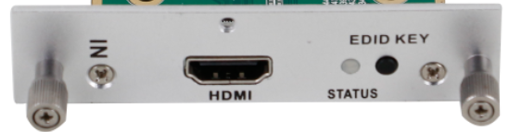 | Resolution up to 4K30  Supports HDCP1.2  EDID Key button
 | HDBaseT | 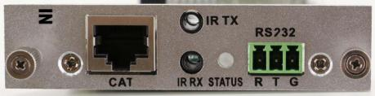 | The distance can up to 70/100m  Supports POC function, RS232 and bi-direction IR transmit  Can work with C70/100 extenders
Output Card | HDMI | 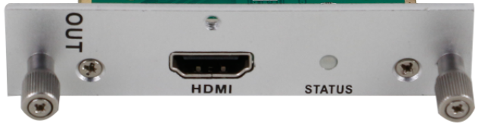 | Resolution up to 4K30  Supports HDCP1.2  EDID Key button
 | HDBaseT | 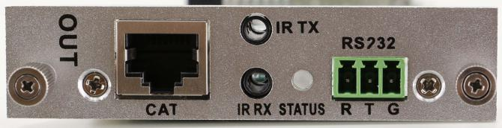 | The distance can up to 70/100m  Supports POC function, RS232 and bi-direction IR transmit  Can work with C70/100 extenders

MiniManager1800 chassis | 1 | Unit
Power Cord | 2 | Pcs

Packing

5. Front buttons
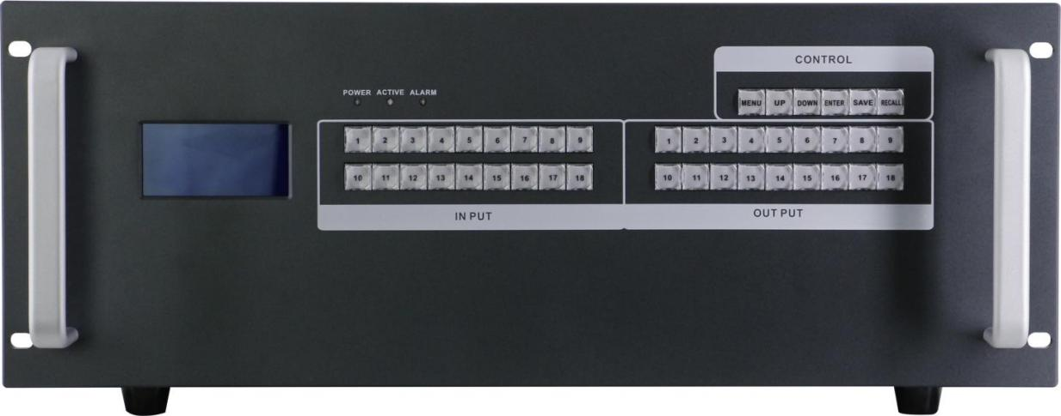
POWER: Power indicator
ACTIVE: Working indicator
ALARM: Problem indicator
INPUT: 18 buttons for inputs
OUTPUT: 18 buttons for outputs

MENU button: Press to switch between all the contents of SWITCH, SCENE, SETUP and VIEW.

UP button: Press to set up the IP address

DOWN button: Press to set up the IP address

SAVE button: Press to save all the changes, ie, ID change, Scenes saving
ENTER button: Press to enter the number when changing IP address
RECALL button: Press to recall the saved scenes or IP

Operation Steps:

2-button Faster Switching:

Users only need to press the numbers from the keys area to choose input and output

ie. Input 1 to output 1,2,3. Only need to press input area “1”, then press output area “1” “2” “3”

Front button will show as below:
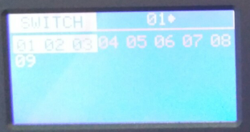
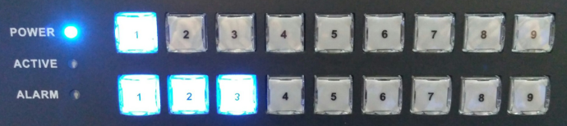

Scene save:

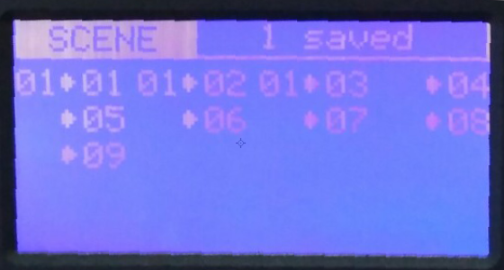
Save current switching status to scene 1: Press MENU switch to SCENE, press number “1” from input area, then only need to press SAVE, display show as below:

Scene recall:

Press MENU switch to SCENE, press number “1” from input area, then only need to press RECALL, display show as below:

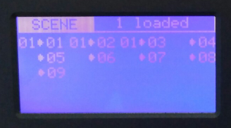

Setup:

IP address set up, Press UP and DOWN to choose the number from input area to change, press ENTER to input, then Press SAVE to save the IP.
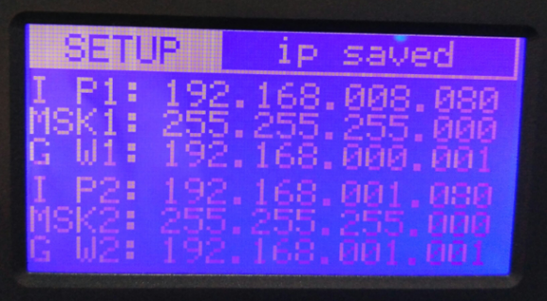
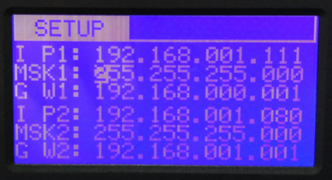

View:

Review the current switching status:1>1,1>2,1>3
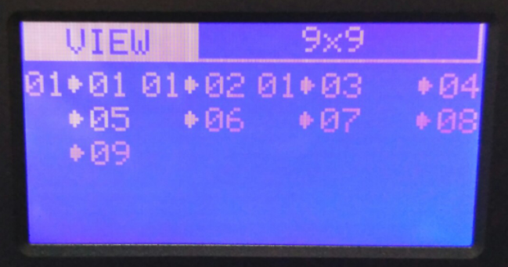

6. WEB control
All our Mini-series matrix systems can support a WEB interface control, the default IP is 192.168.0.80 and 192.168.1.80. Enter 192.168.0.80 to a browser, showing below interface:
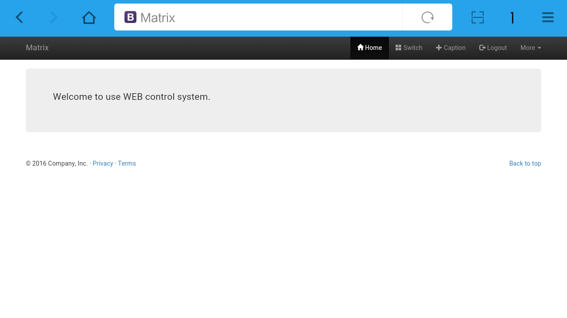

Note: Before using all the function will need to Login first.
After clicking Login showing below interface, both of the user name and password are: admin
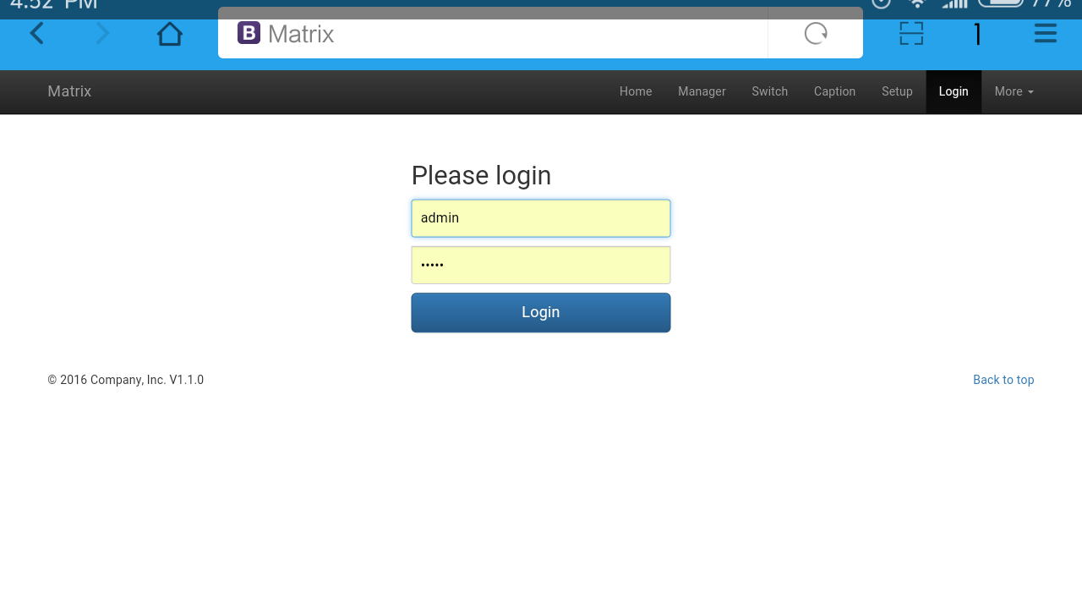
After logging in successfully, on the top will show: Home, Manager, Switch, Caption, Setup, Logout and More icons. Click Manager will show below interface:

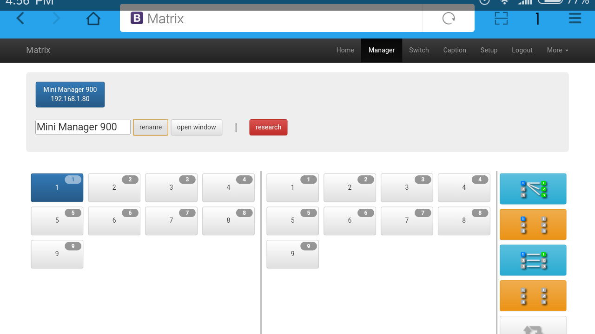
Note: In this icon, users can check all the matrices in the same local area network. Users also can rename and open a window of the selected matrix.

Switch icon:
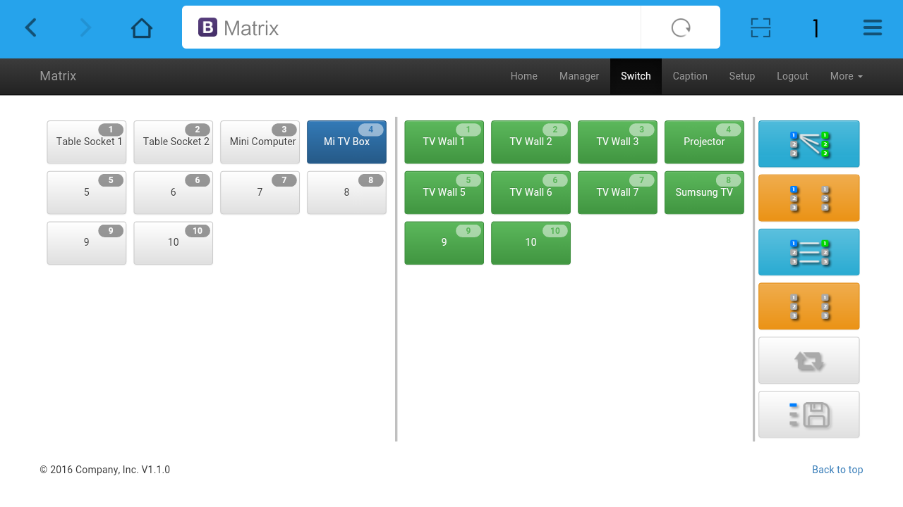
Note: Users can switch here.

Caption icon:
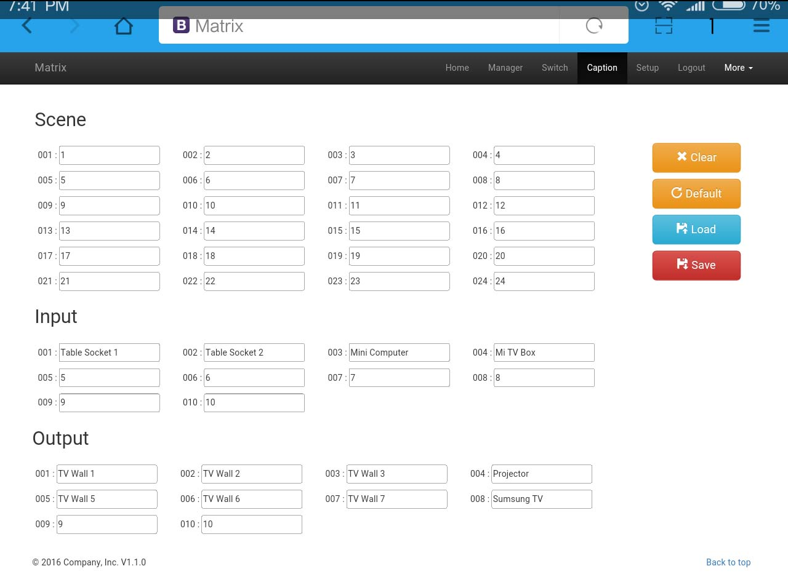
Note: Users can change the scene, input and output names here.

Setup icon:
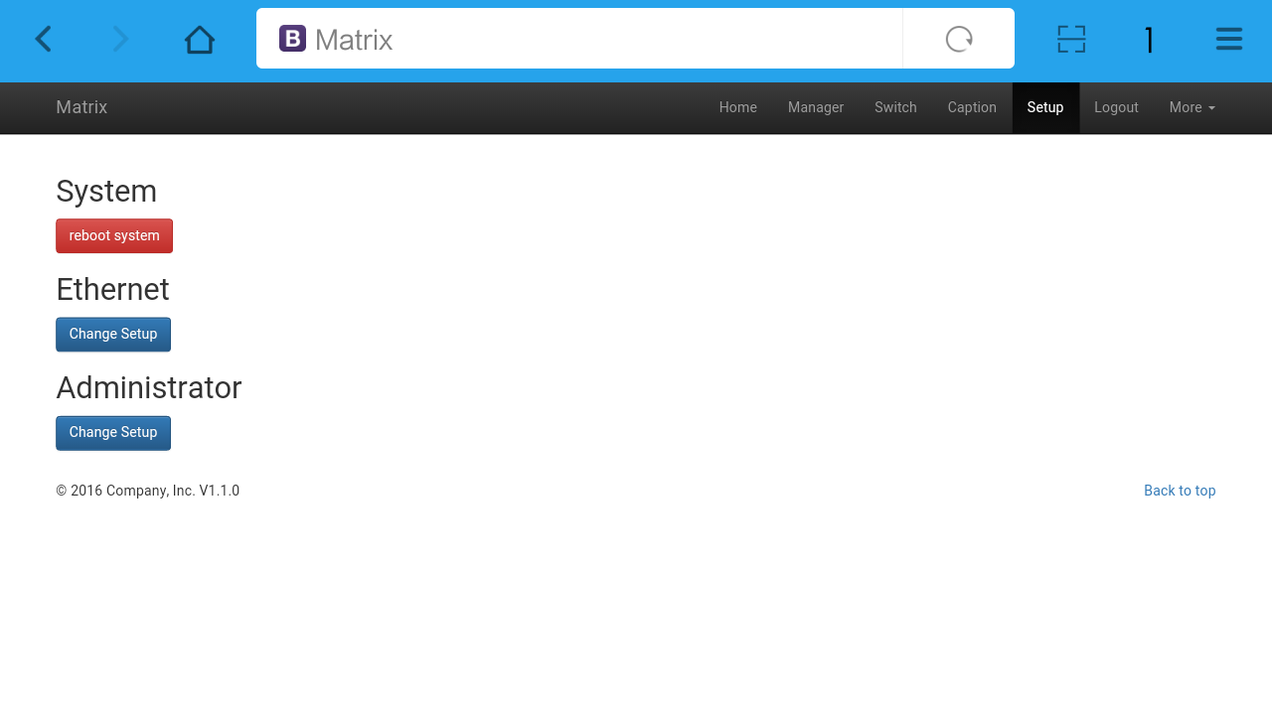
Note: Users can change IP address, user name and password here.

More icon:
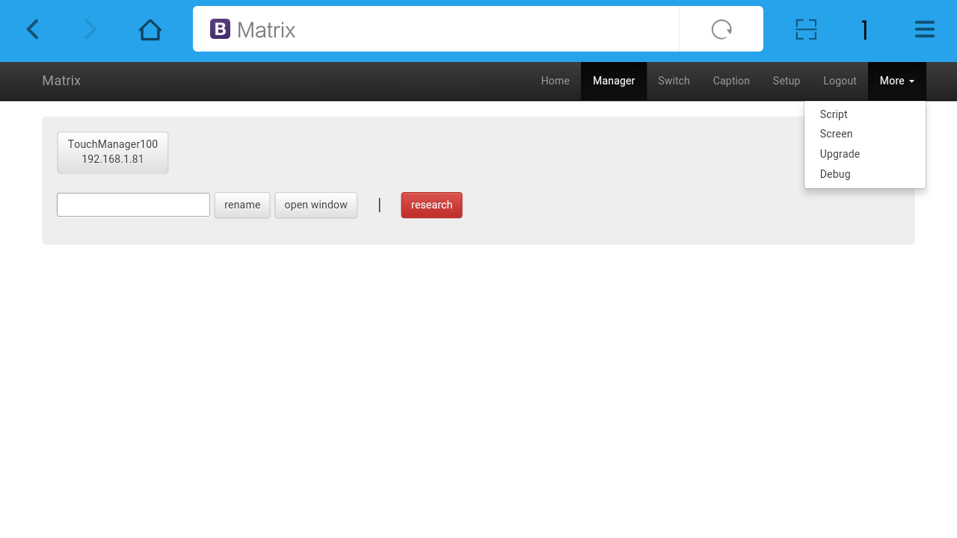
Note: Users can upgrade system from here.

- APP Control
All the MiniManager series matrix will support IOS and Android App control, users only need to connect the matrix with the router or local network. Then download the APP from the application store. The steps and interfaces show as below:
Step 1: Make sure the matrix well connected with the router or local network, and open the APP:
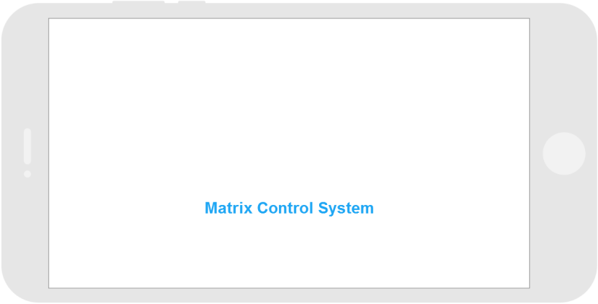
Step 2: Enter the IP address of the matrix:
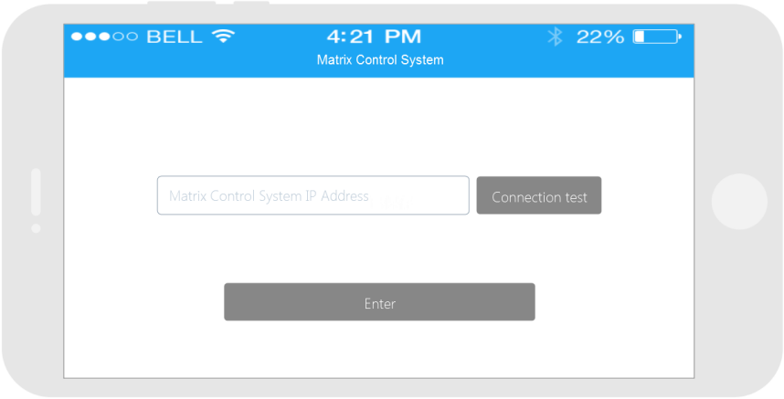

Step 3: After log in successfully, users can switch, change the inputs and outputs name directly.
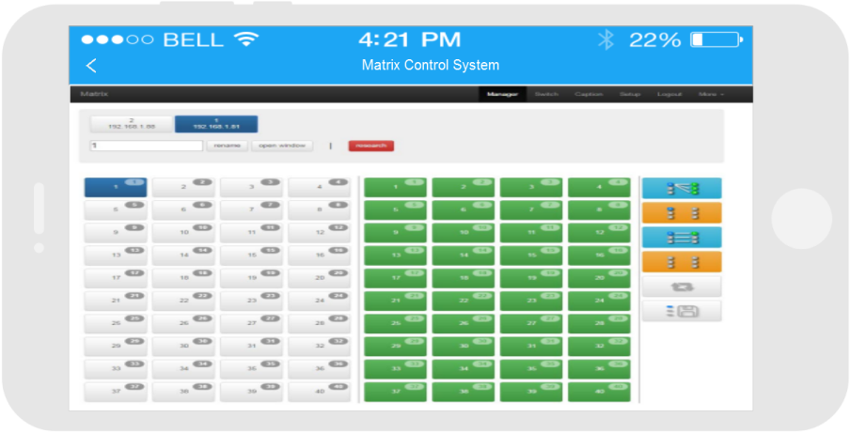
8. RS232 control command
Baud rate: 115200
data bit: 8
Stop bit: 1
Check bit: None
Type | Control command | Function description
Command | [x1]All. | Switch [x1] input to all the outputs
 | All[1]. | Switch all the channels to be one to one. Eg.1->1，2->2，3->3……
 | [x1]X[x2]. | Switch [x1] input to [x2] output
 | [x1]X[x2]&[x3]&[x4]. | Switch [x1] input to [x2], [x3], [x4]
 | Save[Y]. | Save current status to [Y], [Y] can be number 1-9
 | Recall[Y]. | Recall the saved [Y] scene
 | BeepON. | Buzzer on
 | BeepOFF. | Buzzer off

Note:
1. [x1], [x2], [x3], [x4] are the inputs and outputs, normally depend on the matrix, if the matrix is a 10x10 matrix, then the effective range are from 1 to 10. Can’t send this: ‘[‘And’]’
2. Every command need to add the words ‘-’
3. The letters can be capital and small letter

9. Common problem shooting

No signal on the display?
◆ Make sure all the power code well connected
◆ Check the display switcher and make sure it’s in good condition
◆ Make sure the HDMI cable between the device and display are short than 7 meters
◆ Reconnect the HDMI cable and restart the system
◆ Make sure the signal sources are on
◆ Check the cables between the devices and displays are connected correctly.
◆ Dial the switcher 7 to 1, then dial the switcher1,2 and choose the corresponding inputs.
◆ Make sure the resolution less than WUXGA (1920*1200)/ 60HZ
◆ Make sure the display can support the output resolution.

10. After-Sales
10.1 Warranty Information
The Company warrants that the process and materials of the product are not defective under normal use and service for 1 (1) year following the date of purchase from the Company or its authorized distributors.
If the product does not work within the guaranteed warranty period, the company will choose and pay for the repair of the defective product or component, the delivery of the equivalent product or component to the user for replacement of the defective item, or refund the payment which users have made.
The replaced product will become the property of the Company.
The replacement product could be new or repaired.
Whichever is longer, any replacement or repaired of the product or component is for a period of ninety (90) days or the remaining period of the initial warranty. The Company shall not be responsible for any software, firmware, information, or memory data contained in, stored in, or integrated with the product repaired by the customer's return, whether or not during the warranty period.
10.2 Warranty limitations and exceptions
Except above limited warranty, if the product is damaged by over usage, incorrectly use, ignore, accident, unusual physical pressure or voltage, unauthorized modification, alteration or services rendered by someone other than the Company or its authorized agent, the company will not have to bear additional obligations. Except using the product properly in the proper application or normal usage

11. Version Information
Description of version（Document number：DOC-Mini1800）
Date | Version number | Description
Dec 2016 | V1.01.01 | First version

