Mini Manager 900 User Manual

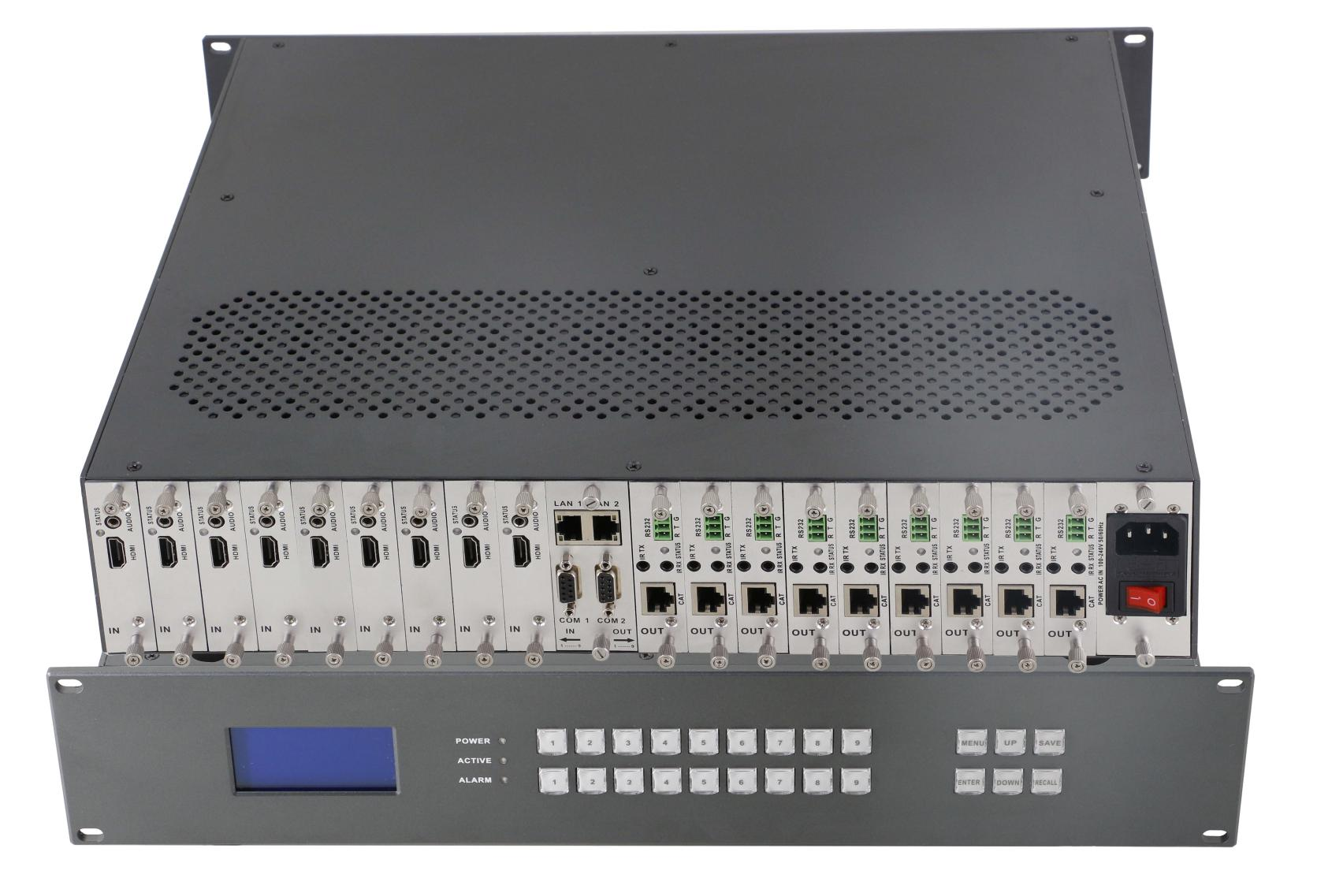

Mini Modular Matrix Series

Content

Part 1. Introduction 3
Part 2. Features 5
Part 3. Specification 6
Part 4. Packing list 8
Part 5. Front buttons control 9
Part 6. Web control 11
Part 7. RS 232 control command 15
Part 8. Common issues 15
Part 9. Attachment 16
Part 10. Maintenance 16

Part 1. Introduction:

The Mini Manager series are an integrated video and audio modular matrix switcher. The superior modular matrix manages any type of signals. This switch supports long haul transmission, maintain power reliability in the event of failure and offer the best flexible solutions for AV system deployment. It supports high-resolution HDMI sources routed to HDMI displays, monitors, projectors, or audio receivers and so on. The EDID can be selected between seven different modes or copied from the attached displays. You can control the switch via front buttons, web control, or RS-232.

Mini Manager 900 Chassis:
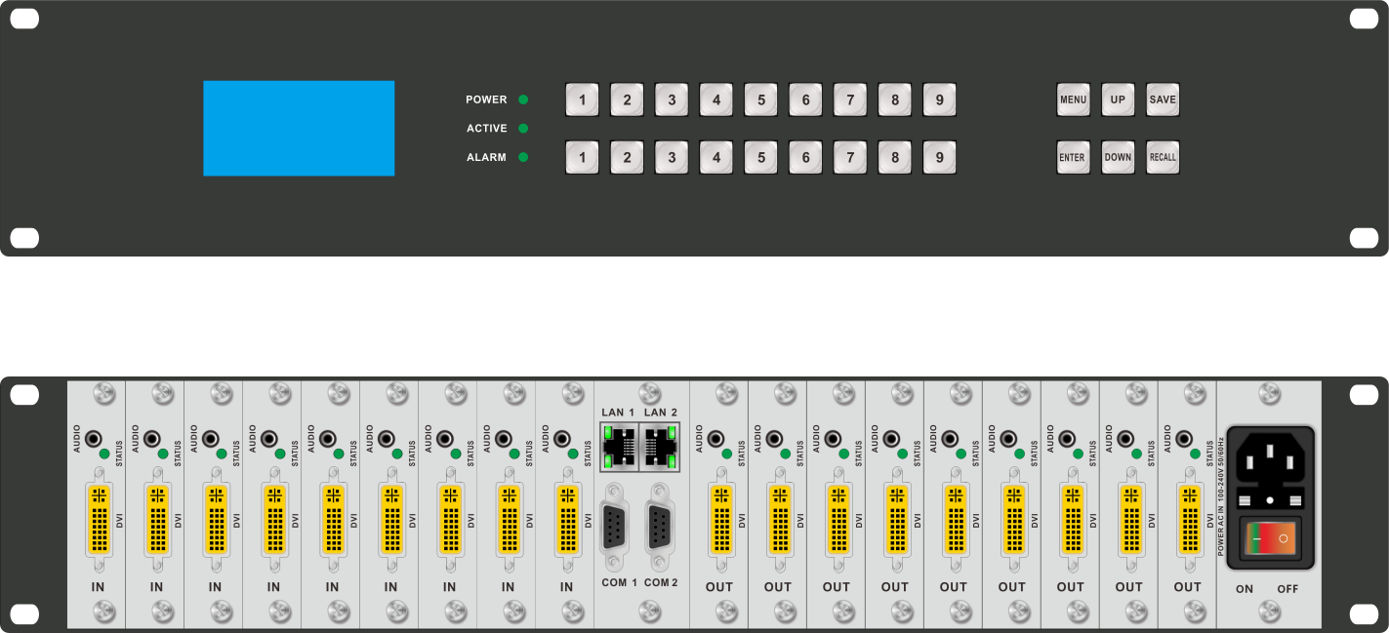

Supports 9 inputs and 9 outputs Mix Modular Matrix
Input supports 3GSDI, DVI, HDMI, Analog Signal, Fiber Signal, HDBT Signal
Output supports 3GSDI, DVI, HDMI, Analog Signal, Fiber Signal, HDBT Signal
Flexible card type design, supports 9 input cards(1-port1 signal input) and 9 output cards(1-port 1 signal input)
Supports seamless switching, no black/ blue/ split screen while switching
Supports resolution exchange, several resolutions can be chosen and used
Supports fiber signal input and output, the distance can up to 10km with single model fiber
Supports HDBT signal input and output, the distance can up to 70/100m with the Cat5e/6 cable
2U standard chassis design
Using dual control system

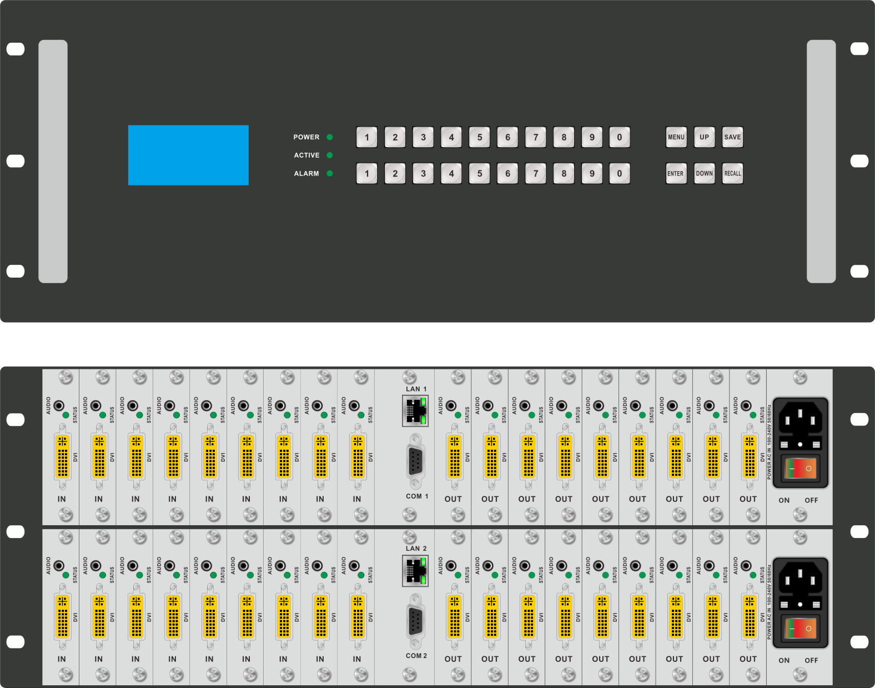
Mini Manager 1800 Chassis:

Supports 18 inputs and 18 outputs Mix Modular Matrix
Input supports 3GSDI, DVI, HDMI, Analog Signal, Fiber Signal, HDBT Signal
Output supports 3GSDI, DVI, HDMI, Analog Signal, Fiber Signal, HDBT Signal
Flexible card type design, supports 18 input cards(1-port 1 signal input) and 18 output cards(1-port 1 signal input)
Supports seamless switching, no black/ blue/ split screen while switching
Supports resolution exchange, several resolutions can be chosen and used
Supports fiber signal input and output, the distance can up to 10km with single model fiber
Supports HDBT signal input and output, the distance can up to 70/100m with the Cat5e/6 cable
4U standard chassis design
Using dual power and control system
Supports Web/ RE232/ Front Buttons control

Part 2. Features:
. Using dual control system
. Dual power system(Except 9x9 in only one power system)
. Supports Web/ RE232/ Front Buttons control
. Standard chassis design
. Supports 9/18 inputs and 9/18 outputs Mix Modular Matrix
. Supports seamless switching, no black/ blue/ split screen while switching
. Supports resolution exchange, several resolutions can be chosen and used
. Input supports 3GSDI, DVI, HDMI, Analog Signal, Fiber Signal, HDBT Signal
. Output supports 3GSDI, DVI, HDMI, Analog Signal, Fiber Signal, HDBT Signal
. Supports fiber signal input and output, the distance can up to 10km with single model fiber
. Supports HDBT signal input and output, the distance can up to 70/100m with Cat5e/ 6 cable
. Flexible card type design, supports 9/18 input cards(1-port 1 card) and 9/18 output cards(1-port 1 card)

Part 3. Specifications:
Model | Mini Manager 900 |  | Mini Manager 1800
Modular Configuration | 9 inputs/9 outputs |  | 18 inputs/18 outputs
Supported Signals  (Input & Outputs) | HDMI, Display Port: up to 2K@60Hz
 | DVI, VGA: up to 1920x1200
 | YPbPr: up to 1080p60Hz
 | CVBS: NTSC/PAL
 | SDI: up to 1080p60Hz
 | CAT: HDBaseT technology, 70/100m Extension (work with extenders)
Control | TCP/IP, RS232, front buttons
Power Supply | 100 – 240VAC, 50-60Hz
Power Consumption | 50W | 70W
Dimension | 440*370*88 | 440*370*176
Weight | 10kg | 25kg
Operating Temperature | -10℃ to 50℃
Storage Temperature | -25℃ to 55℃

Inputs and outputs cards:
Input Card | HDMI | 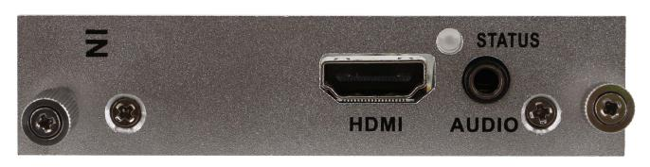 | Resolution up to 1080P60  Supports HDCP  3.5mm audio embedded
 | DVI  (Universal) | 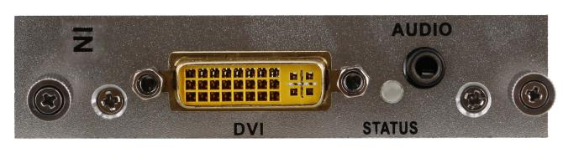 | Supports 1 HDMI/ DVI/ VGA/ YPBPR/ CVBS+LR Signal input  Resolution under 1920*1200  Supports HDCP  3.5mm audio can embedded
 | HDBaseT | 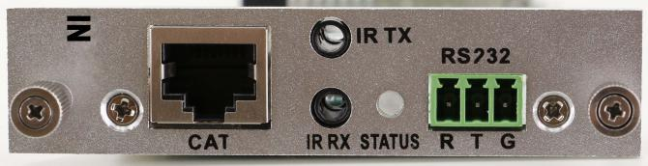 | The distance can up to 70/100m  Supports POC function, RS232 and bi-direction IR transmit  Can work with C70/100 extenders
 | Fiber | 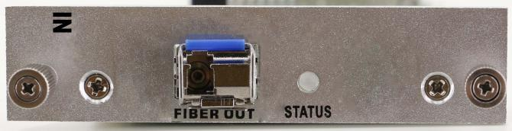 | The distance can up to 10km with 1 core single model LC fiber  Can work with 110D/ M transmitters to realize the long distance transmission
 | SDI | 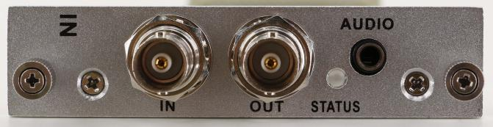 | Supports 1 input and 1 output  Automatically adapt the SD, HD, 3G SDI signal  Audio embedded
Output  Card | HDMI | 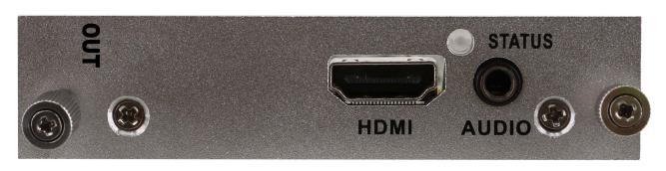 | Supports 1 HDMI+LR Signal input  Resolution up to 1080P60  Supports HDCP  Audio de-embedded
 | DVI  (Universal) | 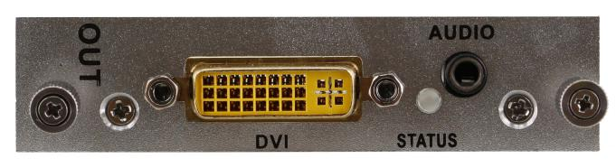 | Supports 1 HDMI/ DVI/ VGA/ YPBPR/ CVBS+LR Signal input  Resolution under 1920*1200  Supports HDCP  3.5mm audio can embedded
 | HDBaseT | 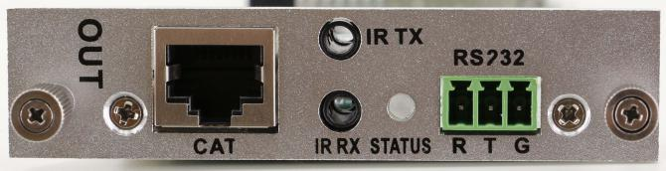 | The distance can up to 70/100m  Supports POC function, RS232 and bi-direction IR transmit  Can work with C70/100 extenders
 | Fiber | 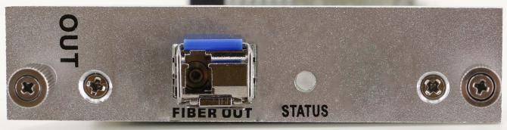 | The distance can up to 10km with 1 core single model LC fiber  Can work with 110D/ M transmitters to realize the long distance transmission
 | SDI | 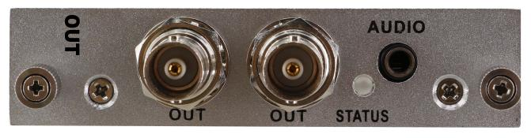 | Supports 1 3GSDI input and 1 3GSDI output  Automatically adapt the SD, HD, 3G SDI signal  Audio de-embedded

Part 4. Packing list:
9x9 chassis 1 pcs
Power cord 1 pcs

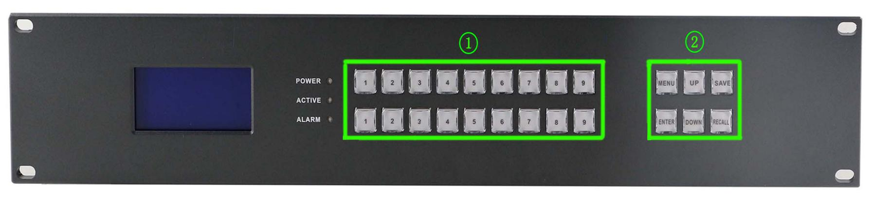
Part 5. Front buttons
: Number keys area: above are inputs, and below are outputs

: Setting up area

MENU button: Press to switch between all the contents of SWITCH,SCENE,SETUP and VIEW.

UP button: Press to set up the IP address

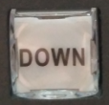

DOWN button: Press to set up the IP address

SAVE button: Press to save all the changes, Eg, ID change, Scenes saving

ENTER button: Press to enter the number when changing IP address

RECALL button: Press to recall the saved scenes or IP

Operation Steps:

Switching: Users only need to press the numbers from the keys area to choose input and outputs

Eg. Input 1 to output 1,2,3. Only need to press input area “1”, then press output area “1” “2” “3” Front button will show as below:
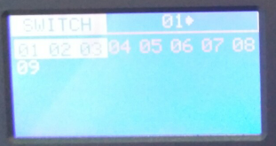
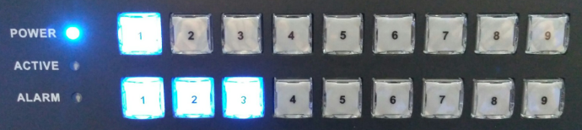

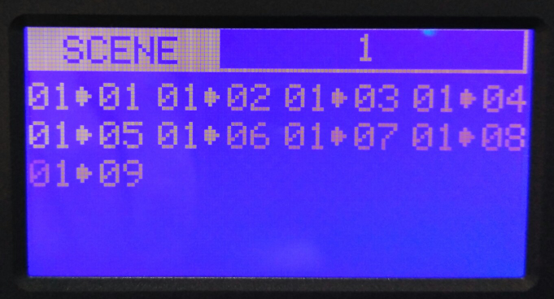
Scene:

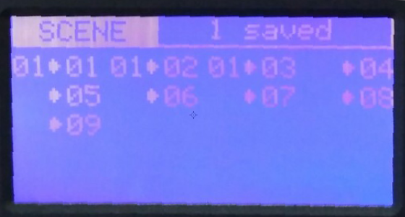
Scene save: Eg. Save current switching status to scene 1: Press MENU switch to SCENE, press number “1” from input area, then only need to press SAVE, display show as below:

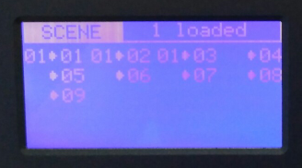
Scene recall: Press MENU switch to SCENE, press number “1” from input area, then only need to press RECALL, display show as below:

Setup:

IP address set up, Press UP and DOWN to choose the number from input area to change, press ENTER to input, then Press SAVE to save the IP.
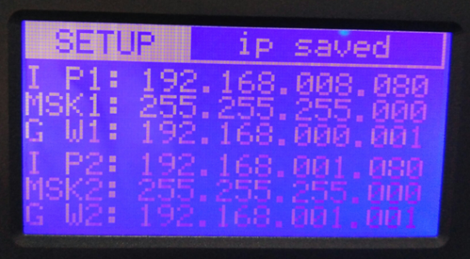
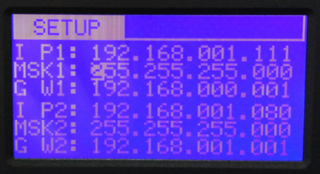

View:

Review the current switching status:1>1,1>2,1>3
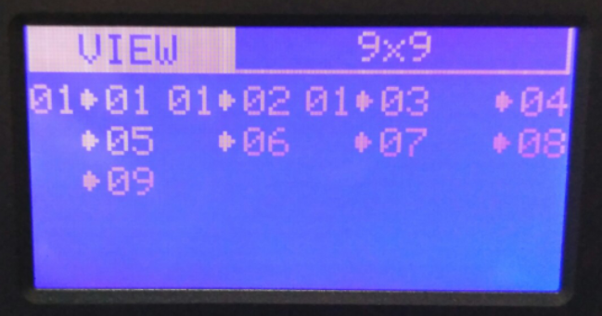

Part 6. WEB control:
All the Mini series matrix can support WEB interface control, the default IP is 192.168.0.80 and 192.168.1.80. Enter 192.168.0.80 to a browser, showing below interface:
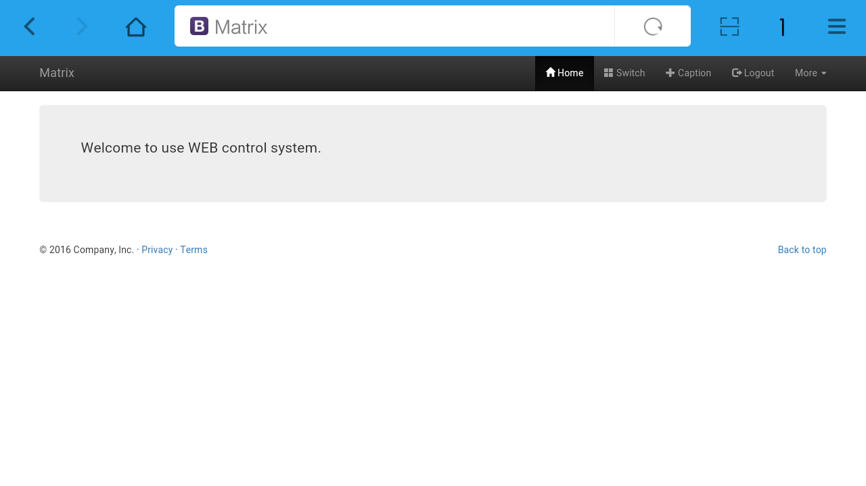

Note: Before using all the function will need to Login first.

Click Login, showing below interface, both of the user name and password are: admin
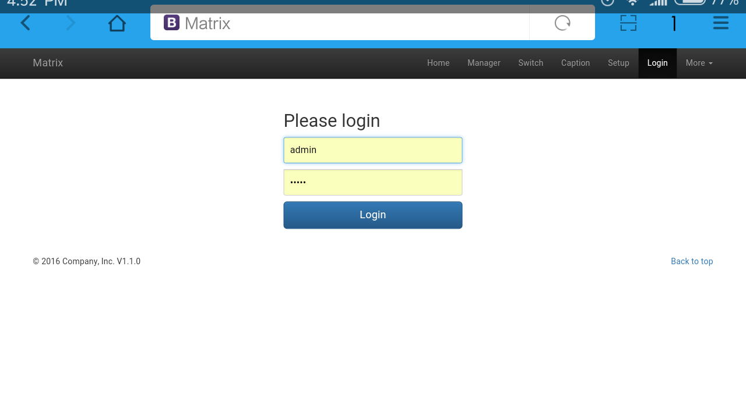
After logging in successfully, on the top will show: Home, Manager, Switch, Caption, Setup, Logout and Morn icons. Click Manager will show below interface:

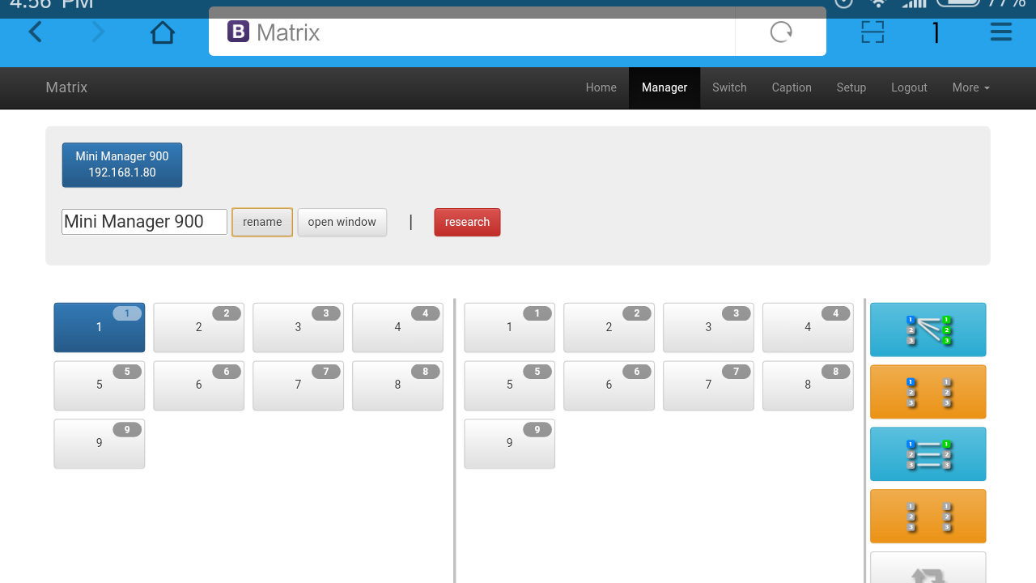
Note: In this icon, users can check all the matrices in the same local area network. Users also can rename and open a window of the selected matrix.

Switch icon:
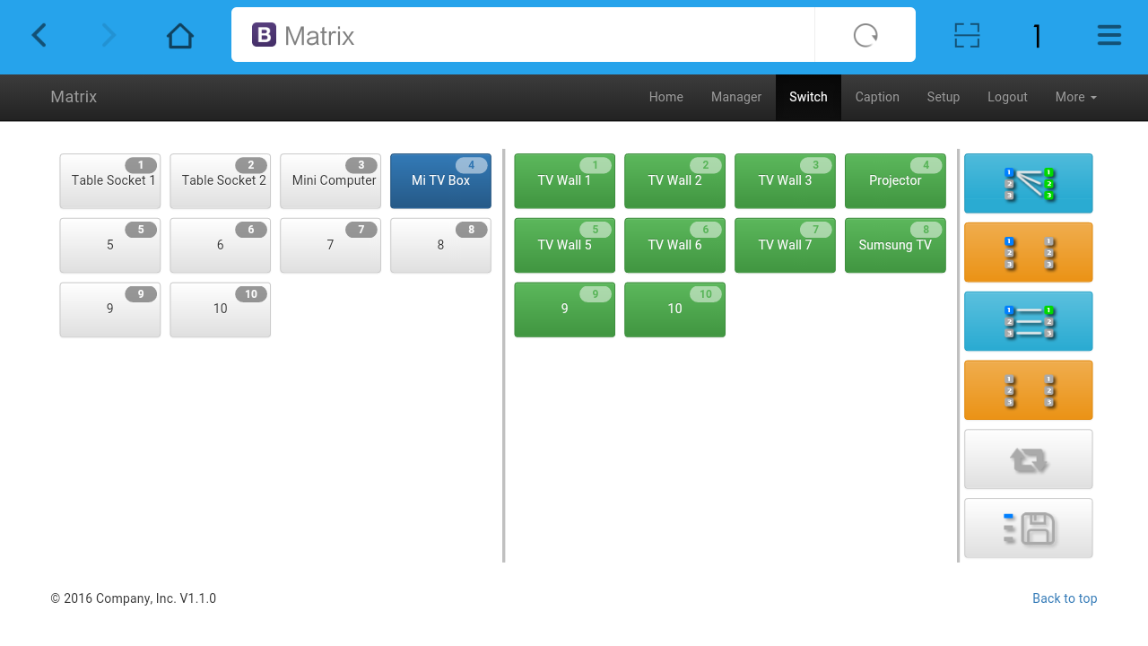
Note: Users can switch here.

Caption icon:
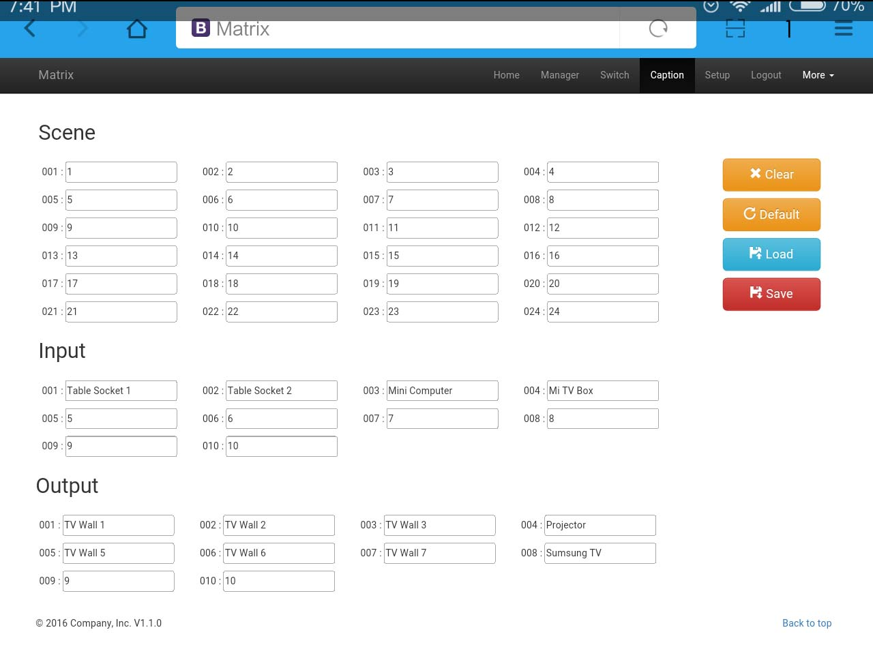
Note: Users can change the scene, input and output names here.

Setup icon:
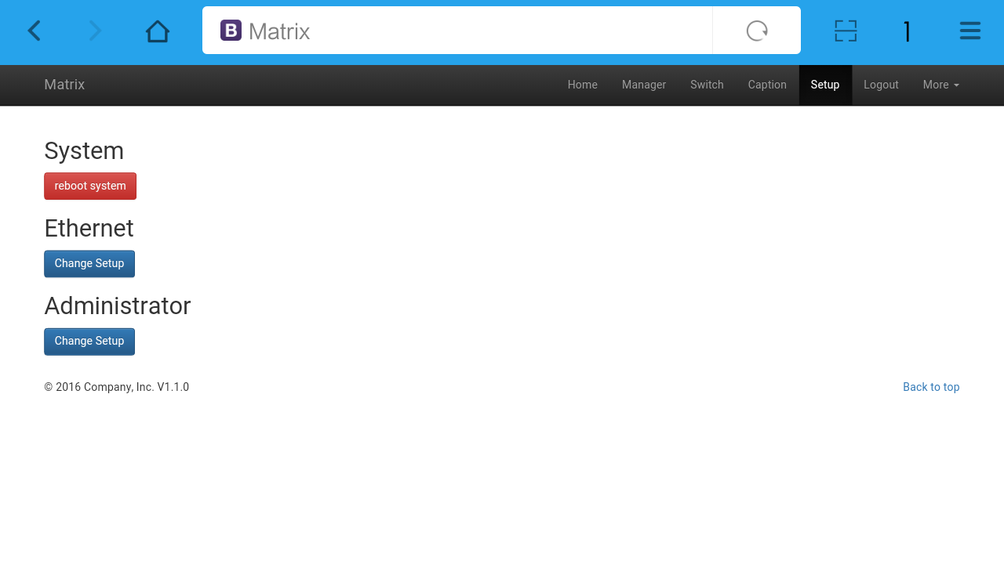
Note: Users can change IP address, user name and password here.

More icon:
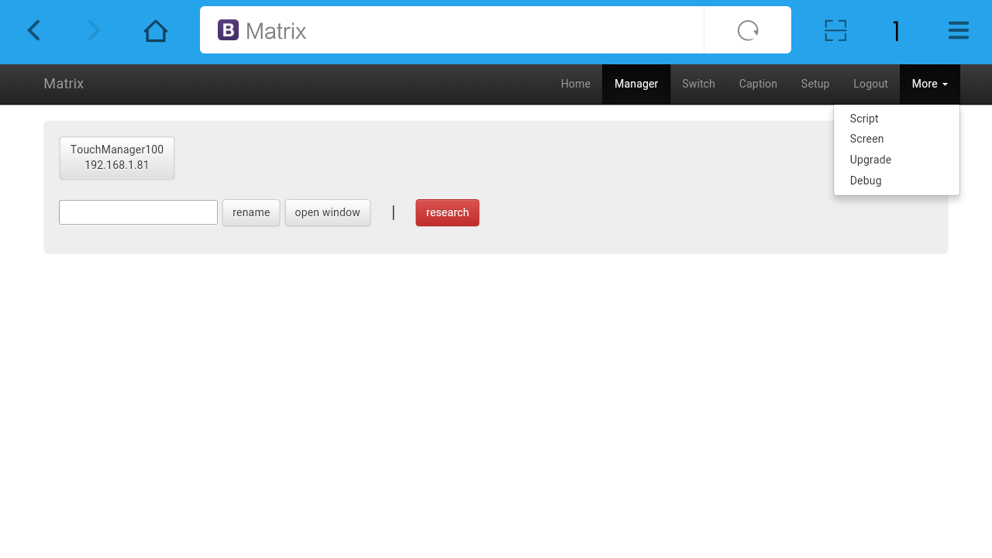
Note: Users can upgrade here.

Part 7. RS232 control command:
1. RS232 communication protocol and central control code:
Communication protocol: Baud rate: 115200; data bit: 8; Stop bit:1; Check bit: None

Type | Control command | Function description
Command | [x1]All. | Switch [x1] input to all the outputs
 | All[1]. | Switch all the channels to be one to one. Eg.1->1，2->2，3->3……
 | [x1]X[x2]. | Switch [x1] input to [x2] output
 | [x1]X[x2]&[x3]&[x4]. | Switch [x1] input to [x2], [x3], [x4]
 | Save[Y]. | Save current status to [Y], [Y] can be number 1-9
 | Recall[Y]. | Recall the saved [Y] scene
 | BeepON. | Buzzer on
 | BeepOFF. | Buzzer off

Note:
1. [x1], [x2], [x3], [x4] are the inputs and outputs, normally depend on the matrix, if the matrix is a 10x10 matrix, then the effective range are from 1 to 10. Can’t send this kinds of words ‘[‘And’]’
2. Every command need to add the words ‘-’
3. The letters can be capital and small letter

Part 8. Common issues:
1. No respond on the touch screen
◆ Make sure all the power code well connected
◆ Check the display switcher and make sure it’s in good condition
◆ Make sure the the DVI cable between the device and display are short than 7 meters
◆ Reconnect the DVI cable and restart the system
◆ Make sure the signal sources are on
◆ Check the cables between the devices and displays are connected correctly.
◆ Dial the switcher 7 to 1, then dial the switcher1,2 and choose the corresponding inputs.
◆ Make sure the resolution less than WUXGA(1920*1200)/ 60HZ
◆ Make sure the display can support the output resolution.

Part 9. Attachment:

Version and info:
Version | Writer | Date
V1.0 | Technical department | October, 2016

Part 10. Maintenance
Clean this unit with a soft, dry cloth. Never use alcohol, paint thinner or benzine to clean this unit.

● Provided Service

1) Damage Requiring service: The unit should be serviced by qualified service personnel if:
The DC power supply cord or AC adapter has been damaged;
Objects or liquids have gotten into the unit;
The unit has been exposed to rain;
The unit does not operate normally or exhibits a marked change in performance;
The unit has been dropped or the cabinet damaged.
2) Servicing Personnel: Do not attempt to service the unit beyond that described in these operating instructions. Refer all other servicing to authorized servicing personnel.
3) Replacement parts: When parts need replacing ensure the service uses parts specified by the manufacturer or parts that have the same characteristics as the original parts. Unauthorized substitutes may result in fire, electric shock, or other hazards.
4) Safety check: After repairs or service, ask the service to perform safety checks to confirm that the unit is in proper working condition.

● Mail-In Service

When shipping the unit, carefully pack and send it prepaid, adequately insured and preferably in the original carton. Include a letter detailing the complaint and provide a daytime phone and/or email address where you can be reached.
If repair is needed during the limited warranty period the purchaser will be required to furnish a sales receipt/proof of purchase indicating date of purchase, amount paid and place of purchase. Customer will be charged for the repair of any unit received without such proof of purchase.

● Warranty

If your product does not work properly because of a defect in materials or workmanship, We (referred to as “the warrantor”) will, for the length of the period indicated as below, (Parts (3) Years, Labor(3) years)which starts with the date of original purchase (“Limited Warranty period”), at its option either (a) repair your product with new or refurbished parts, or (b) replace it with a new or a refurbished product. The decision to repair or replace will be made by the warrantor.
During the “Labor” Limited Warranty period there will be no charge for labor. During the “Parts” warranty period, there will be no charge for parts. You must mail-in your product during the warranty period. This Limited Warranty is extended only to the original purchaser and only covers product purchased as new. A purchase receipt or other proof of original purchase date is required for Limited Warranty service.

● Warranty Limits And Exclusions

1)This Limited Warranty ONLY COVERS failures due to defects in materials or workmanship, and DOES NOT COVER normal wear and tear or cosmetic damage. The Limited Warranty ALSO DOES NOT COVER damages which occurred in shipment, or failures which are caused by products not supplied by the warrantor, or failures which result from accidents, misuse, abuse, neglect, mishandling, misapplication, alteration, faulty installation, set-up adjustments, maladjustment of consumer controls, improper maintenance, power line surge, lightning damage, modification, or service by anyone other than a Factory Service Center or other Authorized Service, or damage that is attributable to acts of God.
2)There are no express warranties except as listed under “limited warranty coverage”. The warrantor is not liable for incidental or consequential damages resulting from the use of this product, or arising out of any breach of this warranty. (As examples, this excludes damages for lost time, cost of having someone remove or re-install an installed unit if applicable, travel to and from the service location, loss of or damage to media or images, data or other recorded content. The items listed are not exclusive, but are for illustration only.)
3)Parts and service, which are not covered by this limited warranty, are your responsibility.

