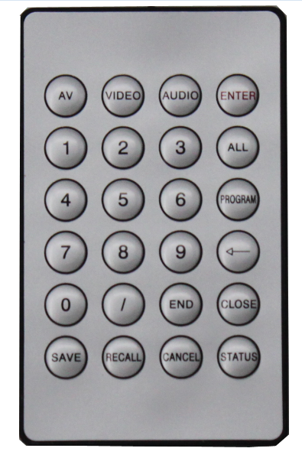
Eg1: Switch the AV of input 1 to output 3 and output 4:

1.Press “1”, the LCD shows Input command “1”, then please select the switching ways

2. Press “AV”, LCD shows “1B”, then please select the output ports

3.Press “3”, the LCD shows “1B3”, then please press “/”

4. After pressing “/”, the LCD shows “1B3,”

5. Then please press “4”, the LCD show “1B3,4”

6. Then press “END”，the LCD will show “1B3,4.”

7. Press “Enter” to make sure operating the switching. LCD display“1B3，4.” switch OK!

Conclusion: “1”→ Select “AV” or “Audio” or “Video” → “3”→ “/”→ “4”→ “END”→ “ENTER”

Eg2：Check out the status of output4：

Press “4”, then press “STATUS”. LCD screen will show the switching info of output4

