1x2 HDMI Splitter Over Single Cat5e/6 Cable Up to 50M with IR
Operating Instructions

Notice
The information in this document is subject to change without notice. Every effort has been made in the preparation of this document to ensure accuracy of the contents, but all statements, information, and recommendations in this document do not constitute the warranty of any kind, express or implied.

Features
- Distribute 1 HDMI signal to 2 identical UTP outputs synchronously, with 1 - looping HDMI output.
- Transmit over 50m single Cat5e/6 cable.
- Can be cascaded for 4 layers.
- With wide-band Bi-Direction IR control (38 ~ 56 kHz).
(IR extension from Sender to Receiver or from Receiver to Sender)
- Support Full HD 1080p, VESA resolution: 1920x1200.
- Supports Dolby TrueHD, DTS-HD Master Audio.
- Support 3D.

Package Contents
- 1 x HDMI Splitter
- 1 x 5V DC Adapter
- 1 x User Manual

1

SPECIFICATIONS
Operating Temperature Range | -5 to +35℃(+23 to +95℉)
Operating Humidity Range | 5 to 90%RH (No Condensation)
Video Amplifier Bandwidth | 140MHz
Input Video Signal | 0.5-1.0 Volts P-P
Input DDC Signal | 5 volts p-p (TTL)
Data transfer speed rate | 6.75Gbps(Maximum)
Input port | 1xHDMI
Output ports | 2xCat5e/6, 1xHDMI
Video Format Supported | DTV/HDTV:480i/576i/480P/576P/720P/1080i/1080P  VESA resolution:1920x1200① 3D video support
Vertical Frequency range | 60Hz
Support Audio Format | DTS-HD Master Audio, Dolby True HD, multi-channel 5.1, stereo etc ②
Transmission Distance | 1080P 8-bit 50m  Over single cat5e or cat6 cable/24AWG/Solid③
Power consumption | 6W(Max)
Dimension (L×W×H) | L149xW79xH28mm
Net Weight | 317.7g
Note: ① The transmission distance is Max 40m under 1920x1200 resolution.
② The distance is 40m under 5.1CH or 7.1CH.
③ Under perfect transmission conditions including straight cable runs with no electrical interference, bends, kinks, patch panels or wall outlets.

PANEL DESCRIPTIONS

Front Panel

1. DIP switch for EDID setting 2. IR-TX port
3. IR-RX port 4. Indicator of HDMI output
5. Indicator of HDMI input 6. Power input indicator

Rear Panel
7. CAT-5E/6 out ports 8. HDMI output
9. HDMI input 10. Power input

DIP Switch for EDID Setting
DIP Switch | EDID
0000 | Default (1080P2D 2ch)
0001 | Copy from HDMI output
0010 | 1080P2D 2CH
0011 | 1080P2D 6CH
0100 | 1080P2D 8CH
0101 | Reserved
0110 | 1080P3D 2CH
0111 | 1080P3D 6CH
1111 | 1080P3D 8CH

Connecting and operating
- Connect the HDMI input source into HDMI splitter.
- Connect HDMI splitter and receiver by single cat5e/6 cable (The cable termination must follow the standard of EIA/TIA 568B).
- Connect the HDMI display (such as HD-LCD/HD-DLP) into the HDMI output of receiver.
- Connect the Loop HDMI output port of HDMI Splitter with the HDMI Display (such as HD-LCD/HD-DLP) by HDMI cable.
- Plug IR TX cable and IR RX cable to IR port of the Splitter.
- Plug IR TX cable and IR RX cable to IR port of the Receiver.
- Insert the DC 5V power supply into HDMI splitter and receiver.

Connection Diagram
Application 1:
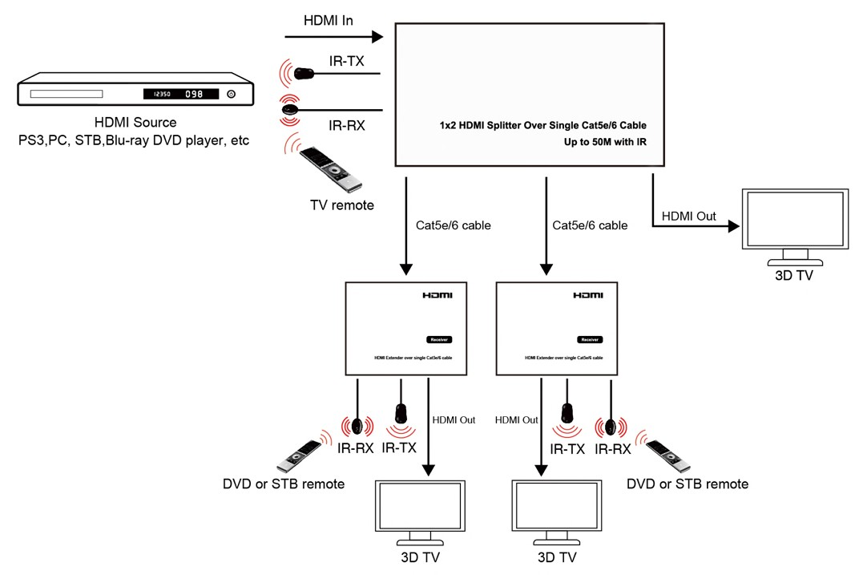
Application 2: Cascade for 4 layers
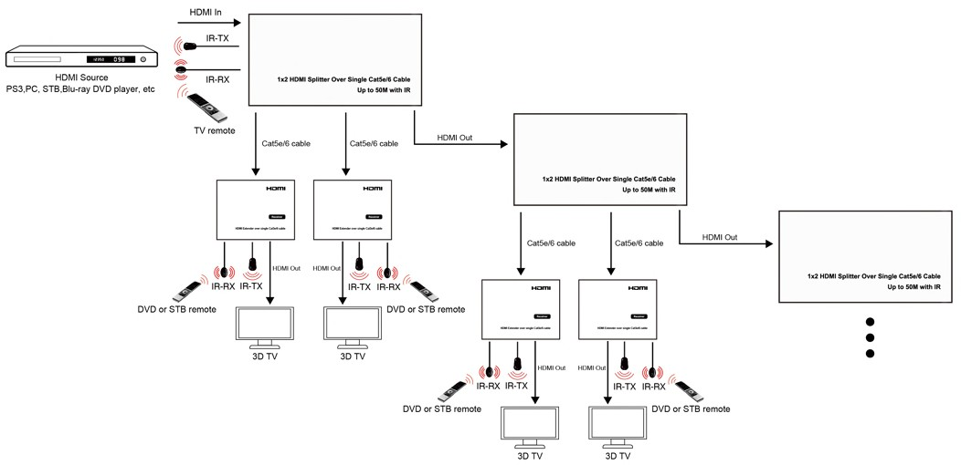

MAINTENANCE
Clean this unit with a soft, dry cloth. Never use alcohol, paint thinner of benzene to clean this unit.

PRODUCT SERVICE

Damage requiring service:
The unit should be serviced by qualified service personnel if:
- The DC power supply cord or AC adaptor has been damaged;
- Objects or liquids have gotten into the unit;
- The unit has been exposed to rain;
- The unit does not operate normally or exhibits a marked change in performance;
- The unit has been dropped or the cabinet damaged.
- Servicing Personnel: Do not attempt to service the unit beyond that described in these operating instructions. Refer all other servicing to authorized servicing personnel.
- Replacement parts: When parts need replacing ensure the servicer uses parts specified by the manufacturer or parts that have the same characteristics as the original parts. Unauthorized substitutes may result in fire, electric shock, or other hazards.
- Safety check: After repairs or service, ask the servicer to perform safety checks to confirm that the unit is in proper working condition.

WARRANTY
If your product does not work properly because of a defect in materials or workmanship, our Company (referred to as "the warrantor" ) will, for the length of the period indicated as below, (Parts(1)Year, Labor(1) Year) which starts with the date of original purchase ("Limited Warranty period"), at its option either(a) repair your product with new or refurbished parts, or (b) replace it with a new of a refurbished product. The decision to repair or replace will be made by the warrantor.
During the "Labor" Limited Warranty period there will be no charge for labor.
During the "Parts" warranty period, there will be no charge for parts. You must mail-in your product during the warranty period. This Limited Warranty is extended only to the original purchaser and only covers product purchased as new. A purchase receipt or other proof of original purchase date is required for Limited Warranty service.

MAIL-IN SERVICE
When shipping the unit carefully pack and send it prepaid, adequately insured and preferably in the original carton. Include a letter detailing the complaint and provide a day time phone and/or email address where you can be reached.

LIMITED WARRANTY LIMITS AND EXCLUSIONS
- This Limited Warranty ONLY COVERS failures due to defects in materials or workmanship, and DOES NOT COVER normal wear and tear or cosmetic damage. The Limited Warranty ALSO DOES NOT COVER damages which occurred in shipment, or failures which are caused by products not supplied by warrantor, or failures which result from accidents, misuse, abuse, neglect, mishandling, misapplication, alteration, faulty installation, set-up adjustments, maladjustment of consumer controls, improper maintenance, power line surge, lightning damage, modification, or service by anyone other than a Factory Service center or other Authorized Servicer, or damage that is attributable to acts of God.
- THERE ARE NO EXPRESS WARRANTIES EXCEPT AS LISTED UNDER "LIMITED WARRANTY COVERAGE". THE WARRANTOR IS NOT LIABLE FOR INCIDENTAL OR CONSEQUENTIAL DAMAGES RESULTING FROM THE USE OF THIS PRODUCT, OR ARISING OUT OF ANY BREACH OF THIS WARRANTY. (As examples, this excludes damages for lost time, cost of having someone remove or re-install an installed unit if applicable, travel to and from the service, loss of or damage to media or images, data or other recorded content. The items listed are not exclusive, but are for illustration only.)
- PARTS AND SERVICE, WHICH ARE NOT COVERED BY THIS LIMITED WARRANTY, ARE YOUR RESPONSIBILITY.

