Operating Instructions

HDMI Extender
Transmission more than 3800M

Operating Instructions
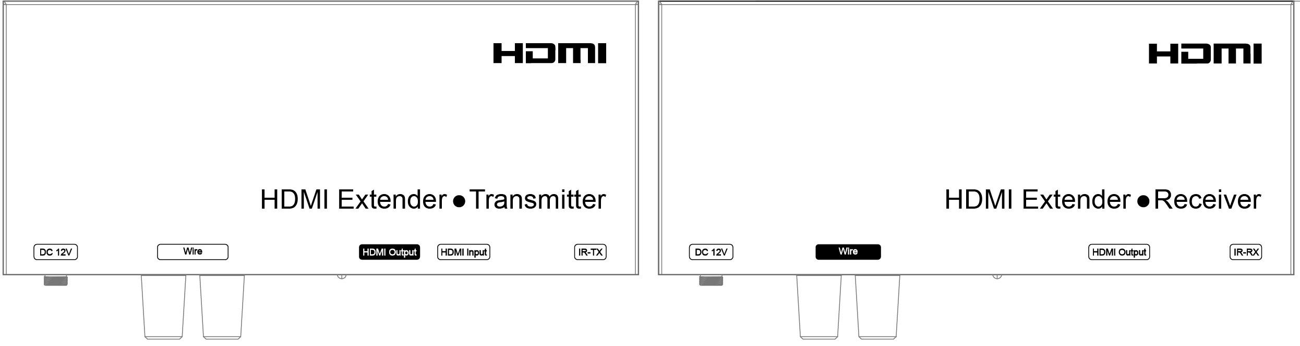
Dear Customer
Thank you for purchasing this product. For optimum performance and safety, please read these instructions carefully before connecting, operating or adjusting this product. Please keep this manual for future reference.

FEATURES
- HDMI over 2-conductor cable
(Such as Twisted cable, telephone cable, Cat5e/6/7 cable etc)
- With 1x Loop HDMI output at transmitter
- Transmission more than 3800m
- Support Multi-level cascading
- HDMI Resolution up to 1080p
- HDCP compliant
- IR pass-through control
- Power Supply DC12V

This product is NOT "HDMI over AC"!
Please ensure you do not establish a direct connection between the transmitter and the receiver using an active AC power outlet. Doing so will
damage your unit and will be dangerous！
This product can’t work with existing power lines in the home or building directly！

NOTICE
Our company reserves the right to make changes in the hardware, packaging and any accompanying documentation without prior written notice.

Operating Instructions

TABLE OF CONTENTS
Specifications Package Contents Panel Descriptions
Connecting and Operating Typical Application Maintenance
Product Service Warranty

SPECIFICATIONS

PANEL DESCRIPTIONS

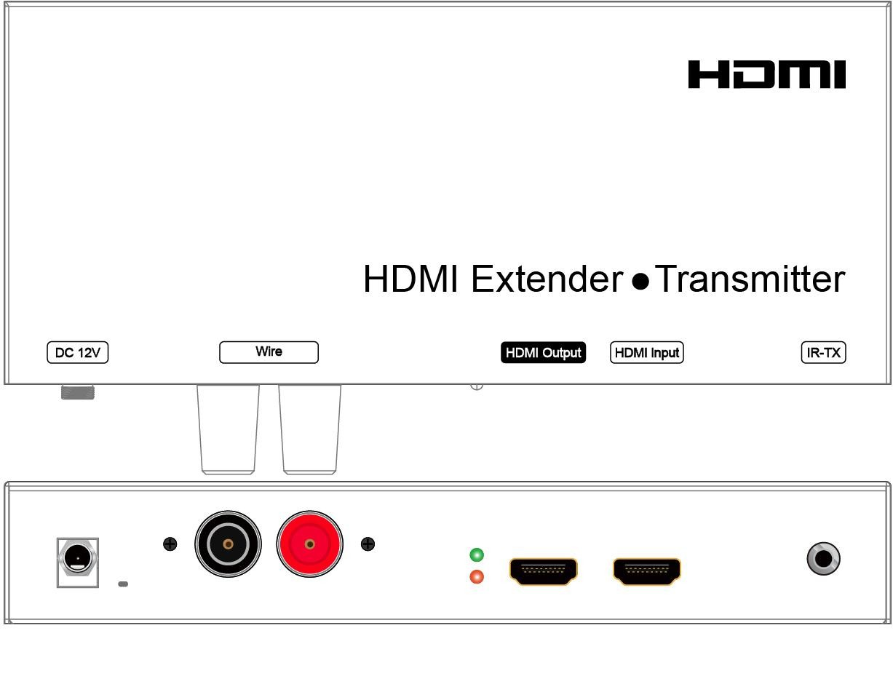Transmitter Panel
Operating Instructions

  - Power input port 2) Terminal Post to connect 2-conductor cable
Operating Temperature Range | -10 to +45℃(+14 to +113℉)
Operating Humidity Range | 5 to 90%RH (No Condensation)
Support Audio Format | LPCM audio format
Transmission Distance | 3800m 2-Conductor cable(Recommend to use 12AWG-19AWG cable)
Support Video Format | DTV/HDTV:480i/ 480P/576i/576P/720P/1080i/1080P
 | VESA: 800x600, 1024x768, 1280x768,1280x960,1280x1024,
 | 1680x1050,1920x1080, 1280x720, 1360x768,1400x1050,1280x1024.
Connector on Transmitter | 1x HDMI Input, 1x HDMI Looing output
 | 1x3.5mm jack for IR-TX
 | 1x Red Terminal Post, 1x Black Terminal Post
 | DC 5.5 x2.1mm Jack
Connector on Receiver | 1x Red Terminal Post, 1x Black Terminal Post
 | 1x HDMI Output, 3.5mm
 | 1x3.5mm jack for IR-RX
 | DC 5.5 x2.1mm Jack
Power consumption | Transmitter: 6.5watts(Maximum),Receiver:5.5watts (Maximum)
Dimension (L×W×H) | L206.2xW110xH33mm
IR frequency | 38K-56KHZ
Net Weight | Transmitter: 545g Receiver: 548g

3) Green indicator of data status 4) Red indicator of power input
5) HDMI Output port 6) HDMI Input port
7) IR-TX

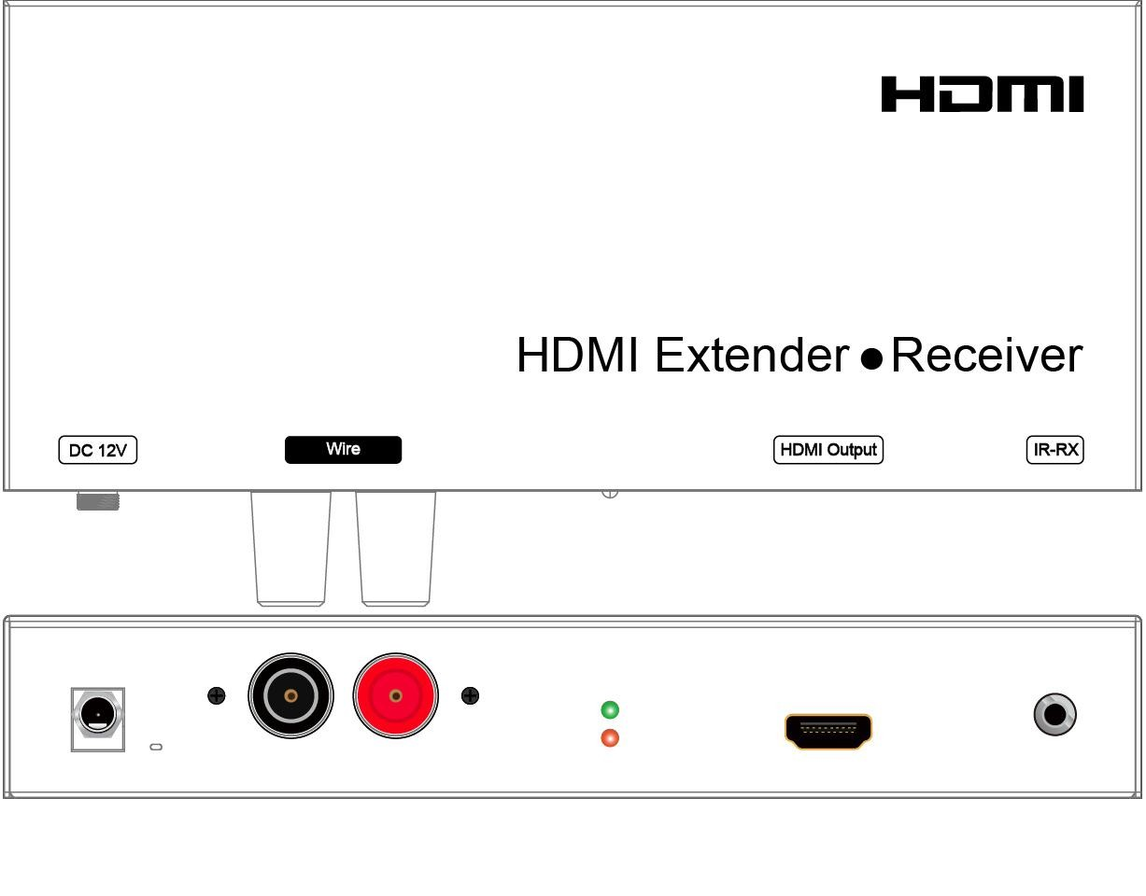Receiver Panel

Note1: Specifications are subject to change without notice. Mass and dimensions are approximate.

PACKING CONTENTS
- . Main Unit: HDMI Extender( Transmitter& Receiver)
- . 2x Power Adapter DC 12V
- . 8x Screws
- . 4x Detachable Mounting Ears
- . 1x User’s Manual

1) Power input port 2) Terminal Post to connect 2-conductor cable
3) Green indicator of data status 4) Red indicator of power input
- HDMI Output port 6) IR-RX

Operating Instructions

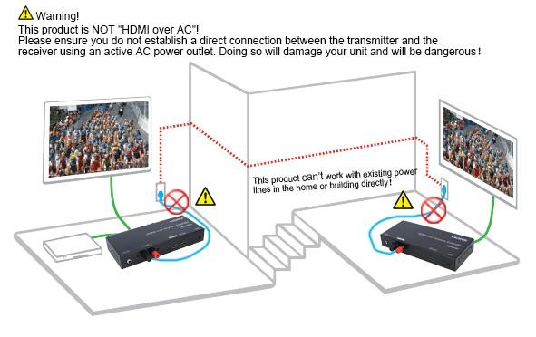
Connection Diagram

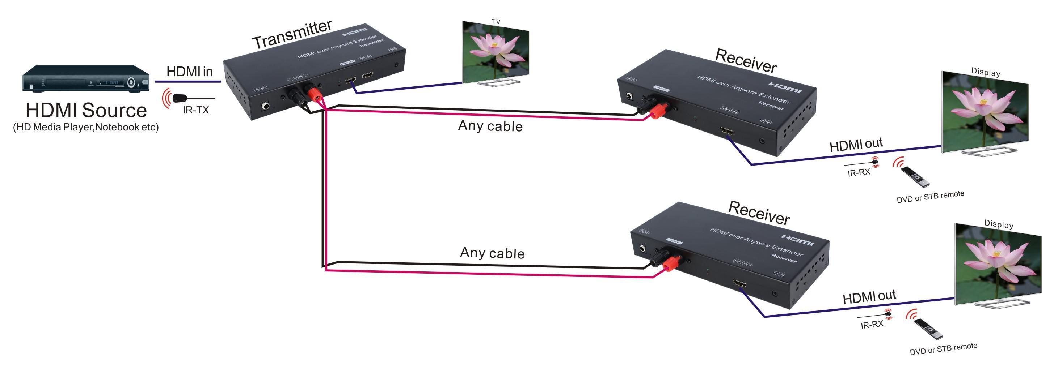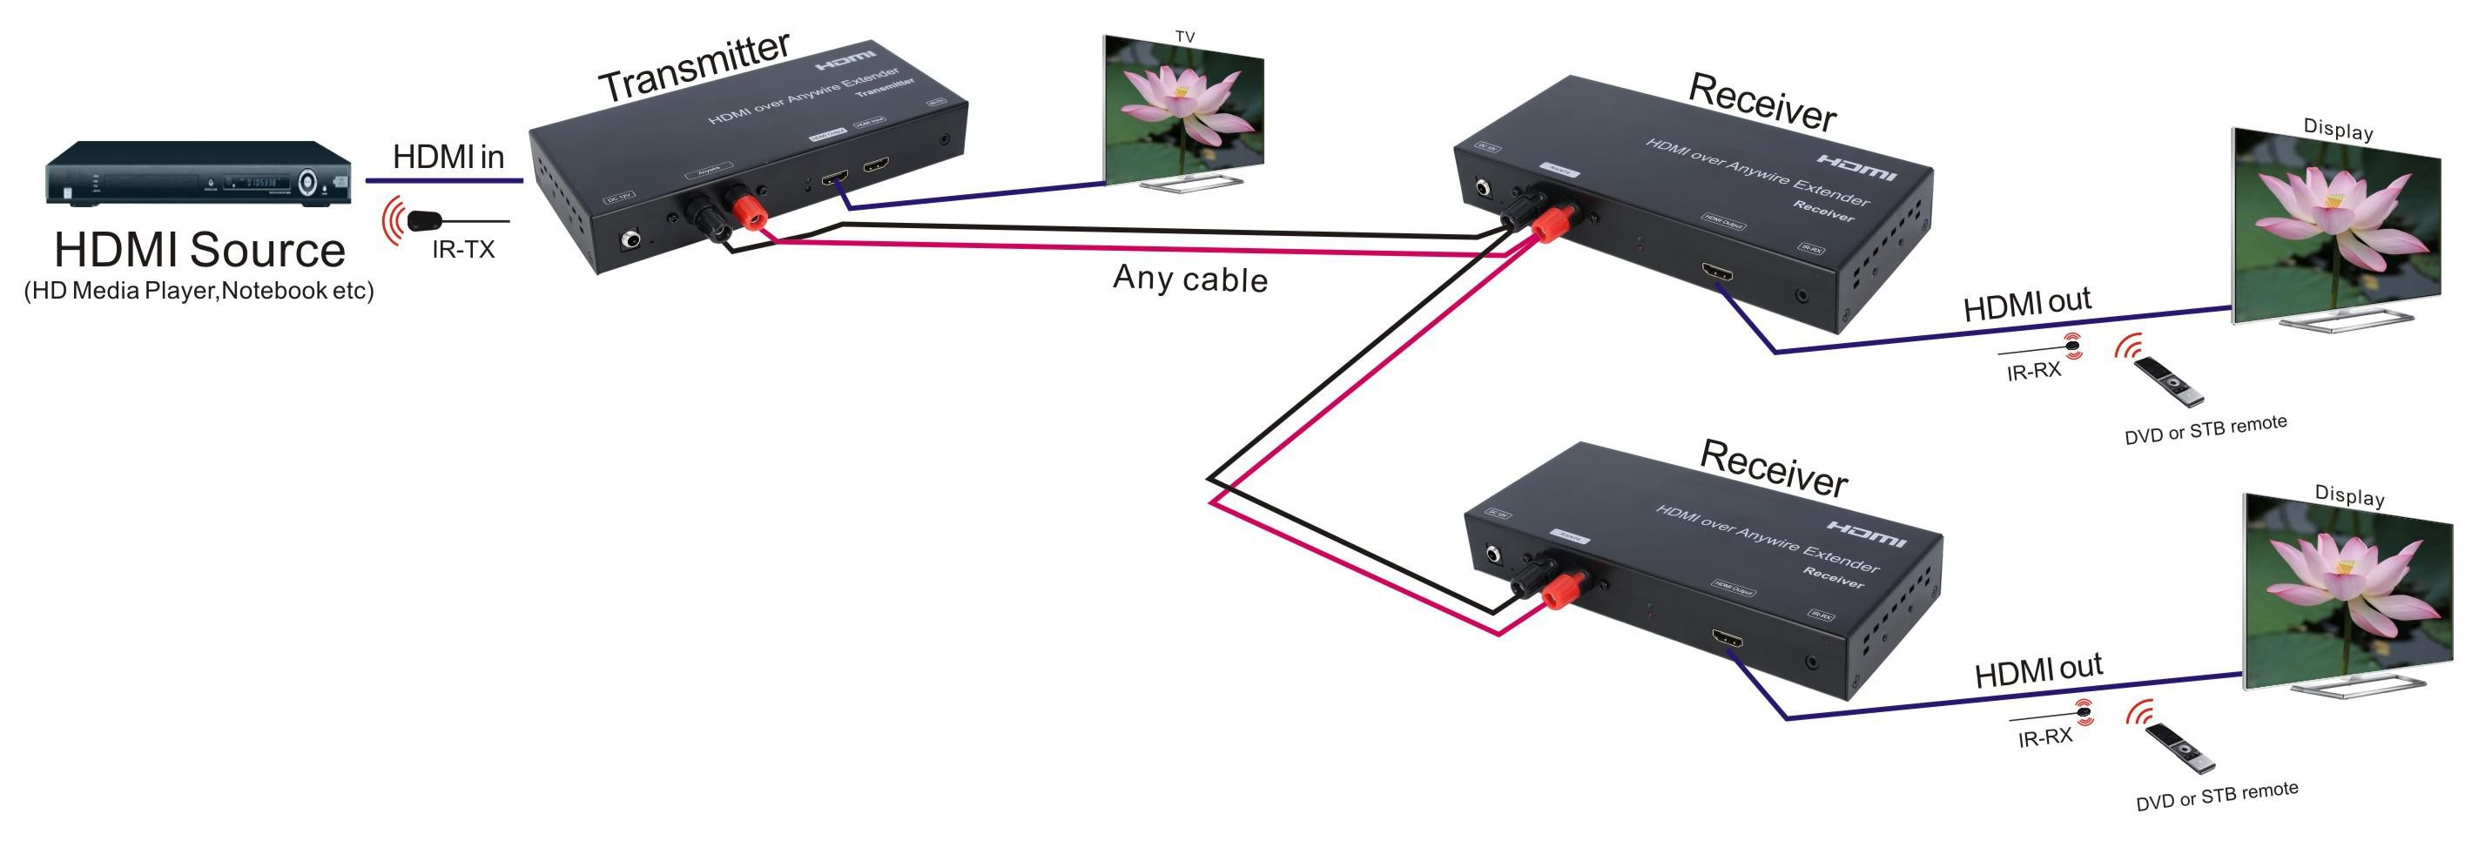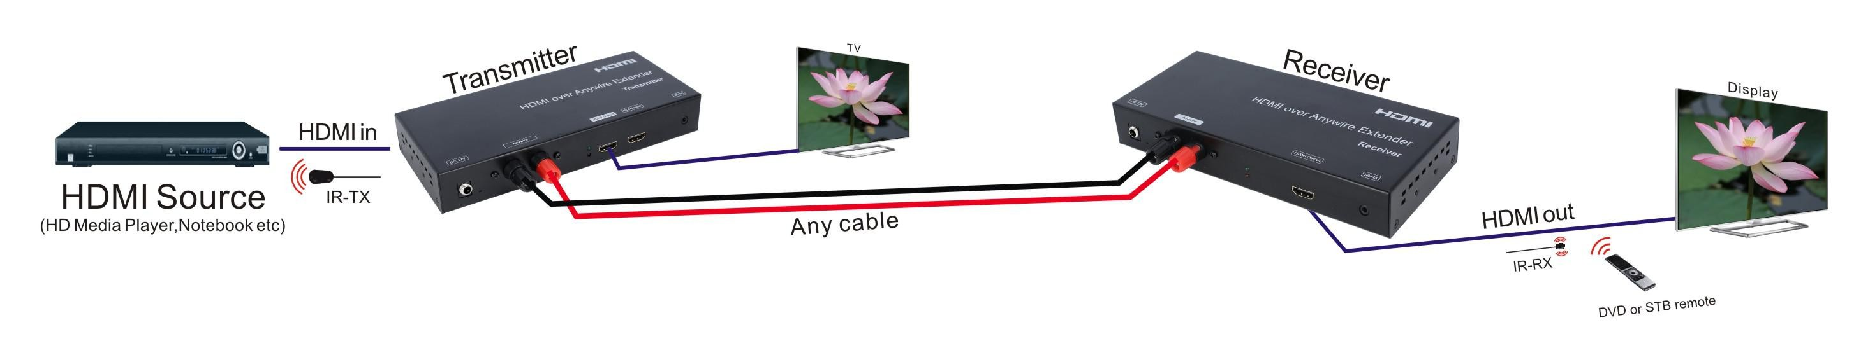Application 1: Unicast
Application 3: Multi-level cascading
Application 2: Multicast
Operating Instructions

CONNECTING AND OPERATING
  - Connect the HDMI input source (such as HD-DVD/PS3/STB etc) into transmitter over HDMI cable.
  - Connect the transmitter to the receiver by any 2-conductor cable.
  - Connect the HDMI output (such as HD-LCD/HD-DLP) into the receiver over HDMI cable.
  - Connect the IR TX cable into “IR TX” port of the transmitter; Connect the IR RX cable into “IR RX” port of the receiver.
  - Connect power adapter in to the transmitter and receiver. NOTE: Insert/Extract cables gently.

MAINTENANCE
Clean this unit with a soft, dry cloth. Never use alcohol, paint thinner of benzine to clean this unit.

PRODUCT SERVICE

Damage requiring service:
The unit should be serviced by qualified service personnel if:
- The DC power supply cord or AC adaptor has been damaged;
- Objects or liquids have gotten into the unit;
- The unit has been exposed to rain;
- The unit does not operate normally or exhibits a marked change in performance;
- The unit has been dropped or the cabinet damaged.
- Servicing Personnel: Do not attempt to service the unit beyond that described in these operating instructions. Refer all other servicing to authorized servicing personnel.
- Replacement parts: When parts need replacing ensure the servicer uses parts specified by the manufacturer or parts that have the same characteristics as the original parts. Unauthorized substitutes may result in fire, electric shock, or other hazards.
- Safety check: After repairs or service, ask the servicer to perform safety checks to confirm that the unit is in proper working condition.

Operating Instructions

WARRANTY
If your product does not work properly because of a defect in materials or workmanship, our Company (referred to as "the warrantor" ) will, for the length of the period indicated as below, (Parts(1)Year and Labor which starts with the date of original purchase ("Limited Warranty period"), at its option either(a) repair your product with new or refurbished parts, or (b) replace it with a new of a refurbished product. The decision to repair or replace will be made by the warrantor.
During the "Labor" Limited Warranty period there will be no charge for labor.
During the "Parts" warranty period, there will be no charge for parts. You must mail-in your product during the warranty period. This Limited Warranty is extended only to the original purchaser and only covers product purchased as new. A purchase receipt or other proof of original purchase date is required for Limited Warranty service.

MAIL-IN SERVICE
When shipping the unit carefully pack and send it prepaid, adequately insured and preferably in the original carton. Include a letter detailing the complaint and provide a day time phone and/or email address where you can be reached.

LIMITED WARRANTY LIMITS AND EXCLUSIONS
- This Limited Warranty ONLY COVERS failures due to defects in materials or workmanship, and DOES NOT COVER normal wear and tear or cosmetic damage. The Limited Warranty ALSO DOES NOT COVER damages which occurred in shipment, or failures which are caused by products not supplied by warrant or, or failures which result from accidents, misuse, abuse, neglect, mishandling, misapplication, alteration, faulty installation, set-up adjustments, misadjustment of consumer controls, improper maintenance, power line surge, lightning damage, modification, or service by anyone other than a Factory Service center or other Authorized Servicer, or damage that is attributable to acts of God.
- THERE ARE NO EXPRESS WARRANTIES EXCEPT AS LISTED UNDER "LIMITED WARRANTY COVERAGE". THE WARRANTOR IS NOT LIABLE FOR INCIDENTAL OR CONSEQUENTIAL DAMAGES RESULTING FROM THE USE OF THIS PRODUCT, OR ARISING OUT OF ANY BREACH OF THIS WARRNTY. (As examples, this excludes damages for lost time, cost of having someone remove or re-install an installed unit if applicable,
travel to and from the service, loss of or damage to media or images, data or other recorded content. The items listed are not exclusive, but are for illustration only.)
- PARTS AND SERVICE, WHICH ARE NOT COVERED BY THIS LIMITED WARRANTY, ARE YOUR RESPONSIBILITY.

