4K 5x1 Multi-format Scaler Switcher

Thank you for purchasing this product
For optimum performance and safety, please read these instructions carefully before connecting, operating or adjusting this product. Please keep this manual for future reference.

Surge protection device recommended
This product contains sensitive electrical components that may be damaged by electrical spikes, surges, electric shock, lightning strikes, etc. Use of surge protection systems is highly recommended in order to protect and extend the service lifeof your equipment.

Table of Contents
1. Introduction ········································································..· 2
- Features 2
- Package Contents 2
- Specifications 3·····
- Operation Controls and Functions..., 4
- Connection Diagram 14

Introduction
The Multi-inputs with HDMI output scaler box supports 5 inputs of 4xHDMI and 1xVGA(YPbPr,CVBS). The input source is capable to switch and scale to adopt resolution then transmit over HDMI output. The HDTV resolution is achievable. The system could be controlled and configure by easily operation of panel button, IR remote and RS-232. This scaler box is a suitable solution for presentation purpose at classroom and conference room.

Features
--} Compliant with HDMl2.0/1.4b, HDCP2.2/1.4;
--} Support multi inputs: 4 x HDMI, 1 x VGA ( YPbPr, CVBS);
--} Support HDMI input resolutions up to 4K UHD 4:4:4 @50/60;
--} Support output resolutions up to 4K UHD 4:4:4 @60;
--} Support two input switching modes: auto or manual;
--} Support EDID management;
--} Support pass-through of PCM 2CH;
--} Device could be controlled via touch panel button, IR remote and RS-232;
--} Support USB online software upgrading;

- Package Contents
--} 1xMulti-format Scaler Switcher
--} 2xMounting ears
--} 1xRemote Control Unit
--} 1xlR Receiver Cable
--} 1x12V/1A Power Adapter

-,¢,- 1x3RCA(Female) to D-SUB(Male) Cable
-,¢,- 1x3.5mmjack(Male) to 2RCA(Female) Cable
-,¢,- 1xUser Manual

- Specifications

Technical
HDMI Compliance | HDMI 2.0/1.4b
HDCP Compliance | HDCP 2.2/1.4
Video Input  Resolutions | HDMI: up to 4K2K@50/60Hz(4:4:4)
 | C-Video: PAUNTSC3.58/NTSC4.43/SECAM/PALM/PAL N
 | YPBPR: 480i to1080p
 | VGA: 640x480 to1920x1200
HDMI Ot.tput  Reeolutions | 4K2K60,4K2K30,1920X1OBOp/50, 1920X1080p/60 ,  1280X7 2 0p/50 , 1280 X720p/60 1024x768/60,1280x800/60,  1360x768/60,1400x1050/60, 1680x1050 /60,1920x1200/60;
Audio Formats | LPCM2.0CH
ESD Protection | Human body model - ±BkV (air-gap discharge) & ±4kV (contact discharge)
Connections
Input ports | 4x HDMI Type A [19-pin female) 1 x VGA[female]  1x3.5mm mini jack
Output ports | 1x HDMI Type A [19-pin female) 1x3.5mm mini jack
Control Interfaces | 1x1Rin  1 x RS-232  1x USB service(update)

Mechanical
Housing | Metal
Color | Black
Dimensions | 110mm [W] x 288mm [DJ x 32mm [HJ
Weight | 880g
Power Supply | DC 12V/1A Adaptor (US/EU standards, CE/FCC/UL certified)
Power Consumption | 9W(max)
Operation  Temperature | 32 - 104"F / 0 - 40"C
storage temperature | -4 - 140"F 1- 20 - so·c
Relative Humidity | 20 - 90% RH (no condensation)

- Operation Controls and Functions
  - Front Panel
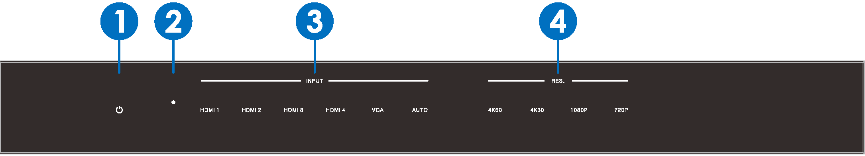
0 Power button and indicator:
Switches between standby and work mode.When this device is switched to the standby mode, the indicator turns red.When switching to work mode, the indicator turns blue
E) IR Window:
Receiving IR signal from remote control unit which come with scaler switcher

QInput Source & Auto buttons:
Press these buttons for source selection. The active source will be light to corresponding indicators on the front panel. AUTO button for auto-switching or manual-switching mode, when the indicator turns blue.the device switch to auto-switching mode, when the indicator turns off, the device switch to
manual.switching mode.

0 Output Resolution buttons:
Press these buttons for output resolutions selection. Select between 4K60.4K30, 1080P60,720P60; for more other resolutions options, Please use remote control or RS-232 control tools.

  - Rear Panel
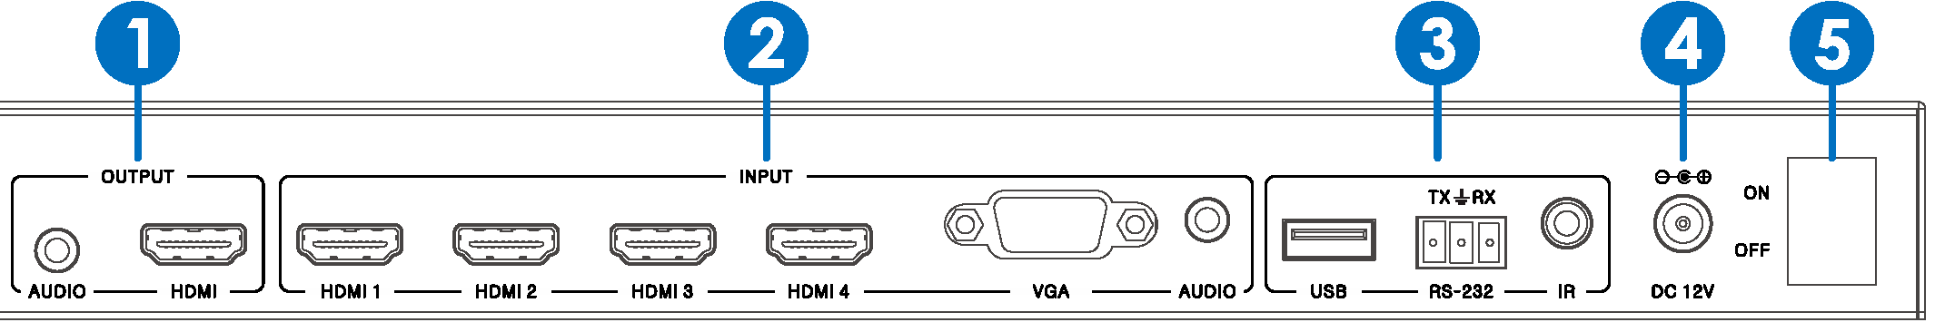

e output:
Connect to an HDMI display or AV Receiver for video and audio output. Connect theUR stereo audio output to the analog audio input port of your amplifier.

E) lnput:
The The input ports include 4 HDMI & 1 VGA input ports. The VGA ports supports YPbPr, C-video and VGA input formats.

E) Control:
use
USB port connects with USB flash disk or other storage that contains the software update file to update the system firmware.

RS232
Serial control port, 3p captive screw connector, connects with a control device (such as a computer) to control the scaler switcher.
IR
Connects with IR receiver, to receive IR signals sent by the IR remote or remote controller of other device.

0 Power:
Plug the 12V DC power supply into the unit and connect the adaptor to an AC outlet.

Q ON/OFF:
Power ON/OFF switch.

  - OSD MENU
The scaler switcher provides a powerful OSD operation menu.Press MENU button on IR remote to enter in OSD menu,The users can change some settings through the OSD menu.
5.3-1 Main MENU
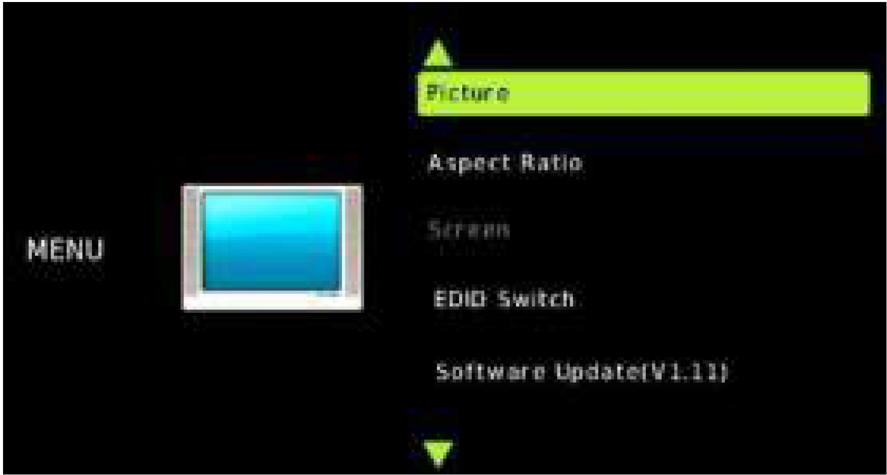
The Main MENU includes Picture, Aspect ratio.Screen, EDID and Software update options.

5.3-2 Picture

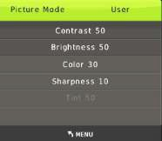

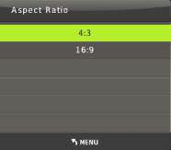

5.3-4 Screen

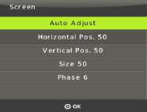

5.3-5 EDID
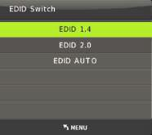

5.3-6 Software update
The scaler switcher supports software updates via USB flash disk. The procedure is as follows:
- Copy the file "MERGE.bin" to the root directory of a USB flash disk. (Make sure the file is copied to the root directory. The "MERGE.bin" file is provided/authorized by our engineering department or from our website)
- Plug the USB flash disk to the scaler switcher USB port on its rear panel.
- Press the MENU -->software update-->YES enter to start the update.the OSD will display the update process.
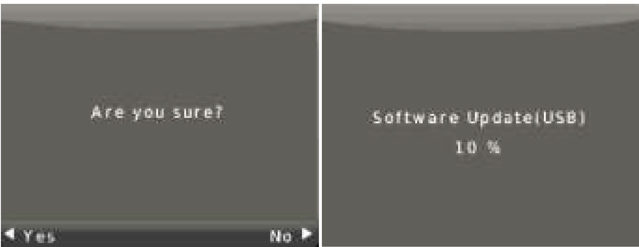

5.3-7 Resolution
The scaler switcher HDMI output resolutions support multiple modes. Press the "RES" button on the IR remote, the resolution menu will display. The user can select suitable resolution for HDTV or monitor.Auto means that the HDMI resolutions based on the EDID information read from the display device.

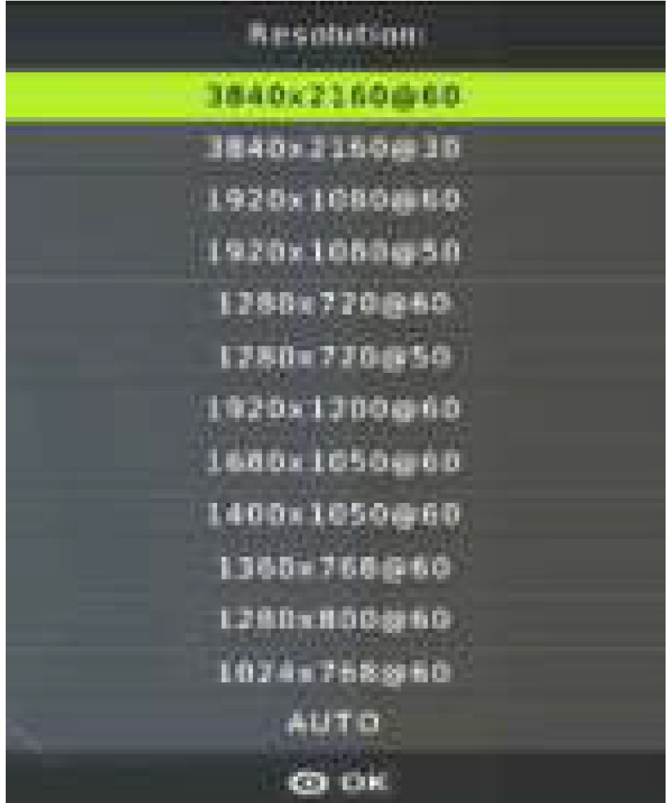

  - Remote Control

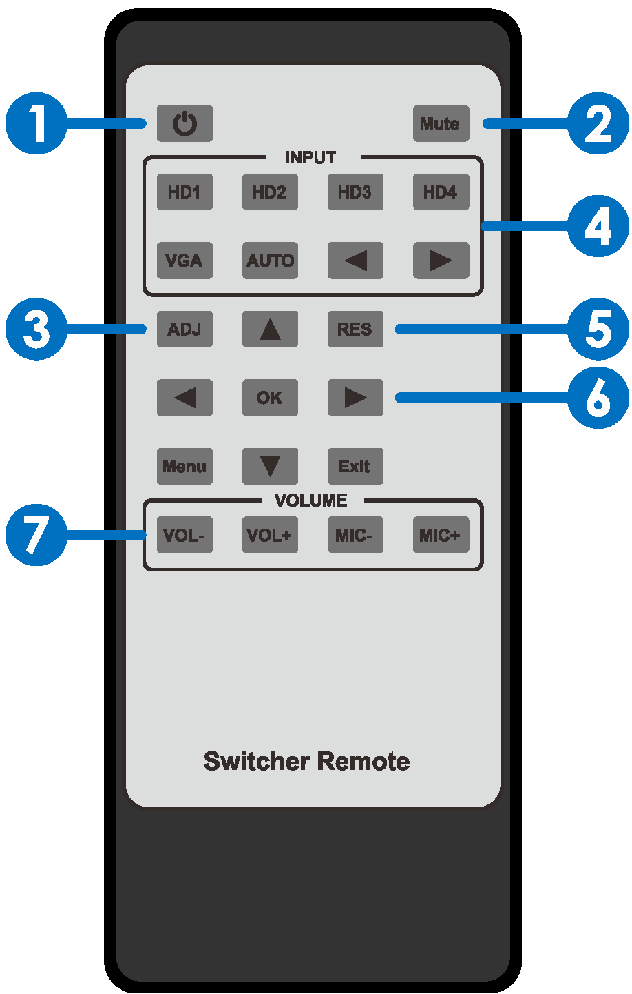
0 Press this button to power on the scaler switcher or set it to standby mode.
f) Press this button for mute or unmute the
audio output.
E) Press this button for operate VGA input auto adjustment function;
0 Press these buttons for select the input
sources.
0 Press this button for select HDMI output
resolution. (Press and hold 5 seconds or more, the HDMI output resolution will reset to 720p60Hz.)

0 Menu operation buttons:
MENU: press to enter in OSD menu. EXIT: press to exit OSD menu.
OK: confirm button.
UP/DWON/LEFT/RIGHT button:for OSD value setting.
f) VOL-/+:decrease or increase audio volume, MIC-/+: Unused.

Auto-Switching function
The scaler switcher have auto-switching mode and manual-switching mode.when the user select auto-switching mode, It will follows the following principles:
5.5-1 New input principle
Once a new input signal is detected, the scaler switcher will switch to this new signal automatically.

5.5-2 Power rebooting principle
The scaler switcher offers the function to remember the signal last used after rebooting. Once rebooted, it will automatically enter auto-switching mode, and then detect all inputs and memorize their connection status for future reboots. If the last used input signal is still available, then it will choose that signal. If not, it will detect all input signals with priority on HDMl1->HDM12->HDMl3->HDMl4->VGA(YPbPr/CV8S).

5.5-3 Signal removing principle
Once the current signal is removed, the scaler switcher will detect all input signals with priority on HDMl1->HDMl2->HDMl3->HDMl4->VGA(YPbPr/CV8S). It will transfer the first signal detected to the output

Notice: Auto-switching function works only when there is a new input signal or if aninput signal is removed..

  - VGA/YPbPr/CVBS input
The VGA input port is a multiple format port , It can compliant with VGA/YPbPr/CVBS input signal. The scaler switcher will auto detect the input signal type and format. The user can use the convert cable for YPbPr or CVBS signal input.

Ml-- - - - - ,a.i E--

Blue . Pb
Red . Pr
- • • °"
Green -+ y

Blue
N
l- - - - - -- - a,E - -- • E )=o Red -. c vBs

Green

  - Operations of RS232 Control
Please connect the scaler switcher with input devices and output device needed, then connect it with a computer that is installed with RS232 control software.
Double-click the software icon to run this software on your computer. The interface of the control software is showed as below:

u;--
--
=
-
-
...,
.. ------- -

-- -· -· -· 4
--
.....
-
-- -
.' ..
-

- .....IMll'I..,... --
.........

_
---
---
w
[El

1:l/15
.....
- ...

- Connection Diagram

TV or Monitor

Notebook

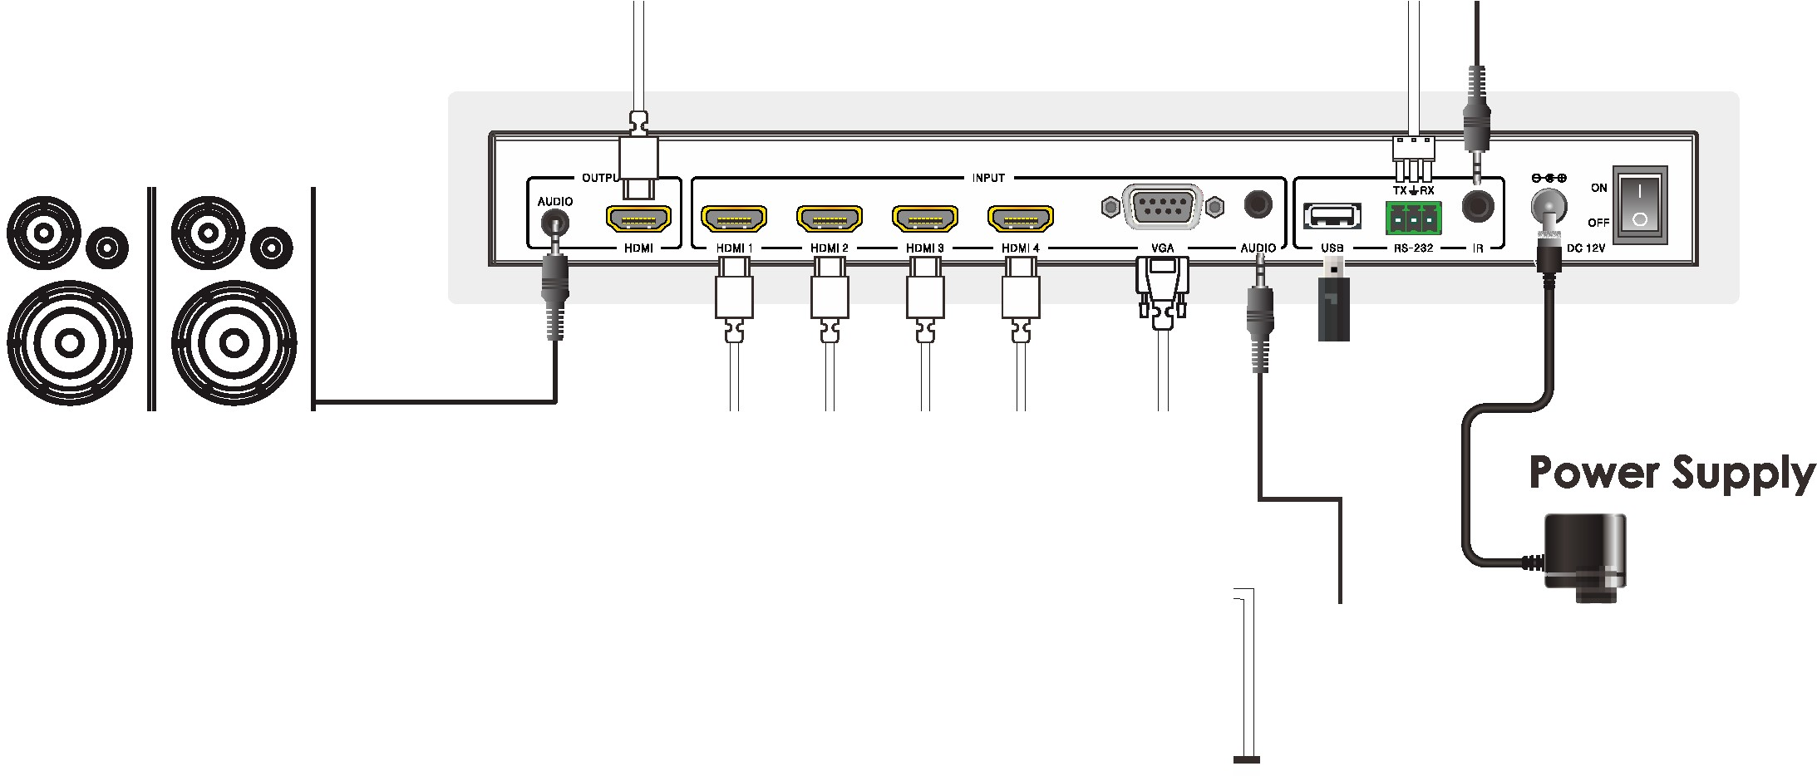IR Extender

2.0 Speakers

er-------;:::: =_==-=rr:--=, =
D
L 2J
I L........I L........I I ·-------
DVD or Blu-ray Player Notebook

14/15

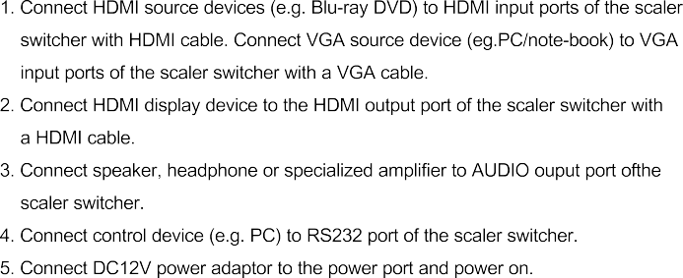

15/15

