HDTVCPRO3D42S
HDMI 4 by 2 v1.4 Switcher

with HEAC

Operation Manual

HDTVCPRO3D42S

Disclaimers

The information in this manual has been carefully checked and is believed to be accurate. HDTV Supply assumes no responsibility for any infringements of patents or other rights of third parties which may result from its use.
HDTV Supply assumes no responsibility for any inaccuracies that may be contained in this document. HDTV Supply also makes
no commitment to update or to keep current the information contained in this document.
HDTV Supply reserves the right to make improvements to this
document and/or product at any time and without notice.

Copyright Notice

No part of this document may be reproduced, transmitted, transcribed, stored in a retrieval system, or any of its part translated into any language or computer file, in any form or by any means
- electronic, mechanical, magnetic, optical, chemical, manual,
or otherwise - without express written permission and consent from
HDTV Supply.

Trademark Acknowledgments

All products or service names mentioned in this document may be trademarks of the companies with which they are associated.
Safety Precautions

Please read all instructions before attempting to unpack or install or operate this equipment, and before connecting the power supply. Please keep the following in mind as you unpack and install this equipment:

➢ Always follow basic safety precautions to reduce the risk of fire, electrical shock and injury to persons.
➢ To prevent fire or shock hazard, do not expose the unit to rain, moisture or install this product near water.
➢ Never spill liquid of any kind on or into this product.
➢ Never push an object of any kind into this product through module openings or empty slots, as you may damage parts.
➢ Do not attach the power supply cabling to building surfaces.
➢ Do not allow anything to rest on the power cabling or allow it to be abused by persons walking on it.
➢ To protect the equipment from overheating, do not block the
slots and openings in the module housing that provide ventilation.

Revision History

Version No Date Summary of Change
RDV1 | 20110103 | Preliminary Release
RDV2 | 20110413 | Preliminary Release

Table of Contents

1. Introduction .................................................................................. 1
2. Applications ................................................................................. 1
3. Package Contents ...................................................................... 1
4. System Requirements .................................................................. 1
5. Features ........................................................................................ 2
6. Specifications .............................................................................. 2
7. Operation Controls and Functions ............................................. 3
7.1 Front Panel.................................................................... 3
7.2 Rear Panel .................................................................... 4
8. Remote Control............................................................................ 5
9. RS-232 Protocol ............................................................................ 5
9.1 Pin Definition ................................................................. 5
9.2 Command .................................................................... 5
10. Connection and Installation ...................................................... 6
1. Introduction
This is a high performance four input & two outputs HDMIM Switch Splitter supports, the output ports support Audio Return Channel (ARC) and HDMI Ethernet Channel (HEC) follow by HDMI v1.4 specification. The ARC provides an S/ PDIF link from and HDMITM sink and output through ARC port to AVR to get true audio from the sink. The HEC feature adds a connection to the HDMI
link that is capable of carrying the same data as a full duplex, 100Mbps Ethernet connection. Using an HDMI with HEAC cable allowing for convenient integration of Digital Televisions (DTVs) into the end user’s home network system.

2. Applications
• Simultaneous display one HDMI source on 2 TVs
• Professional audio display
• Showroom display
• Education demo
• Commercial usage

3. Package Contents
• 4 x 2 HDMI Switch Splitter with HEAC
• 5V/2.6A DC power supply adaptor
• Operation Manual

4. System Requirements
• Source equipments with HDMI output connector(s)
• Displays TV/monitor with HDMI input connector(s)
• Two output ports can be connect to the Ethernet Channel (HEC) of Digital Televisions (DTVs) from end user’s home network system and Audio Return Channel (ARC) can output to the AVR to get true audio from the sink.
5. Features
• Support multiplexed HDMI 4-input and 2-output
• Two output ports support Ethernet Channel (HEC) and Audio Return
Channel (ARC) follow by HDMI v1.4 specification
• HDMI 1.4 support:
√ Audio Return Channel (ARC)
√ 3D
√ CEC
√ HDMI Ethernet Channel (HEC), enabling high-speed, bi-directional networking at up to 100Mb/sec
• Deep Color support 36/30/24-bit, 1080p@60Hz
• EDID can selected Standard, TV or Lock EDID feature
• Audio support:
√ HDMI 1.4 compatible audio interface
√ Dedicated, flexible audio input/output port
√ Dolby TrueHD
√ DTS-HD Master Audio
√ Full audio input and output support

6. Specifications

Frequency Bandwidth 2.25Gbps (single link) Input Ports 4x HDMI (Female type) Output Ports 2 x HDMI (Female type)
2 x Ethernet
2 x ARC
Output Resolution 480i ~1080p 50/60, 1080p24, VGA~UXGA
ESD Protection Human Body model: ±8kV (air-gap discharge)
± 4kV (contact discharge) Dimensions (mm) 240(W) x 113(D) x 49(H)
Weight(g) 810
Chassis Material Metal
Silkscreen Color Black
Operating Temperature 0°C ~ 40°C/ 32°F ~104°F Storage Temperature -20°C ~ 60°C/ -4°F ~140°F Relative Humidity 20~90% RH (non-condensing) Power Consumption 4.2W
7. Operation Controls and Functions
The following sections describe the hardware components of the unit.
7.1 Front Panel

1 2 3 4 5

1. IR Remote Control Sensor.
2. Audio/3D content indicator: The system will automatically detect incoming audio/video signal and the Green LEDs will illuminate
accordingly.
3. Input selection: Press input button to select input source, the Blue LED will illuminate accordingly. When non of the LED is illuminating this means no
input is selected, this is to allow the device to access the ARC feature alone.
4. EDID selection: This EDID control button is determined if you are going to use the EDID from the display attached to output 1 or use an onboard
EDID the Green LED will illuminate accordingly. When press EDID button longer then 3 seconds, the RED LED will illuminate which means the EDID already lock STD or TV EDID as you selected accordingly.
5. Power LED Indicator: The LED will illuminate when the power is connected.
7.2 Rear Panel

1 2 2 2 3 4

1. RS-232: This slot is to connect with a PC or control system with D-Sub 9pin
cable for RS-232 control. For detail RS-232 commands please refers to section 9.
2. HDMI 1~2out/ARC 1~2/Ethernet 1~2: Connect Ethernet and Audio Return
Channel to capabilities of sink, The HDMI output display will pass the
Ethernet and Audio signal via HDMI cable to HDMI output port individually, each HDMI will separate the Ethernet and audio and send it out from ARC and Ethernet ports. For ARC, when user had a
display with a built-in tuner or DVD player and wanted to send content “upstream” from the TV back to the audio system to play with multi- channel audio.
The HDMI Ethernet Channel, it can consolidates video, audio and data streams into a single HDMI cable to the Ethernet Hub/AP to access the internet and it incorporates a dedicated data channel into the HDMI link, enabling high-speed, bi-directional networking at up to 100Mb/sec to control and search from the sink. (Please see section 10 for diagram illustration).
Note:
1.Be sure to connect devices with one of the new cables designed to support HDMI Ethernet Channel functionality, either the standard HDMI cable with Ethernet or High Speed HDMI cable with Ethernet.
2.When the HDMI output with the Audio and ARC are exist at the same time the ARC will be the first priority to access.
3. HDMI input 1~4: Connect to HDMI or DVI sources equipment such as DVD player or set-top-box for input video and audio sending.
4. Power: Plug the DC 5V power supply into the splitter and connect the adaptor to AC wall outlet.
8. Remote Control
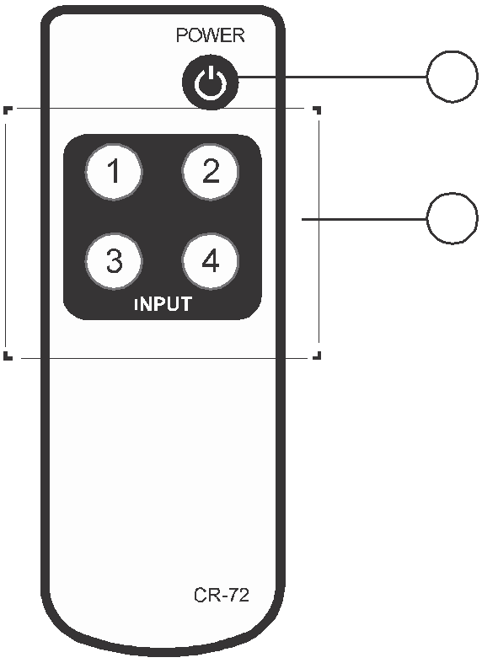

① Power button: Press to switch On the device, 1 press it again to set the device in standby mode.
② 1~4: Press the desire input button to select the 2 input source.

9. RS-232 Protocol
9.1 Pin Definition

CPRO-3D42S |  |  | Remote Control Console
PIN | Definition | ►  ◄ | PIN | Definition
1 | NC | ►  ◄ | 1 | NC
2 | Tx | ►  ◄ | 2 | Rx
3 | Rx | ►  ◄ | 3 | Tx
4 | NC | ►  ◄ | 4 | NC
5 | GND | ►  ◄ | 5 | GND
6 | NC | ►  ◄ | 6 | NC
7 | NC | ►  ◄ | 7 | NC
8 | NC | ►  ◄ | 8 | NC
9 | NC | ►  ◄ | 9 | NC
Baud Rate: 9600bps
Data bit: 8bits Parity: None Stop bit: 1 bit
Flow Control: None
9.2 Command

Command | Action
POWER 00 | Power Off (standby)
POWER 01 | Power On
PORT 11 | Output Select Input 1
PORT 12 | Output Select Input 2
PORT 13 | Output Select Input 3
PORT 14 | Output Select Input 4
PORT 00 | No Input Selection

10. Connection and Installation
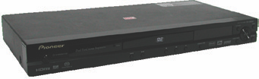

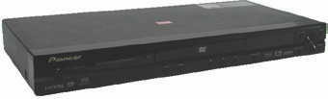
DVD

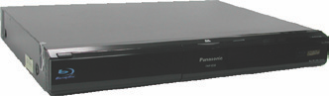
DVD Blu-Ray

Blu-Ray

Example:
Audio Loop Out

HDMI IN1 is

selected
ARC

INTERNET

HUB

AVR
Tuner TV With ARC

or
PC NB

AVR

Monitor without ARC

Speakers

Speakers

Acronyms A

Acronym Complete Term

ARC Audio Return Channel

CEC Consumer Electronics Control

EDID Extended Display Identification Data

HEC HDMI Ethernet Channel

HDCP High-bandwidth Digital content protection

HEAC HDMI Ethernet Audio Channel

HDMI High-Definition Multimedia Interface

