EDID Emulator Series
ITEM NO.: EE01H HDMI EDID Emulator

The EE01H HDMI EDID Emulator design for 1080P and 4K2K HDMI signal sources, enables you to capture and store EDID (Extended Display Identification Data) information when connected to a display. It can be powered directly from the HDMI source or with an optional external power supply.
EDID information contains important display settings such as maximum image size, color characteristics, factory pre-set timings, frequency range limits, etc., and since most video extender systems don’t offer EDID communication between the source and remote display, the HDMI EDID Emulator is a perfect workaround for ensuring the optimum signal is provided to the display to help prolong the life of your displays.
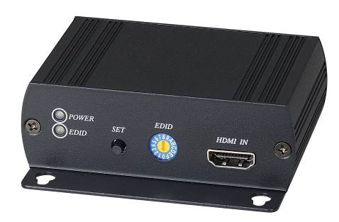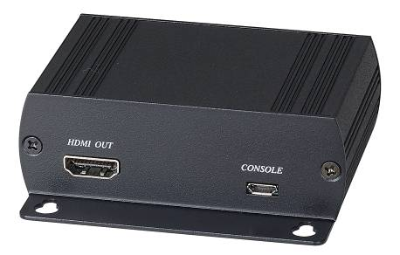
EE01H HDMI EDID Emulator

Features:
- Support 4 different EDID function: read, write, emulate, by pass
- Allows the source device to read the selected EDID information from the unit default or learned EDID memory.
- Built in rotary switch, support up to 12 sets default EDID setting
- Allow to save 3 sets custom EDID.
- Built in USB port to allow user to write EDID
- Built in Equalizer for reliable signal quality performance.
- Support HDMI 1.4a
- HDCP compliant.
- Support 4K2K@30Hz and 3D capable.
- Resolution support up to 4K x 2K (3840 x 2160@24、25、30Hz or 4096 x 2160@24Hz)

LED:
Green ON Power on
OFF Power off

Blue ON EDID error
Slow Flash Read/write EDID
Quick Flash Write EDID

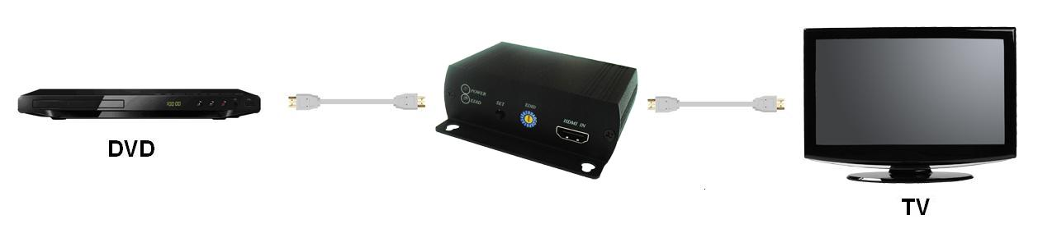

Panel View:

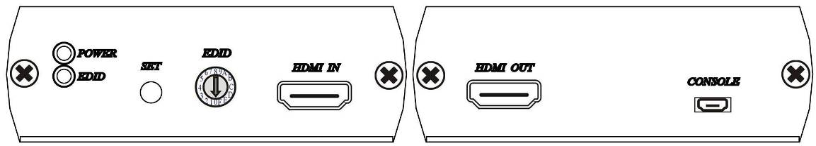

EDID Rotary Switch:
0:By pass mode
1:Custom EDID #1
2:Custom EDID #2
3:Custom EDID #3
4:720p@60Hz，LPCM 2 channel
5:1080i@50Hz，LPCM 2 channel
6:1080i@60Hz，LPCM 2 channel
7:1080p@24Hz，LPCM 2 channel
8:1080p@25Hz，LPCM 2 channel
9:1080p@50Hz，LPCM 2 channel
A:1080p@60Hz，LPCM 2 channel
B:1080p@24 Hz，LPCM 5.1 channel
C:1080p@50 Hz，LPCM 5.1 channel
D:1080p@60 Hz，LPCM 5.1 channel
E:1080p@60 Hz，LPCM 7.1 channel
F:3840 x 2160@30 Hz (4K x 2K)，LPCM 2 channel

EDID Operation:
  - By Pass Mode:Rotary switch turn to 0, connect source and monitor, the DDC will connect directly.

  - Manual Learning EDID Mode:Rotary switch turn to 1~3:
    - Press SET button 3 seconds to learn and write the EDID
    - Press SET button 0.5 second to select learned EDID

  - Default Mode:Rotary switch turn to 4~F, press SET button 0.5 second to select default EDID.

Caution:
- When learning EDID by manual: If EDID failed, the resolution will back to default at 720@60Hz resolution.
- EE01H built in micro USB for external power when your HDMI source not able to provide enough power to the receiver. For example, when using multiple EE01H with HDMI distributor, the power consumption may over the limitation of the HDMI device, please use micro USB to DC plug cable (package included) with 5V power adaptor (optional) for external power.

EDID Loader installation:

Double Click Setup file in CD path “EDID Loader” to install

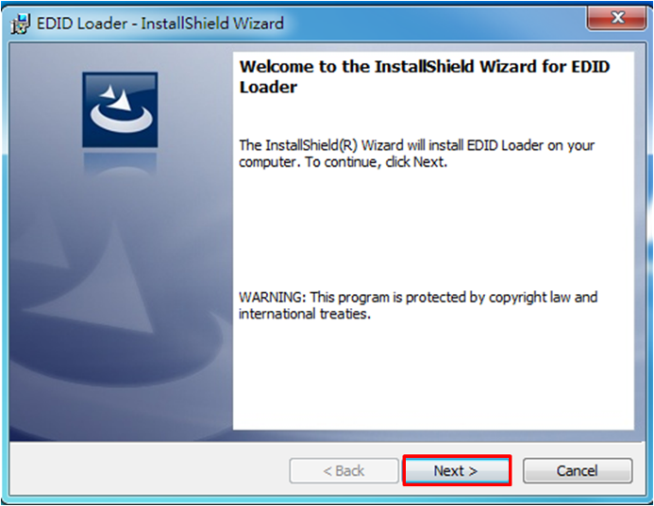
Click「Next」to next step

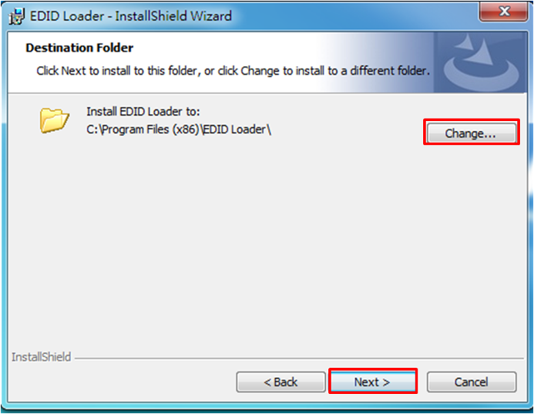
Default path is “C:\Program files (x86)\EDID Loader\, To change the installation path, please click「Change...」, Click「Next」button to next step

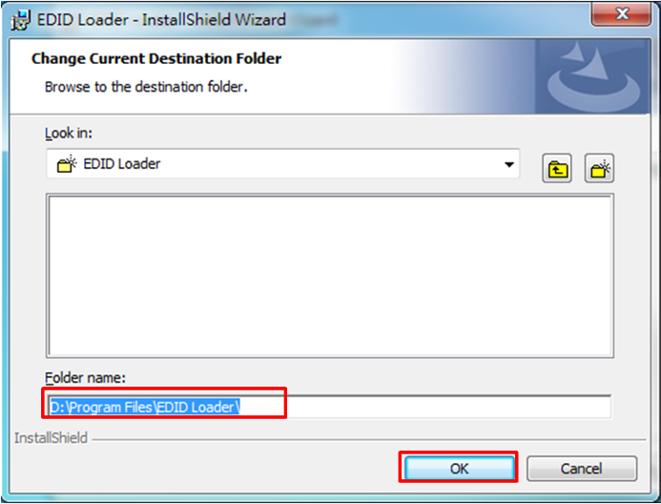
If click「Change...」 icon it will show up the modified window
After modified the path, click「OK」to back, click「Next」to next step.

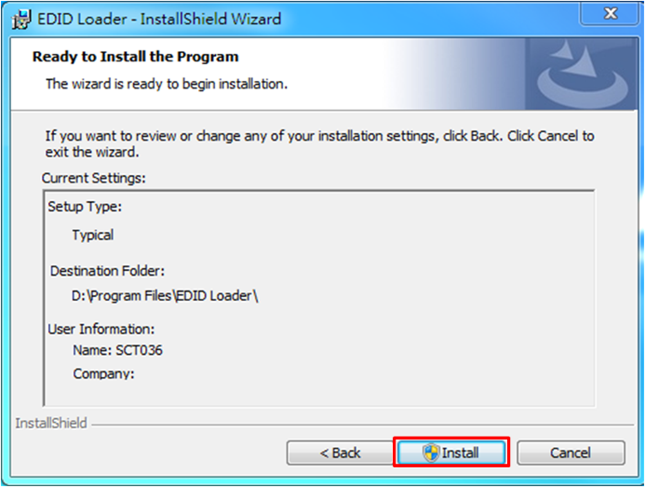
Click「Install」to start installation

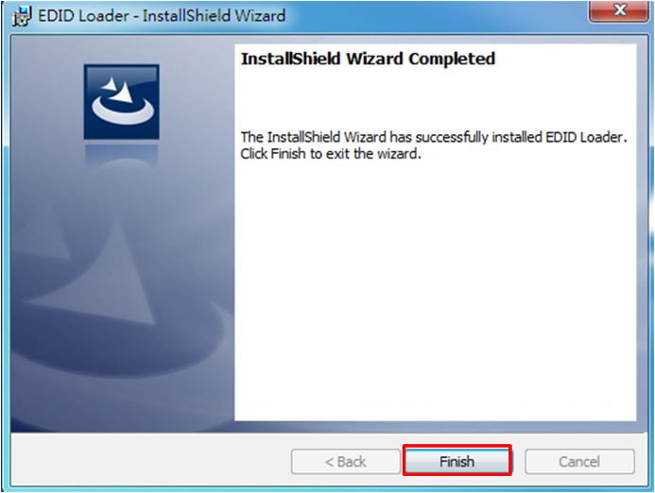
After installation, click「Finish」to complete the installation


It will show “EDID Loader” icon on desktop, click the icon to run the program

EDID Loader Instruction:
Click shortcut of EDID Loader to enter the program

Write EDID:
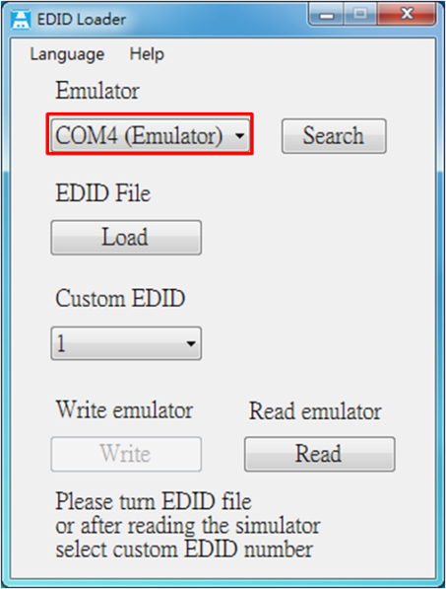

In main screen you will see the「COM4 (Emulator)」 if the emulator have been connected with PC and installed driver properly

*If it shows (Matrix) please pull down and select (Emulator)
*「TCP/IP」in the pull down menu is for other products, not for emulator

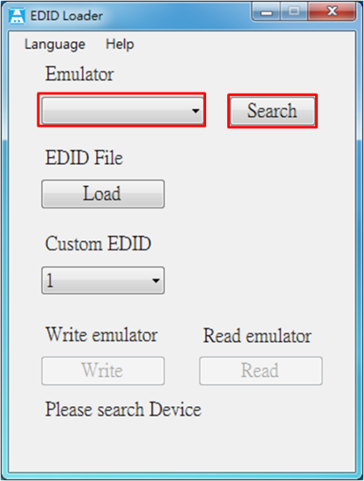

If the menu is blank please click「Search」 to find the emulator

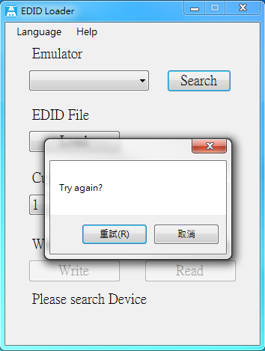

If still not find any devices it will show message “Try again?”
Please check the USB cable connection or use another USB port of PC then click 「Retry」

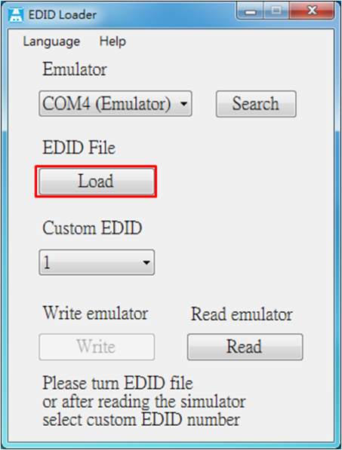

After emulation connected please click「Load」 to load EDID file
It will show select file windows as below

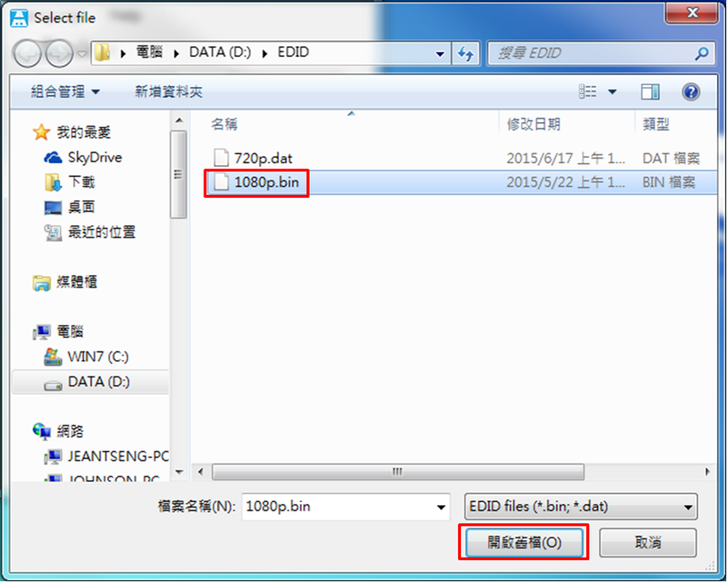

Select the EDID then click「Open」
*Support format「dat」 and 「bin」

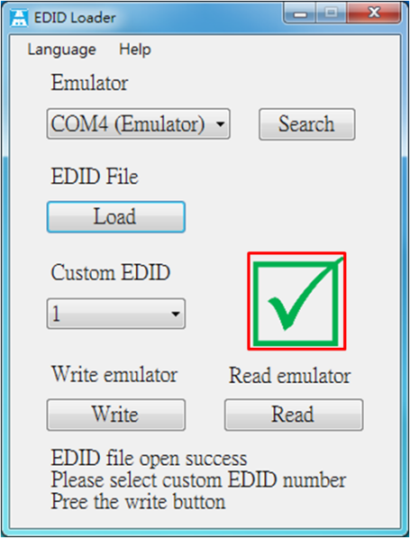

If the file is correct it will show a green checked icon
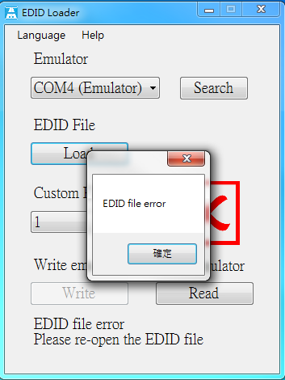

If the file is not correct format is will show a red X and message “EDID file error”

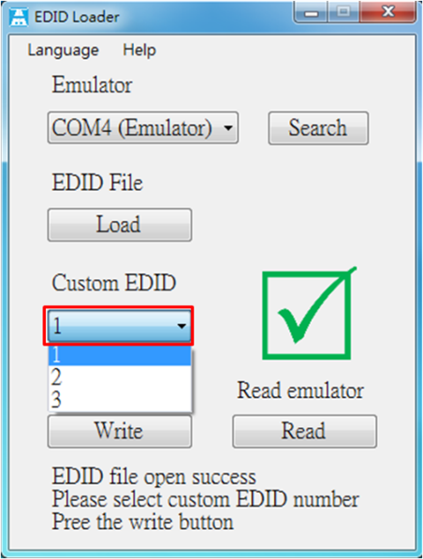

After open the EDID file pull down “Custom EDID” to select the bank 1~3 of EDID

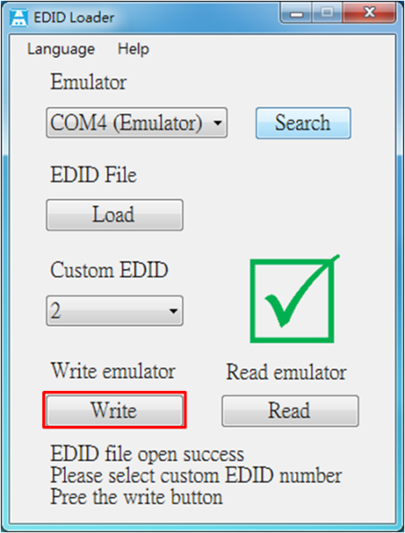

Click「Write」to process

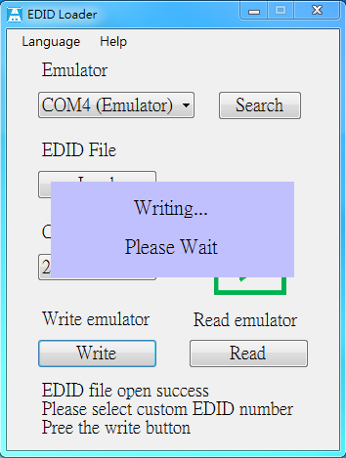

It will show message “Writing… Please Wait” when process

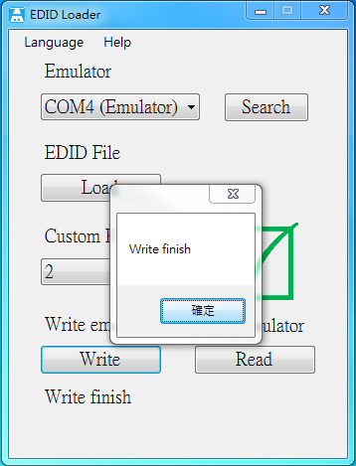

It will show message “Write finish” when finished

Read EDID:
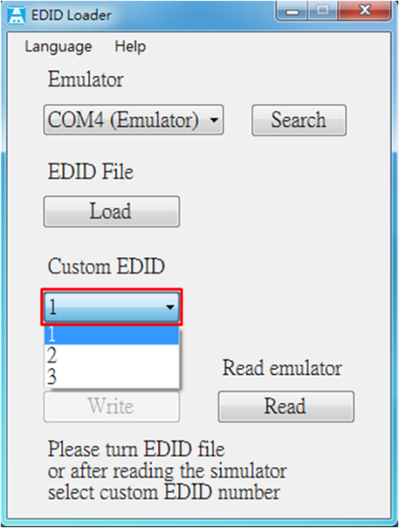

Pull down the “Custom EDID” to select the bank 1~3 of EDID

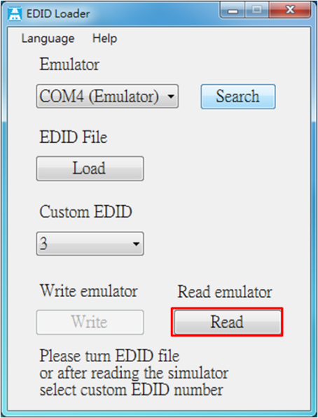

Click 「Read」

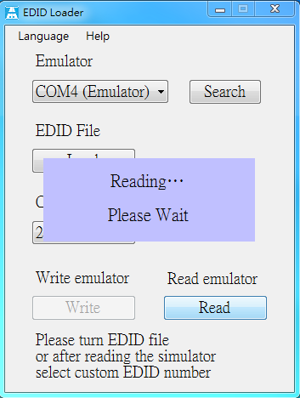

It will show message “Reading… Please Wait” when process

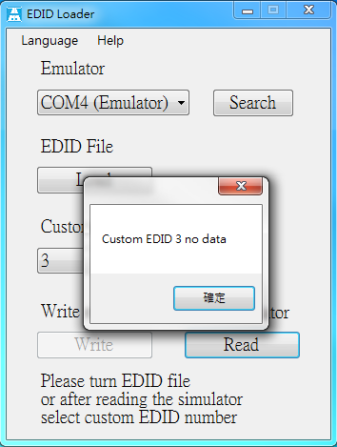

If there is no date in selected bank it will show message “Custom EDID x no data”

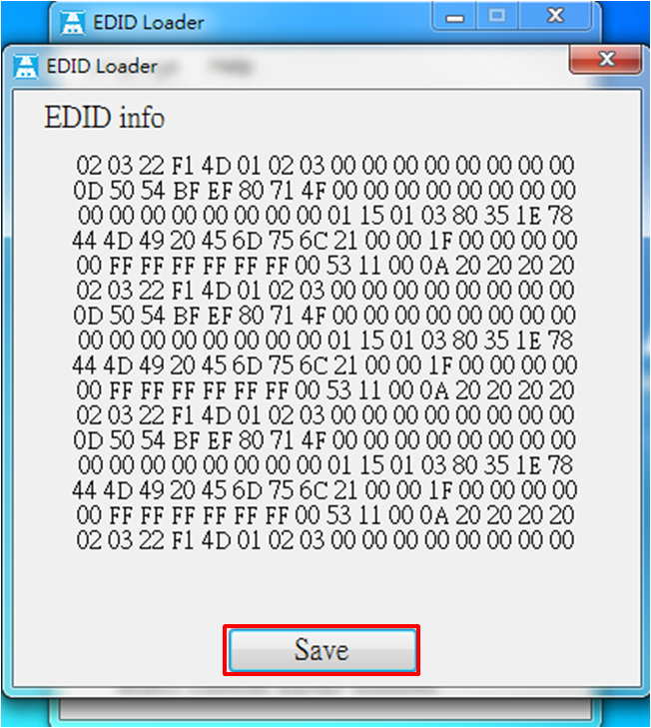

It will show EDID information after read, click 「Save」 to save to file
It will show save file windows as below

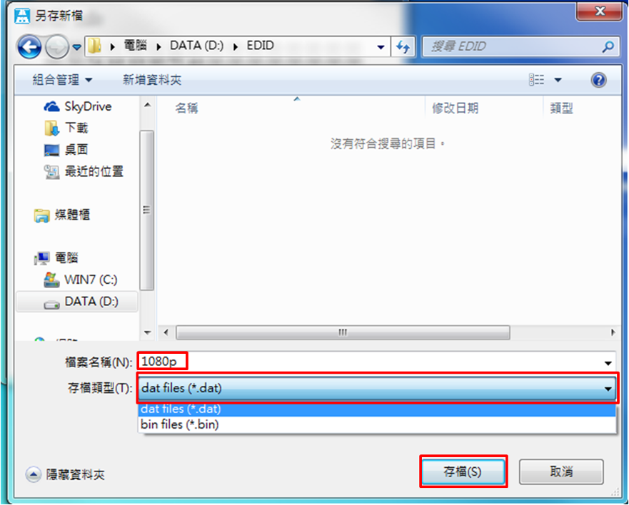

Key in the file name and select the format then click 「Save」

Select Language
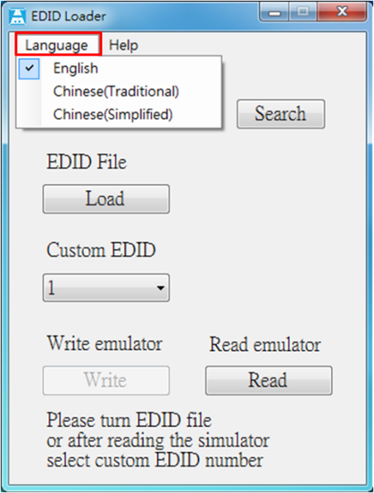
Click「Language」 to change English, Chinese Traditional and Chinese Simplified

EE01H Package Include:
EE01H x 1 pcs
CD x 1 pcs
Micro USB to DC jack cable x 1 pcs

Specification:

ITEM NO. | EE01H
Support Resolution | 4K x 2K (3840 x 2160@24、25、30Hz or 4096 x 2160@24Hz)
LED | LED x 2 (Green, Blue)
Video Input /Output | HDMI x 2
EDID Writing | Micro USB x 1
EDID Switch | 16 Rotary Switch x 1 (0~9 & A~F)
EDID Read/Write | Tact Switch x 1
Power Consumption | 1.7 W ( Max)
Power Adapter | DC 5V / 1A
Temperature | Operation: 0 to 55℃, Storage: -20 TO 85℃, Humidity: up to 95%
Dimension mm | 88 x85 x30 mm
Weight g | 185 g

Rev. A

