U S E R M A N U A L

1X4 HDMI 2.0 splitter 4K
(HDMI 2.0,HDCP2.2 ,4K,IR extension, EDID management, RS232)

Enjoy the vivid world !

INTRODUCTION

This 1x4 HDMI Splitter uses a single HDMI source,accessing to multiple HDMI sinks. It allows one HDMI device to be split easily to 4 HDMI compatible monitors or projectors. In addition，it can be placed at the end of a long HDMI cable to regenerate the HDMI signal. The resolution of this hdmi splitter can be up to 3840X2160/60Hz.
This product can support EDID management function, comes with eight kinds of EDID mode, the users can choose according to their own needs. In addition, this product is with built-in IR extension function, it can work with our hdmi 2.0 repeater which has IR-RX to receive the IR command to control the source

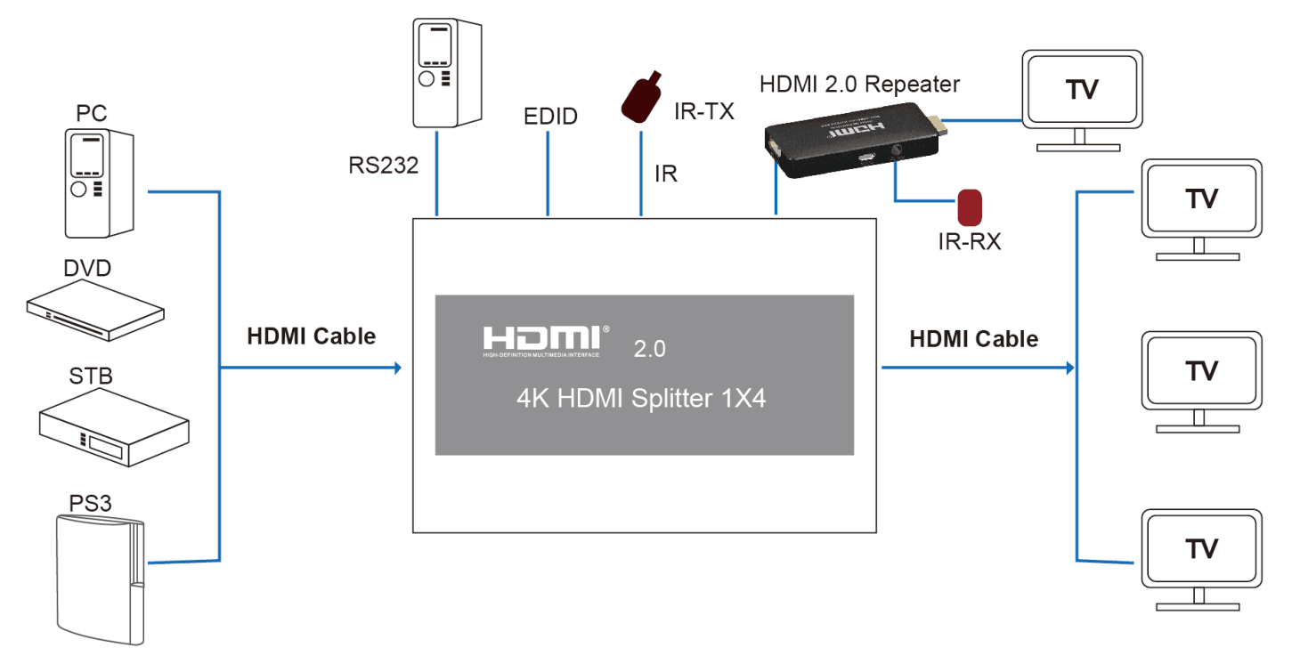

FEATURES
- Support HDMI 2.0 ,HDCP2.2
- Support 3D video format
- Support high resolution up to 3840X2160/60HZ
- Support the max baud rate of 6G and TMDS clock can be up to 600 MHz
- Support 8/10/12 bit deep color
- Support AWG26 HDMI standard cable:
when the resolution is 1080p and below, input up to 8 meters,output to 8 meters.
when the resolution is 4K, input up to 8 meters, output up to 8 meters.
- Support single HDMI source，accessing to multiple HDMI sinks, the source can be DVD player, A/V receiver, set top box and etc.
- Built-in IR extension function.（it can work with our hdmi 2.0 repeater which has IR-RX to receive the IR command to remote control the source)
- Support serial port online upgrade
- Support EDID management
- 5V/2A power adapter

Specifications:
HDMI version ………………………………………………………………………………. HDMI 2.0
HDCP version ……………………………………….……………………………………. HDCP 2.2
HDMI resolution ……………………………….. ……….. ……….. …………up to 3840*2160/60Hz
Support video format ………………………………..…………………………8/10/12bit Deep color
Support audio format………………..………. …….DTS-HD/Dolby-trueHD/DTS/Dolby-AC3/DSD
Max bandwidth………………………………………………………………………………….600MHz
Max baud rate……………….…….………………….…………………………………………..6Gbps
Input cable distance.…………………………….(1080p resolution) ≤8m,(4K resolution)≤8m AWG26 HDMI standard cable
Output cable distance…………………………(1080p resolution) ≤8m,(4K resolution)≤8m AWG26 HDMI standard cable
Max working current……………………………………………………………………………....1.4 A
Power adapter format………………….….input AC (50Hz, 60Hz) 100V-240V; output: DC5V/2A
Operating Temperature range……………………………..…………….………………(-15 to +55℃)
Dimension (L x W x H)………………...............…………..………………………. 220x75x24 (mm)
Weight…….…..………………………………………………………..…….……………………530g

Product photos
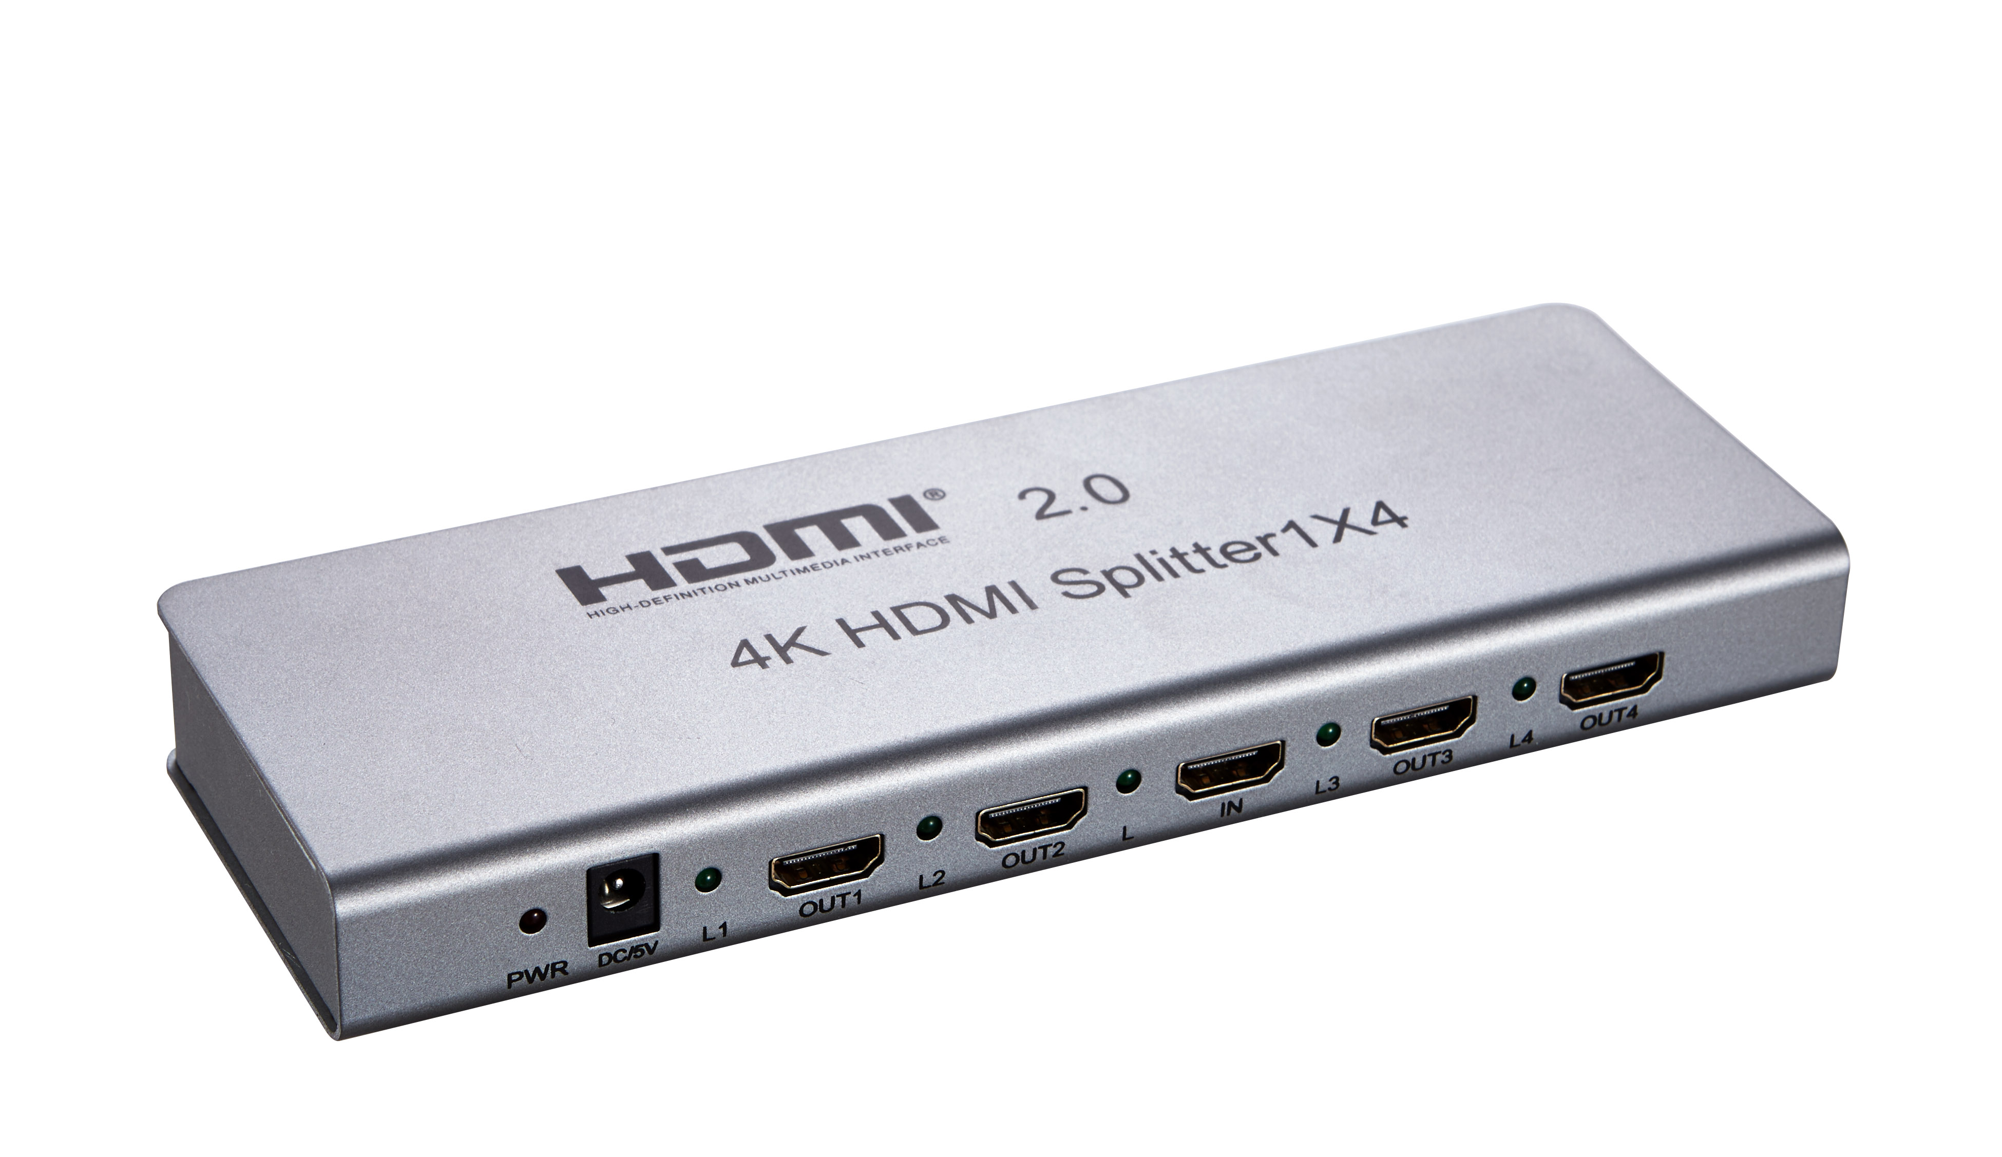

Product interface pictures
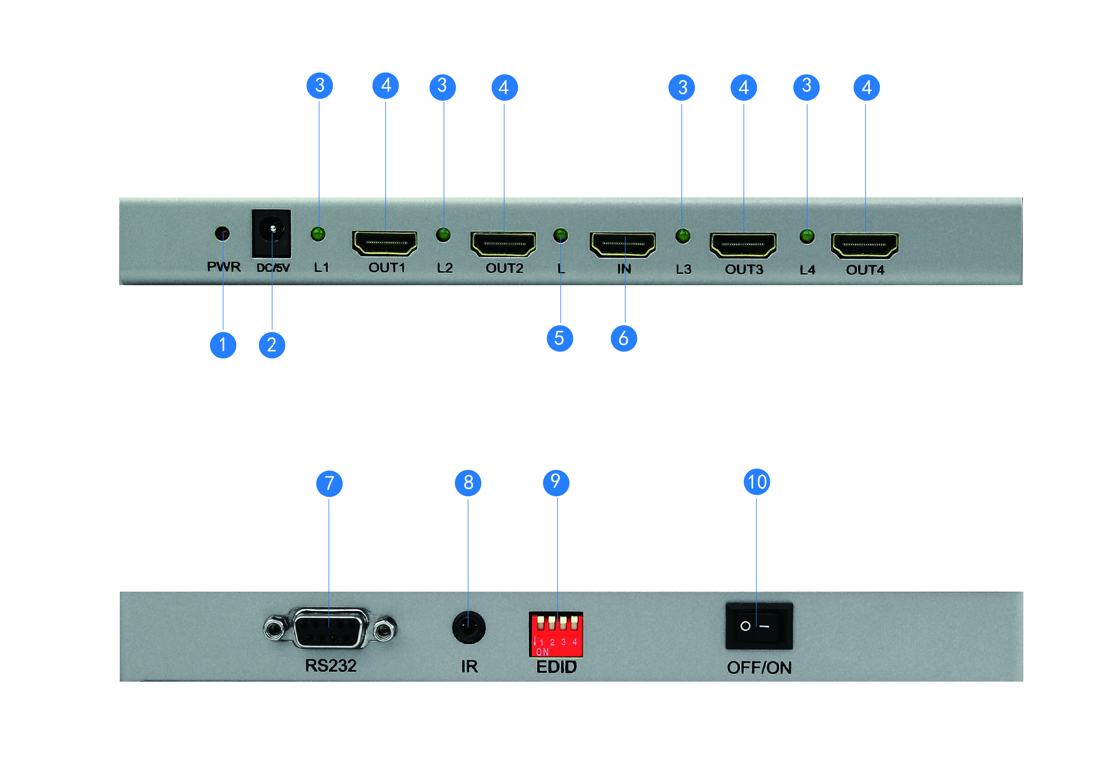

①：Power adapter indicator
②：5V Power Interface
③：LED Output indicator
④：HDMI output
⑤：LED Input Indicator
：HDMI input port
⑦：RS232 port,serial port online upgrade
⑧：IR TX Extension Interface
⑨：DIP switch，using for EDID management
⑩：Power switch

DIP EDID Switch Description：
DIP 1 2 3 4
X 0 0 0 ： copy output1 EDID only
X 0 0 1 : EDID MIX
X 0 1 0 : EDID Download (RS232)
X 0 1 1 : 4K X 2K 30HZ
X 1 0 0 : 4K X 2K 60HZ
X 1 0 1 : 1080P 3D 2ch
X 1 1 0 : 1080P 2D 2ch
X 1 1 1 : 1080P 2D 5.1ch
1 is used for upgrades, 1 is upgrading mode, 0 is normal working mode (switch down is 1, otherwise is 0)

Working Mode Description：
There are two working mode for product, normal working mode and upgrading mode, which is decided by DIP EDID switch 1, 1 is upgrading mode，0 is normal working mode.

IR Extension description：
There is an IR TX Extension port, it can be used with an optional HDMI 2.0 repeater which works as IR-RX and IR extended via HDMI cable

Output port:
Only output1 can support CEC function, output 2~4 support IR extension function

Connection and Operation:
1: connect the HD source to the splitter input with one hdmi cable
2: connect the splitter output to the diaplays with 4 hdmi cables
3: connect 5V/2A power adapter to the splitter

Package include :

1. HDMI splitter x1pc
2. Power adapter x1pc
3. User manual x1pc
4. IR cable x1pair
5. HDMI repeater (optional)

