HDTVST0401AU1
4K 4x1 HDMI Switch w/ Audio Extraction and EDID

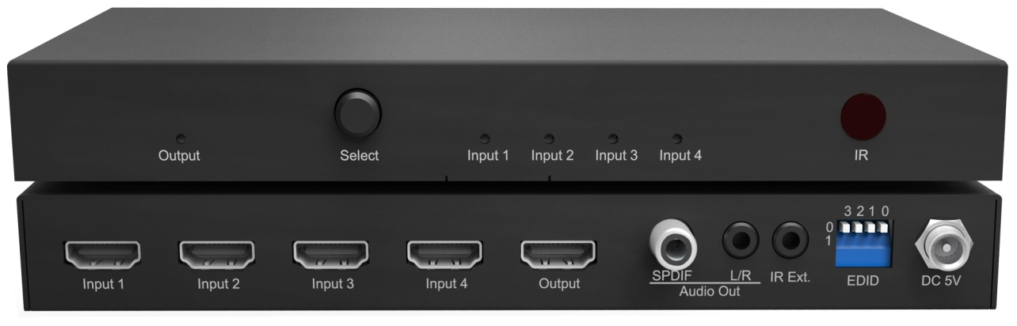

Thank you for purchasing this product. For optimum performance and safety, please read these instructions carefully before connecting, operating or adjusting this product. Please keep this manual for future reference.

SURGE PROTECTION DEVICE RECOMMENDED
This product contains sensitive electrical components that may be damaged by electrical spikes, surges, electric shock, lightning strikes, etc. Use of surge protection systems is highly recommended in order to protect and extend the life of your equipment.

Table of Contents

Introduction 4
Features 4
Panel Descriptions 5
Front Panel 5
Rear Panel 5
Remote Control 7
Application Diagram 7
Specifications 8
Package Contents 8
Maintenance 9
Warranty Policy 9
Limitations of Warranty 9
Exclusive Remedies 10
RMA Policy 10
Standard Replacement 10
Once you have obtained an RMA number 11
Please note: 11

Introduction
HDTV Supply WolfPack HDTVST0401AU1 4x1 Switcher for HDMI switches between any of four DVI or HDMI audio/video sources to one HDTV display, supporting 1080p Full HD up to 4K@30Hz UHD plus all 3D formats, along with multichannel digital audio formats such as Dolby® True HD and DTS-HD® Master Audio™. Embedded audio extractors can extract the audio and output via L/R and Coaxial.

Features
- Supports resolutions up to 1080p@60Hz, 4K@30Hz, 36-bit deep color
- Switches 4 HDMI sources to 1 output without loss
- Extract the audio from HDMI source via analog and digital outputs.
- Dolby TrueHD and DTS-HD master audio pass through HDMI output
- Advanced EDID management for rapid integration of sources and displays
- LEDs for power-on and inputs indication.
- Easy installation with rack-mounting ears
- Small compact size
- Full 3D pass- through.
- HDCP 1.4 compliant

Panel Descriptions

Front Panel
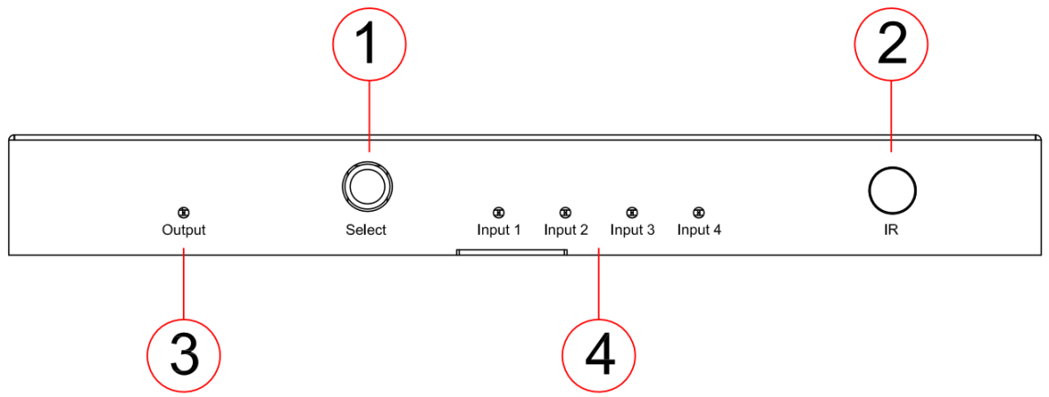
- Input selection push button - Push to select any of the four inputs.
- IR receiver window - Window for receiving remote control signal.
- Output LED indicator - Indicate the status of the output for the unit.
- Input LED indicator - Indicate the status of the inputs for the unit.

Rear Panel
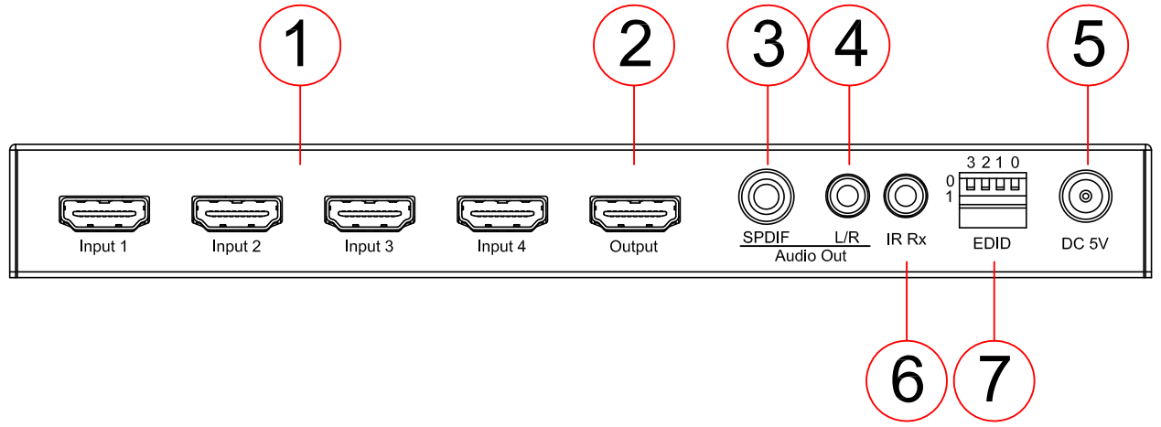
- HDMI inputs 1 to 4 - Connect to HDMI sources.
- HDMI output - Connect to display.
- Coaxial audio out - RCA connector, extract audio from HDMI input.
- L/R audio out - 3.5mm stereo phone-jack, extract audio from HDMI input, will mute if multichannel audio
- Power port - Use the included 5V/1A DC adaptor to power the unit.
- IR receiver port - connect with IR receiver cable for IR remote control extension
- DIP switcher - EDID management.
[DIP]=0000: Copy EDID From Output1
[DIP]=0001: HDMI 1080p@60Hz, Audio 2CH PCM
[DIP]=0010: HDMI 1080p@60Hz, Audio 5.1CH PCM/DTS/DOLBY
[DIP]=0011: HDMI 1080p@60Hz, Audio 7.1CH PCM/DTS/DOLBY/HD
[DIP]=0100: HDMI 1080i@60Hz, Audio 2CH PCM
[DIP]=0101: HDMI 1080i@60Hz, Audio 5.1CH PCM/DTS/DOLBY
[DIP]=0110: HDMI 1080i@60Hz, Audio 7.1CH PCM/DTS/DOLBY/HD
[DIP]=0111: HDMI 1080p@60Hz/3D, Audio 2CH PCM
[DIP]=1000: HDMI 1080p@60Hz/3D, Audio 5.1CH PCM/DTS/DOLBY
[DIP]=1001: HDMI 1080p@60Hz/3D, Audio 7.1CH PCM/DTS/DOLBY/HD
[DIP]=1010: HDMI 4K2K, Audio 2CH PCM
[DIP]=1011: HDMI 4K2K, Audio 5.1CH PCM/DTS/DOLBY
[DIP]=1100: HDMI 4K2K, Audio 7.1CH PCM/DTS/DOLBY/HD
[DIP]=1101: DVI 1280x1024@60Hz, Audio None
[DIP]=1110: DVI 1920x1080@60Hz, Audio None
[DIP]=1111: DVI 1920x1200@60Hz, Audio None

Remote Control
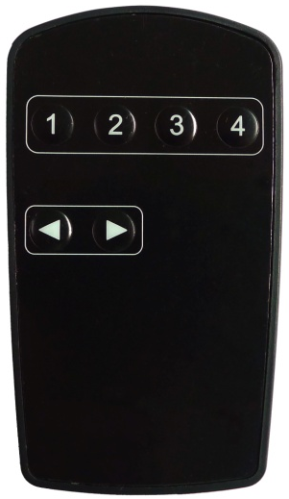
2
1
- Source selection buttons for input 1-4.
- Source cycle buttons for select last/next source.

Application Diagram
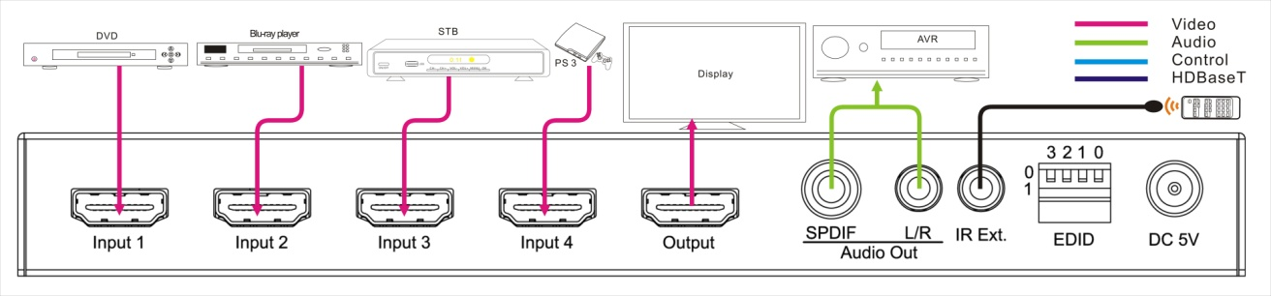

Specifications
Bandwidth | 2.97Gbps per color
Video Input Connectors | 4x HDMI Type A, 19-pin, female
Video Output Connectors | 1x HDMI Type A, 19-pin, female
Audio Output Connectors | 1x RCA(S/PDIF), 1x 3.5mm stereo jack (L/R)
EDID | 4-PIN DIP Switch
Mounting kit | Rack-mounting ears included
Dimensions (W x D x H) | 196mm x 80mm x 22mm, without feet
Shipping Weight | 0.4KG
Operating Temperature | 32°F to 104°F (0°C to 40°C)
Storage Temperature | - 4°F to 140°F (- 20°C to 60°C)
Power Supply | 5V/1A DC

Package Contents
  - 1x HDTVST0401AU1
  - 1x 5V/1A DC Power Supply
  - 1x Remote Control
  - 1x IR Receiver Cable
  - 1x small mounting Ears

Maintenance
Clean this unit with a soft, dry cloth. Never use alcohol, paint thinner or benzene to clean this unit.

Warranty Policy
HDTV Supply includes a 5 Year U.S. Limited Extended Warranty on this product. There are two bundled parts to this 5 year warranty. The 5 year warranty is only for the main device you purchased and does not include any product options or additional products you purchased at the same time.

FIRST YEAR: The first year is direct with HDTV Supply at 800-841-9238. The warranty states that the Product will perform substantially in accordance with the supplied written materials and Product information located on this Product web site page for a period of 1 year from the date of shipment of the Product and that the Product will be free from defects in materials & workmanship under normal use & service for a period of 1 year from date of shipment.

In order to get a warranty replacement for a defective item within the first-year call HDTV Supplys Tech Support Team with your order number at 800-841-9238 and they will verify the product is eligible for a warranty repair. An RMA number will then be issued via email. Shipped replacements will be in like new condition, tested and all components included.

2ND THROUGH 5TH YEAR: The 2nd through 5th year are direct with Consumer Priority Extended Warranty Service (CPS) as they are HDTV Supplys extended warranty provider. They are a large 3rd party repair company with facilities throughout the U.S. and offer our U.S. customers unparalleled product coverage and repairs. If after calling HDTV Supply, at 800-841-9238, we find we can't fix the issue over the phone, and you need a repair, you will henceforth deal directly with CPS for the repairs via their toll free phone number (800) 905-0443 Option 3 during the 2nd through 5th year.

You can call us at 800-841-9238 if you have any questions with this 5 year bundled warranty.

Exclusive Remedies
HDTV Supplys warranty, as stated is in lieu of all other warranties, expressed, implied, or statutory, including those of merchantability and fitness for a particular purpose. The buyer shall pass on to any purchaser, lessee, or other user of HDTV Supplys products, the warranty, and shall indemnify and hold harmless HDTV Supply from any claims or liability of such purchaser, lessee, or user based upon allegations that the buyer, its agents, or employees have made additional warranties or representations as to product preference or use.

The remedies provided herein are the buyer’s sole and exclusive remedies. HDTV Supply shall not be liable for any direct, indirect, special, incidental, or consequential damages, whether based on contract, tort, or any other legal theory.

Please note

Product shipped to HDTV Supply must be properly packaged to prevent loss or damage in transit.

Shipping your RMA to HDTV Supply using regular mailing envelopes is not acceptable, as they do not protect the product from damage during shipping.
HDTV Supply will not repair or replace a module that is shipped in such a way that the product is not properly protected.
HDTV Supply will not accept any product that has been damaged as a result of accident, abuse, misuse, natural or personal disaster, or any unauthorized disassemble, repair or modification.

