**HDTV SUPPLY MATRIX SWITCH USER MANUALS**

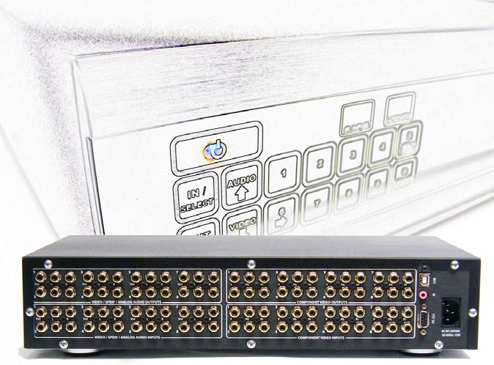

User Manual

**Table of Contents**

**Table of Contents ........................................................................ 2**

**Introduction.................................................................................. 4**

Model Specific Features.............................................................................. 6

**Installation.................................................................................... 7**

**Unpacking....................................................................................................... 7**

**Mounting Requirements................................................................................ 7**

**CAT5 Installation .......................................................................................... 7**

CAT5 Cable Pin-Outs ................................................................................. 7

Grounding Requirements ............................................................................ 7

**Inputs and Outputs........................................................................................ 8**

Notes on I/O Signals ................................................................................... 8

**Operation.................................................................................... 9**

**Overview....................................................................................................... 9**

**Front Panel Control..................................................................................... 9**

**IR Remote Control....................................................................................... 10**

Discrete IR Codes ..................................................................................... 10

Dual Function Keys .................................................................................. 11

**Power............................................................................................................. 11**

Via Front Panel ......................................................................................... 11

Via IR Remote .......................................................................................... 12

Standby Mode ........................................................................................... 12

**Signal Routing Using the Front Panel or IR ............................................. 12**

**Matrix Status................................................................................................ 13**

**Matrix Setup Menu...................................................................................... 13**

Setup Menu Items ..................................................................................... 14

**Volume & Tone Control.............................................................................. 14**

Muting....................................................................................................... 15

**Memory Feature........................................................................................... 15**

**Restoring Factory Defaults ......................................................................... 15**

**Serial Protocol ........................................................................... 16**

**Serial Port Settings ...................................................................................... 16**

**Legacy Protocol............................................................................................ 16**

**Commands Overview................................................................................... 16**

**Common Structures and Syntax................................................................. 16**

**Group Commands........................................................................................ 17**

**Command Delays ......................................................................................... 17**

**One-way Commands.................................................................................... 17**

**Response to Commands............................................................................... 17**

**Errors ............................................................................................................ 18**

**Switching Protocol ....................................................................................... 18**

Command Types or Modes ....................................................................... 18

Audio Transition Time.............................................................................. 19

Volume Only Commands.......................................................................... 19

Serial Control Examples ........................................................................... 20

**Memory Protocol ......................................................................................... 20**

Memory Edit ............................................................................................. 21

**Setup Protocol .............................................................................................. 21**

**Power Control .............................................................................................. 22**

**Query Commands ........................................................................................ 22**

**USB Driver Installation.............................................................. 23**

**USB COM Port Settings.............................................................................. 31**

**Uninstalling the USB drivers ...................................................................... 32**

**Care and Maintenance .............................................................. 32**

**Specifications ............................................................................ 33**

**Performance ................................................................................................. 33**

**Power............................................................................................................. 33**

**Physical ......................................................................................................... 33**

**2 Year Warranty ......................................................................... 34**

**HD Video / Audio Matrix Switches**

Introduction

Congratulations on your purchase of the audio/video matrix switch. The family of matrix switches features component video and both analog and digital audio signal routing with a variety of features, including:

**System Control**

* Serial control via RS232 or USB ports
* IR control via front panel sensor or “wired” (back panel)
* Independent routing of all signal types
* 16 memory locations to store switch configurations and volume/bass/treble levels
* IR discrete code control for volume up, down, and mute for all outputs. Two-code discrete IR command for switching

**Audio Controls** (for models with Analog Audio)

* Volume, Bass, and Treble levels
* Variable duration volume fade up/down
* Volume muting

**High Definition Video** (for models with Component Video/YPbPr)

* Component video (YPbPr) section bandwidth is 140 MHz for 1080p

**Digital Audio**

* Digital audio via SPDIF can also be used for standard video (480p) signals through COAX
* Models that have TOSLINK inputs and outputs are switched together with SPDIF

**Pass-through Outputs**

* The pass-through connections are high bandwidth buffered copies of all the input signals, before the matrix switch
* These pass-through can be used to connect to an additional matrix, adding another 8 outputs
* Up to 12 switches can be stacked to create a full non-blocking 12x96 matrix

All models have an attractive enclosure with brushed aluminum and high gloss acrylic front, and a black top cover. Connectors are gold plated for maximum signal quality and resistance to corrosion.

**Installation**

***Unpacking***

The matrix ships with the following:

1 AC Power cord

1 6 ft. (1.82 m) USB cable

1 6 ft. (1.82 m) RS-232 cable

1 Integrator’s Guide (manual)

1 CD-ROM driver disc

1 Pair of rack mounts ears with screws

Optional: IR remote control

There is a clear film to protect the front panel. To ensure proper touch panel response, remove this film before use.

***Mounting Requirements***

The matrix switch has cooling vents on the sides that must not be covered. Other equipment may be stacked on top of it. It has padded feet, so the matrix may stacked on top of other equipment without causing damage. For rack mounting (2U height), remove the padded feet.

***CAT5 Installation***

**!IMPORTANT!**

**READ BEFORE INSTALLING ANY CABLES**

When installing CAT5 cables to the matrix or the baluns, remove the AC supply to the unit. The CAT5 circuit supplies 24Vdc from the matrix and the in-wall baluns have an exposed circuit board that may be damaged if accidently shorted during mounting.

***CAT5 Cable Pin-Outs***

**!CAUTION!**

Before connecting CAT5 cables, make sure the wire pairs are terminated as shown in Fig.1 and the table below. Do not use any other type of CAT5 balun with the matrix, as they may cause damage to the matrix and the baluns, which is not covered by the warranty. The common standards known as 568A and 568B are electrically equivalent (only the color coding of pairs is different).

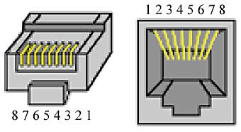

Fig. 1: CAT5 RJ45 connector pin outs

|  |  |  |
| --- | --- | --- |
| **Pin** | **Video Signal Pairs** | **Audio Signal Pairs** |
| 1 | +Y | + Digital audio |
| 2 | -Y | - Digital audio |
| 3 | +Pb | + Left (analog) |
| 4 | 24 Vdc | 24 Vdc |
| 5 | 24 Vdc return | 24 Vdc return |
| 6 | -Pb | - Left (analog) |
| 7 | +Pr | + Right (analog) |
| 8 | -Pr | - Right (analog) |

* The 24 Vdc return is not connected to “ground” or “common”.

***Grounding Requirements***

The CAT5 matrix switches (using baluns) are designed to operate with CAT5 cable runs up to 1000 ft. (305 m). The Hornet uses a patented automatic gain circuit to achieve true high definition video. For best performance, either the TV or the Hornets should be grounded. A TV with a three wire AC plug meets this requirement, but if the TV has a two wire plug, you must ground the balun directly to the AC Outlet.

***Inputs and Outputs***

All signal and control connectors are on the rear panel. All signals are low voltage, but we still recommend removing AC power from the matrix when making the connections (connect AC power last).

|  |  |
| --- | --- |
| **Connector Labels** | **Signal type(s)** |
| Y, Pb, Pr | High definition component video inputs and outputs |
| L, R | Analog audio, stereo Left & Right inputs and outputs |
| D, Vid | Composite video or SPDIF digital audio inputs and outputs |
| Optical Digital Audio Inputs | Digital Audio inputs via optical cable (TOSLINK) |
| Spdif Digital Audio Inputs | Digital Audio inputs via RCA cable (SPDIF) |
| Digital Audio Outputs | Digital Audio outputs via optical and RCA cables |
| Pass-Through Outputs | Used for stacking another matrix switch to increase output zones |
| IR | Input for unmodulated IR control signal via 3.5mm 2 conductor plug (tip = signal)* |
| RS232 | Serial port for control |
| USB | USB port for control. Software is provided to setup USB as a virtual serial port. See the Serial Protocol and USB Driver Installation section of this manual |
| AC 90-240VAC | AC power input (50-60Hz) via IEC320 appliance inlet. Connect last, after all I/O cables |

*Some IR repeater systems are designed to work only with their own IR blasters, and a common “workaround” is to cut these blaster cables and add a 3.5mm plug on the end. In some cases, repeater systems will have noise that prevents signals from being decoded.

***Notes on I/O Signals***

**HD Video Quality & Cable Length**

On Coax/RCA output models, the maximum length of cable to each zone will vary on the quality of the cable. High quality quad-shielded RG6 cables can support zones 300 feet away. For Cat5 output models, standard Cat5 or Cat5e is preferred for runs up to 1,000 feet.

**RS-232 Details**

The serial port is wired as a DCE device, and should be connected to a computer’s RS-232 port with a straight through cable. Connection to most control systems should be with a straight through type serial cable, such as the cable provided with the matrix switch. For the command protocols, see the Serial Protocols section of this guide.

**Operation**

***Overview***

The matrix can be controlled via IR (built in sensor or wired input on rear panel) and serial port (RS232/USB). 8x4 or 8x8 matrices (Fig.2) can also be controlled via the front panel. 8x16, 12x8 or 12x16 matrices cannot be switched via the front panel, so they have a slightly different front panel button set (Fig.3).

***Front Panel Control***

The front panel uses  technology, which senses a human finger touching the panel without any moving parts. When pressed, a button will be illuminated. The front panel configurations are shown in Figs.2-3 below.

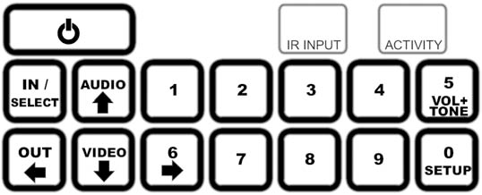

Fig. 2

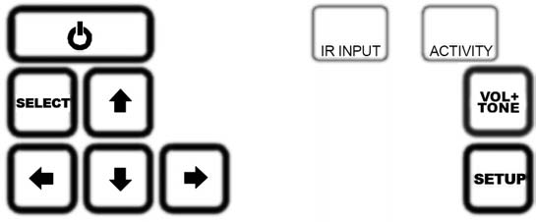

Fig. 3

The **IR INPUT** indicates the location of the IR sensor.

The **ACTIVITY** LED blinks when a command was received in serial, whether valid or not. It also blinks for every valid IR pulse received by the sensor.

***IR Remote Control***

Figure 4 shows the layout of the IR Remote. Controlling the matrix switch via the rear IR jack is the same as using the IR Remote.

***Discrete IR Codes***

Discrete IR Codes allow you to minimize IR codes sent from program macros when doing switching and volume commands. There are discrete codes for volume up, down, and mute for each output. To use the discrete codes, first send the IN# then the OUT#, or the single IR code for each volume function desired. Discrete codes for switching are limited to switching all levels at the same time. For further information on programming of remotes and control systems, you may download the discrete IR codes (HEX format) from our website:

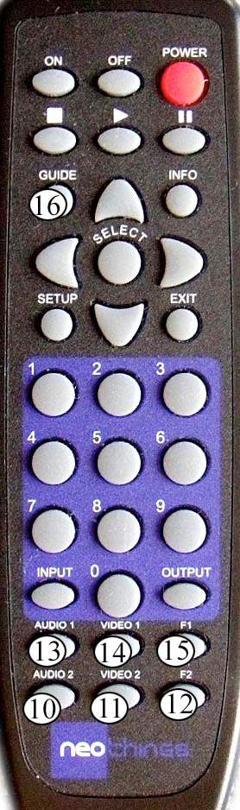

***Dual Function Keys***

For selections greater than 9, dual purpose keys are used. In Fig.4, they are shown as circles with number values:



The numbers are not marked on the actual remote.

For example, on a 12x8 matrix, to choose input number 12, you would press (or use the IR code) for the **F2** key.

***Power***

***Via Front Panel***

A single touch of the power button turns the unit on. To prevent an accidental power down, two button presses are required to shut down the matrix (places matrix into Standby Mode).

***Via IR Remote***

There are three power buttons on the IR remote.

Power Toggle – Changes power state from current state

Power On – Always turns on, regardless of current state

Power Off – Always goes to standby, regardless of current state

***Standby Mode***

When in Standby Mode, all outputs are virtually disconnected, and volumes are set to 0. At this state, the switch can still execute commands from the serial port, just in case your control system or remote did not turn it on first. It will appear to stay in the standby state however even if routes are completed.

In Standby, any command received will not be saved. Thus, when the switch is powered back on, the most recent switch state and volume levels before the unit is powered off will be reloaded.

***Signal Routing Using the Front Panel or IR***

When powered on, three buttons are enabled to start a switching command. The basic routing sequence for audio and/or video uses 4 button sequences. The panel will not allow you to select inputs or outputs that do not exist.

The input number is ***x*** and the output number is ***y***.

|  |  |
| --- | --- |
| **Routing Function** | **Key Sequence** |
| Switch video and audio from input x to output y | INPUT x OUTPUT y |
| Switch input x to all outputs | INPUT x OUTPUT 0 |
| Disconnect output y | INPUT 0 OUTPUT y |
| Switch component video x to output y | VIDEO1* x OUTPUT y |
| Switch composite video x to output y | VIDEO2 x OUTPUT y |
| Switch analog audio x to output y | AUDIO1** x OUTPUT y |
| Switch digital audio x to output y | AUDIO2 x OUTPUT y |

*In front panel, this is labeled as VIDEO

**In front panel, this is labeled as AUDIO

***Matrix Status***

To view the connection status of the matrix inputs and outputs, use the and arrows. The front panel display steps through the output channels, and is formatted to indicate the status of all signals as follows:

< Output 1 >

V12 D01 A09 C00

The top line displays the output number, and the bottom line lists the inputs that are currently connected to that output. Signal types are coded:

V indicates HD signals (Component Video YPbPr)

D indicates Digital Audio signals

A indicates Analog (L/R) Audio

C indicates Composite Video

In some cases, the input numbers may be different, indicating that audio and video have been switched separately. To view another output status, use the left and right arrow keys as needed.

Although the display shows routing status for 4 levels of switching, not all switches have all of these signals. In these cases, just ignore the extra information.

Use the Power or Exit Button to exit. The status display will close automatically after a 30 second period where no buttons pressed.

***Matrix Setup Menu***

|  |  |
| --- | --- |
| **Setup Viewing and Modifications** | **Key** |
| Enter the setup menu | SETUP |
| Step through the setup menu tems. Going to the next item auto-saves and immediately applies any changes made to the item | ↑ and ↓ |
| Modify the setup item | ↑ and ↓ |
| Closes the setup menu without saving changes | POWER or EXIT |
| Save changes to the setup item and exit | SELECT |

***Setup Menu Items***

|  |  |
| --- | --- |
| **Setup Item** | **Description** |
| SET: Panel LED | Controls the entire front panel LEDs. Default is ON. |
| SET: Disp Lamp | Sets the display brightness to 1 of 4 levels. Default is 100% (full brightness). |
| SET: AC PowerUp | Controls what the matrix does when AC power is first applied, and how it recovers from a power outage. ON (default) forces the unit to turn on, and the previous switch state will be restored. STANDBY causes the unit to enter Standby mode when AC power is applied. |
| SET: Touchpanel | Enables or disables the front panel buttons. Default is ON (enabled). |
| SET: Touchsense | Controls the sensitivity of the front panel buttons. Default is HIGH for fastest front panel response. A lower setting reduces the risk for accidental button pushes or false triggers by outside interference. |
| SET: Front IR | Enables or disables the front panel IR sensor. Set to OFF to prevent spurious IR signals from controlling the matrix. Default is ON (enabled). |
| SET: Verbosity | Default is ON, where the matrix echoes responses to any command (via serial, IR, or front panel). When set to OFF, the matrix only echoes responses to serial commands.  Note: Memory commands and mute commands will always echo serial responses, regardless of this setting |
| SET: Volume Preset | “SET TO 100%” will set all analog volumes to 99. This option is for integrators who don’t want to use the Volume and Tone feature. Note: The USE CURRENT option will not change any of the volume settings. |

***Volume & Tone Control***

The volume control ranges from 0 to 99. At level 99, the output level equals the input level for a unity gain. For bass and treble, 50 is used for a “flat” frequency response. Maximum is 99 and minimum is 00.

|  |  |  |
| --- | --- | --- |
| **Audio Control** | **Front Panel Key** | **IR Remote Key** |
| Enter volume menu | VOL+TONE | INFO |
| Scroll through the output numbers or zones | and | and |
| Scroll through Volume, Bass, and Treble settings | SELECT | SELECT |
| Change level setting. Real-time update. Value is auto-saved | ↑ and ↓ | ↑ and ↓ |
| Exit volume setup menu | VOL+TONE | EXIT |

**Note:** Any volume change will un-mute that current output.

***Muting***

There are two types of muting available from serial control:

* Absolute Mute (M0) mutes the output to volume level 0.
* Partial Mute (MP) mutes the output to 10% of the current volume.

Using IR discrete codes, there is only absolute mute available.

Mute is a toggle command, use the exact same command to mute or un-mute any output. Any volume change will also un-mute any muted output.

***Memory Feature***

This feature stores current state of the matrix to a non-volatile memory to minimize macro programming. There are 16 available memory locations designated 1-16. When using the IR remote, use the dual purpose keys as shown

in Fig.4 to access memory slots 10-16.

To store the current state of the matrix to memory location *x*:

***x***

To recall from a memory location *x*:

***x***

***Restoring Factory Defaults***

This sequence initializes the matrix switch, sets everything to default and clears the memory. **All stored information will be lost—use with caution!**

* Using the power switch, place the matrix in the Standby mode.
* Carefully enter the sequence **0 0 7**.

The display should say “Initializing…” and automatically power on.

**Serial Protocol**

***Serial Port Settings***

The serial port operates at 115.2k baud, no parity, 8 data, 1 stop. No hardware flow control is used.

***Legacy Protocol***

Some of the models covered in this manual support legacy serial control codes. It should not be necessary to modify or port your code to the new protocol as long as the model being replaced is the same model name and configuration. The legacy codes are described in each of the respective products serial manual, available at: www.neoprointegrator.com

***Commands Overview***

Commands are structured so that a control program has two-way communication with the matrix. The control system can confirm and store the state of the matrix switch. These commands are also human readable ASCII text, which will help in troubleshooting and testing.

The matrix may also be controlled with one way serial communications.

All models have the ability to switch audio and video separately. Thus matrix looks like several independent switches. These “levels” are also called Command Types.

***Common Structures and Syntax***

Commands are not case sensitive. Upper and lower case characters are used in this manual, but have the same effect.

Numbers are 1 or 2 digits, (leading zeroes not required).

Spaces are not permitted within the square braces—they will generate an error. **Bold font** is used to indicate actual code that is entered or displayed. *Italics* are used to describe the contents, but are not actual code.

A command is always wrapped in square braces:

*[command]*

It is not necessary to follow the command by any carriage returns or other special characters. The closing brace will trigger the switch to process the command.

The switch will only attempt to process a command between matching [ ] braces, so any characters before and after the braces is discarded. If there are invalid characters/values/command between the braces, they will be processed, and the switch will echo the bad command and return an error **[E]**.

Within a command or response, there will be one or more fields, separated by commas:

**[BV,1,2]**

***Group Commands***

A group command is always wrapped in curly brackets:

*{[command1][command2][command3]}*

Group commands are used if the user wants to see one response per command mode inside the group brackets. So if there are two volume commands in one group bracket, there will only be one volume response.

Group commands are also used for memory edit function, this will be discussed later.

***Command Delays***

Delays are not required between individual commands or group commands when sending up to 32 commands at a time to the matrix switch. For more than 32 commands, wait 500ms before sending.

***One-way Commands***

One-way commands, (where there is no programming that depends on feedback) can be sent to the matrix at any time, regardless of the state of the matrix (e.g. on Standby mode).

***Response to Commands***

The serial port does not echo characters sent, except when an invalid command is sent. When a valid command is received and executed, code indicating the status of the entire matrix pertaining to the received command is returned. The contents depend on the type of command and the model.

The response will be in curly brackets **{ }**, like in a group command, and can be used as a command back to the matrix or be used as an input to memory edit function.

***Errors***

Any command with invalid parameters or a syntax error will result in a response of:

**[E]**

***Switching Protocol***

**Note:** Some NeoPro matrix switch models do not have all these features and will display the error **[E]** response when such a command is received. Refer to the Model Specific Features section for details.

Switching commands use this structure

***[mc,i,o,t]***

***m*** is the first letter of the model name (refer to Model Specific Features section)

***c*** is the Command Type or Mode

***i*** depends on the Command Type:

For switching ***i*** is the Input number. Input 0 will disable the selected output zone. For **L**, **B**, and **T** (Volume, Bass, Treble commands) ***i*** is a value from 0-99.

***o*** is the Output number (0 to maximum number of outputs). Output **0** sends the selected input to all output zones (Party Mode).

***t*** is time in seconds

Optional for delays and fades, ignored in **B** & **T** Commands.

***Command Types or Modes***

**X** switches All A/V Signals

**V** switches High Definition Video (YPbPr)

**D** switches Digital Audio (SPDIF)

**A** switches Analog Audio (L/R stereo)

**C** switches Composite Video

**L** sets the Volume Level

**B** sets the Bass Level (***i*** values from **0** to **99)**. Flat response = **50**. Greater values for boost and less than 50 to attenuate.

**T** sets the Treble Level (***i*** values from **0** to **99).** Flat response = **50** Greater values for boost and less than 50 to attenuate.

***Audio Transition Time***

The time parameter, fourth parameter in a command, is used to smooth transitions between volume levels. It may be used to minimize “pop” or sudden noises when switching audio sources.

For Volume:

**[BL,99,1,10]**

This command will have a smooth transition from current volume to 99 within 10 seconds.

For Switching:

**[BX,2,1,10]**

This command will fade the volume in output 1 to 0 in 5 seconds, switch video and audio from input 2 to output 1, and fade the volume back to current in 5 seconds.

For V, D, and C commands, the volume will not fade but instead delay for half the time parameter before it switches.

B, and T commands are not affected by transition time and will be executed immediately.

For lower volumes, the matrix switch will not wait for the time to expire, which means switching can happen faster once the target volume is reached.

***Volume Only Commands***

Please check the Features section to ensure your NeoPro model has this feature.

These commands only affect analog audio. The Volume command format is:

***[mL,f,n]***

***m*** is the first letter of the model name (refer to Model Specific Features section)

***L*** indicates volume command mode

***f*** is the specific function

**M0** for absolute mute

**MP** for partial mute

**U** to increase volume by one

**D** to decrease volume by one

***n*** is the output number

***Serial Control Examples***

Here are a few examples of serial control code:

**[BV,1,2]**

8x8 HD AV matrix: Switches HD Video input 1 to output 2

**[GX,0,0,3]**

8x16 AV matrix: Disable all outputs in 1.5 seconds

**{[LL,99,1][LB,99,1][LT,99,1]}**

12x8 AV P/T matrix: (Group) Set volume, bass, and treble to 99 for output 1

**[RL,M0,0]**

12x16 AV CAT5: Mute (absolute) all outputs

***Memory Protocol***

Memory functions enable the user to store, recall, view, and edit switch configurations. There are 16 memory locations available, designated 1-16.

The Memory Command structure begins with **M**:

***[M,x,n]***

|  |  |  |
| --- | --- | --- |
| **x** | **n (memory location)** | **Memory Function** |
| S | 1 -16 | Store current state to memory location n |
| R | 1 -16 | Recall memory location n |
| V | 1 -16 | View memory location n via serial |
| C | 1 -16 | Clear memory location n |
| E | 1 -16 | Edit memory location n |

Memory function stores volume, bass, and treble values, and all input-output combinations in the matrix switch. Fading time cannot be stored in memory using memory store. Instead, the user can use memory edit function to store the time field.

For a paging setup example, do the following:

* Save the current matrix configuration
* Switch all outputs to input 1, set all volumes to 99
* Restore the saved configuration once the paging is done

The macro for this sequence is:

**[M,S,1]**

**{[BA,1,0][BL,99,0]}**

**[M,R,1]**

***Memory Edit***

Memory edit allows the user to modify the contents of a memory slot. To do this, send the memory edit command then send a group command:

*[M,E,n]*

*{ [ ] [ ] [ ] [ ] }*

***n*** is the memory slot to edit

For this code format, note:

* These commands will be stored in the memory location, but will not be executed.
* The memory edit function only accepts switch commands, including volume & tone commands.
* The commands can contain a time parameter, as used for audio transitions.
* While memory edit command is active invalid code inside a group bracket **{ }** will be ignored.
* Commands after the closing bracket will be treated as normal commands.
* If no opening bracket is detected right after invoking the memory edit command, the program will exit the memory edit function without saving anything to the designated memory location.

***Setup Protocol***

Setup commands have 3 parameters:

***[S,x,n]***

***S*** invokes the Setup function

* The table below lists values for ***x*** and ***n*:**

|  |  |  |  |  |
| --- | --- | --- | --- | --- |
| **x** | **n** | **Setup Function** | | |
| L | 0 | Led OFF | | |
| **x** | **n** | | **Setup Function** |
| L | 1 | | Led ON |
| R | 0 | | IR OFF |
| R | 1 | | IR ON |
| B | 0 | | Front Panel Buttons OFF |
| B | 1 | | Front Panel Buttons ON |
| V | 0 | | Verbosity OFF |
| V | 1 | | Verbosity ON |
| D | 25 | | Display Brightness 25% |
| D | 50 | | Display Brightness 50% |
| D | 75 | | Display Brightness 75% |
| D | 100 | | Display Brightness 100% |
| S | L | | Front Panel Sensitivity LOW |
| S | M | | Front Panel Sensitivity MEDIUM |
| S | H | | Front Panel Sensitivity HIGH |
| A | 0 | | On Power Up – STANDBY |
| A | 1 | | On Power Up – ON |

***Power Control***

The power ON command is:

**[P,1]**

The power OFF command is:

**[P,0]**

***Query Commands***

***x*** is the first letter of model name. Responses are in **{ }** brackets.

|  |  |  |
| --- | --- | --- |
| **Command** | **Result** | **Notes** |
| [?V] | Firmware version |  |
| [?P] | Power status |  |
| [?S] | Setup values |  |
| [?x] | All matrix state | x is first letter of model name |
| [?xV] | Component/HD (YPbBr)matrix state | Video matrices only |
| [?xV] | Digital audio matrix state |  |
| [?xA] | Analog audio matrix state |  |
| [?xC] | Composite video matrix state |  |
| [?xL] | Audio Volume levels |  |
| [?xB] | Bass levels |  |
| [ | T |  |

Responses can be re-used as input back to the matrix switch. Queries only respond to valid command types and levels.

**USB Driver Installation**

When using the USB port, the matrix switch will be installed as a virtual COM port. This means that any control program capable of controlling a device through a normal serial port should be able to control the matrix through a USB port.

This driver set is for all versions of MS Windows. Linux and Mac drivers can be made available upon request.

The following steps are for Windows XP, but other versions of Windows are similar.

Step 1 – Connect the USB cable to the matrix and controlling computer.

Windows will detect the new hardware, and launch the plug and play wizard.

Step 2 – Found New Hardware Wizard

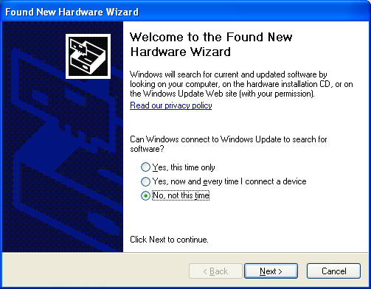

The first window will attempt to use the internet to find the driver, Select “**No, not at this time**”, and click **Next**.

Step 3 – Driver location

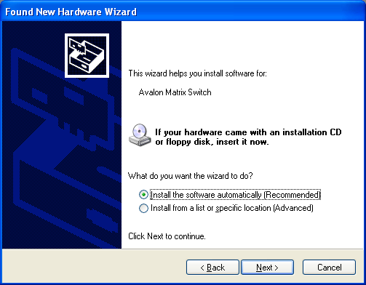

The next window attempts to find the driver disc. Insert the driver CD disc in the CD-ROM drive if you haven’t already.

Leave the button labeled “Install the software automatically (recommended)” selected, and click Next.

Step 4 – Continue Anyway

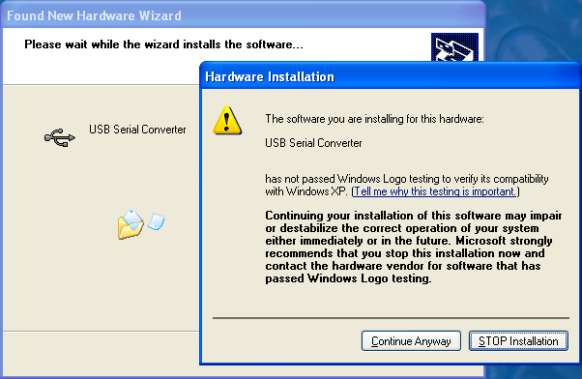

Windows will prompt on logo testing. Click “**Continue Anyway**”

Step 5 – Completion of first half

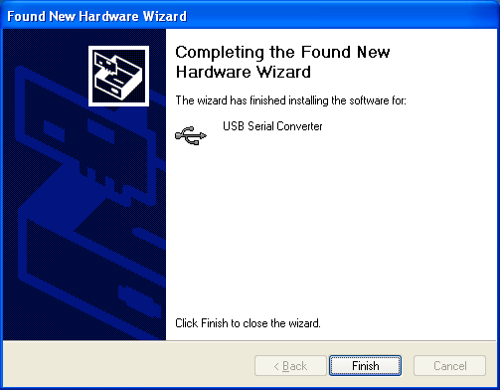

Click “**Finish**”.

Step 6 – Installing virtual COM port driver

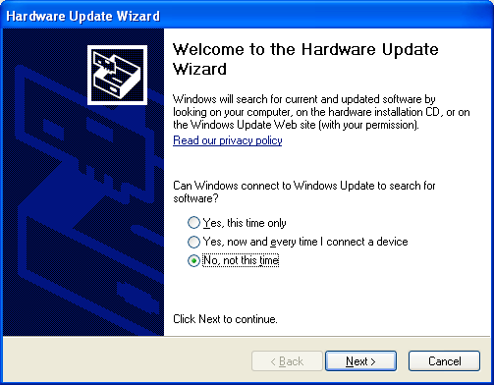

Windows will again start the new hardware wizard to install the virtual COM port driver. Click “**No, not this time**”, then click **Next**.

Step 7 – Finding the driver

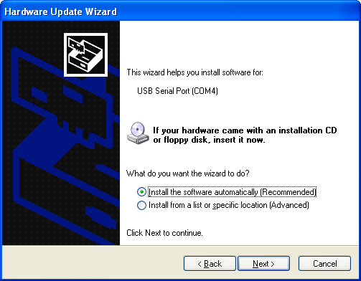

Leave the button labeled “Install the software automatically (recommended)” selected, and click Next.

Step 8 – Continue Anyway

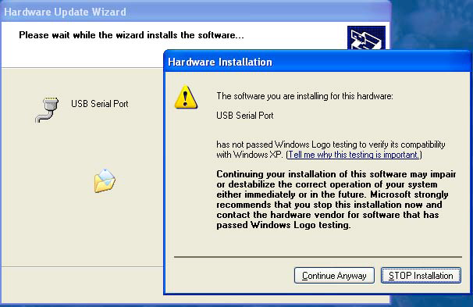

Windows will prompt on logo testing. Click “**Continue Anyway**”

Step 9 – Completing the Hardware Update Wizard

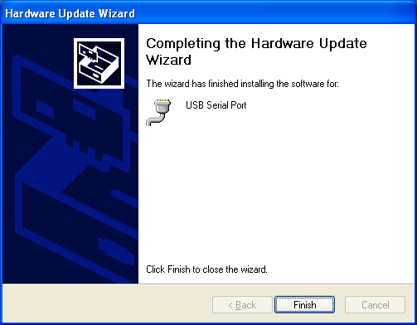

This is the final step, click **Finish**

At this point, the drivers are installed properly.

***USB COM Port Settings***

Whether using a Windows terminal program such as Hyperterminal, a control application, or a dedicated control system, the baud rate settings are the same: 115.2K baud (change using Bits per second dropdown), 8 data, no parity, 1 stop, no flow control. The COM port shown in the following example may change depending on your system.

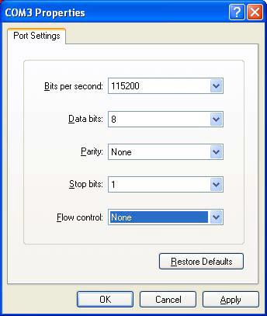

***Uninstalling the USB drivers***

There is typically no harm in leaving the drivers installed in Windows. It is usually best to keep them installed, so that when the device is plugged back in, it will be recognized automatically and is assigned the same COM port number.

However, if you need to uninstall the drivers for any reason, use the Windows Control panel to do so.

To Uninstall:

Click the **Start** Menu

Select Settings, then Control Panel

Click Add or Remove Programs

Find Matrix Switch USB Drivers

Click Change /Remove

Follow the on screen instructions.

**Care and Maintenance**

The matrix switch does not require any regular maintenance besides keeping it clean.

Never use harsh cleaners or solvents on the front panel. There are several dusting products for electronics, and standard glass cleaner may be used.

Spray any liquids onto a towel first, then wipe the front panel with the moist towel.

Should the matrix switch fail to operate as expected, please contact NeoPro for service advice. THERE ARE NO ADJUSTMENTS OR USER SERVICEABLE PARTS INSIDE THE CABINET.

**Specifications**

***Performance***

*See the Model Specific Features section at the beginning of this manual to determine which specifications are applicable.*

***Component Video***

Input coupling AC

Input impedance/termination 75 ohms

Output coupling DC

Output impedance 75 ohms source terminated

Output video bandwidth (-3dB) 140 MHz

Crosstalk Below –80dB

Video modes 480i, 480p, 540i, 540p, 576i, 576p,720p, 1080i, 1080p

Video vertical rates 24, 25, 29.97, 30, 50, 59.97, 60

***Composite Video & Digital***

***Audio***

Output video bandwidth (-1dB) 10 MHz

Crosstalk Below –80dB

***Audio (Analog L/R)***

Input termination 10K ohms

Audio bandwidth 20-20KHz, +/- 0.5dB

Gain and output type Variable gain (0%= -100bD, 100%=0db), low impedance output

***Power***

Input voltage 90-240V AC 50-60Hz autosensing

Input power (Depends on model, max 50W)

***Physical***

Dim. with feet (removable) 17”W x 3.75”H x 10.75”D

Dim without feet 17”W x 3.55”H x 10.75”D

Weight 8.8 lbs (shipping wt. 13 lbs.)

**2 Year Warranty**

HDTV Supply warrants this product against defects in material and workmanship for a period of 2 years. This warranty applies to the original end-user purchaser and installation service provider. HDTV Supply will, solely at its option, repair or replace this product with a functionally equivalent new or factory-reconditioned product during the warranty period. The consumer should contact the installation service provider that resold the product who will in turn deliver the product to HDTV Supply. All transportation risks and costs in connection with this warranty service are the responsibility of the consumer.

In order to keep this warranty in effect, the product must have been handled and used as prescribed in the instructions accompanying this warranty. This warranty does not cover any damage due to accident, misuse, abuse, or negligence. Repair or replacement, as provided under this warranty, is your exclusive remedy. HDTV Supply shall not be liable for any incidental or consequential damages. Implied warranties of merchantability and fitness for a particular purpose on this product are limited to the duration of this warranty.

Some states/countries do not allow the exclusion or limitation of incidental or consequential damages, so the above limitation or exclusion may not apply to you. Some states/countries do not allow limitations on how long an implied

Warranty lasts, so the above limitation may not apply to you. This warranty gives you specific legal rights, and you may also have other rights that vary from state to state and country to country.

**HDTV Supply, Inc.**  
3835-R East Thousand Oaks Blvd  
Unit 295  
Westlake Village, CA 91362  
(800) 841-9238  
(805) 277-1870 Direct  
(805) 435-2623 FAX for orders, RMA info and availability  
WEB: www.HDTVSupply.com  
EMAIL: support@hdtvsupply.com